Table of Contents

Section 1 - 2 -

0:00 - 2 -

14:00 - 6 -

Section 2 - 11 -

27:00 - 11 -

Section 3 - 28 -

Section 4 - 35 -

37:00 - 35 -

37:45 - 35 -

45:00 - 50 -

# Section 1

## 0:00

I heard you wanted an advanced react project so in this video we're going to be creating an advanced note-taking app 0:05 that has filtering categories markdown support full routing deleting editing 0:11 updating everything you could think of inside of this application it has it and it's all going to be written in react 0:16 using typescript so this is the perfect Advanced project for your resume [Music] 0:23 there is nothing worse than getting an email like this you know your site's broken but have no idea how to fix it 0:30 but with today's video sponsor highlight this is a problem of the past that's because highlight is not only an error 0:36 tracking system but it also gives you a replay of exactly what users did on your site to cause these errors which means 0:42 when you get emails like this you can just go into highlight look at the replay and see exactly what the user did 0:47 and you can fix that bug in no time highlight integrates into pretty much any framework you can think of such as 0:52 react or view in just a couple lines of code and with those few lines of code you're going to be getting full access into things like devtools logs Network 0:59 requests for every single session that a user takes on your page which makes it so easy to track all those different 1:04 errors the best part about highlight is it makes detecting those errors so easy so you can fix them before you have tons 1:10 of churn on your site and if you're interested in trying out highlight yourself you're going to want to use the link down in the description below and 1:16 if you enter the coupon code web dev simplified all one word you're going to get a two month free trial instead of 1:21 the normal one month free trial just make sure you do that within six months of this video going live welcome back to 1:26 web dev simplified my name is Kyle and my job is to simplify the web for you so you can start building your dream 1:32 project sooner as you can see this is the demo of what we're going to build out in this application so you can see we have full markdown support for the 1:38 body of all of our different nodes they can all have a title we can put different tags and we can even add new tags for example I can create a new tag 1:45 right here and now that's adding that new tag so if I go back here you can see we have a brand new tag with the title of new and we can come in here we can 1:52 filter by different things so I could search for just this has article I could filter by tags I could filter by labels 1:57 and tags for example I could say like this to get just that article so a lot of that I can edit all of my different 2:02 tags so if I put a 2 on the end of react now all my react tags have that too on the end of them so it's super flexible 2:08 with what you can do and we're going to be building out all of this in this video using typescript now to get started with what I have on the left 2:14 side of my screen here all I did was I ran the command npm create Vite so it'll 2:20 look just like this npm create Vite and you just go through all the steps that ask you say that you want to do a react 2:26 application in typescript and that's going to give you the exact same code I have here minus a few things I just essentially removed some of the stuff we 2:33 don't actually need so we just have these really simple files right here if we look you can see that this application is running and it just has 2:39 the text High being printed out now in order to create this application we're going to be using react router for all 2:44 of our routing and we're going to be using bootstrap for all of our styling so I just want to import those libraries by saying npmi react bootstrap and 2:52 bootstrap that's going to install those libraries for bootstrap for us and we also need react router so we can just 2:59 type in react router Dom I hit enter and that's going to download the different libraries that we're going to be using for this project and in order to use 3:05 bootstrap we need to import that local bootstrap file which is just bootstrap slash dist CSS 3:12 bootstrap.min.css that's going to give us a CSS for bootstrap and already if we look over here when we save you'll 3:17 notice that there's some slight differences because bootstrap has some default styling that is applied right here so the very first thing I want want 3:23 to do is get our router set up for react router so what we can do is we can come in here with the browser router we just 3:30 want to essentially wrap our application inside of our browser router that gives us access to routing inside of react 3:36 router and then our app we actually just need to use that router so we can come in here and we can wrap everything 3:41 inside of a route component just like this make sure I import routes 3:49 we'll just come up here import routes from react router Dom and we can just 3:56 get rid of this High text for now so we just have our routes and if you're unfamiliar with react router we're going to be using some fairly basic stuff in 4:02 this video but I do have a full react router crash course I'll link in the cards and description for you now inside 4:07 of here we want to Define our different routes so each one of those is going to have a route like that route there we go 4:13 and each one of these routes we need to give a path in our case let's just do our home path for now which is just 4:18 going to have a slash like this we'll make this self-closing for now because we can define an element and that is 4:24 what we're going to render for now let's just say we're going to Rend out the text High instead of an H1 so our fat 4:29 that slash route it's going to render out high like this so if we refresh our page you can see it's rendering out the 4:34 text High just like we had before now the next thing I want to render out is A New Path so it's Slash new it's going to 4:39 give us to a different thing so we're just going to put the text new inside of here this will say home for example so now if we go to Slash new it's going to 4:46 render the text new but if we go to a URL that doesn't exist you're going to notice we just get a blank page I want 4:52 to fix that so we're going to create a route that the pass is equal to Star that'll match 4:57 literally everything so if we type in something that doesn't exist it'll match this route here and for our element what 5:03 I want to do is I just want to use the navigate element which is built into react router so we can just come up here 5:08 we can say navigate like that and this navigate is going to have a to field and I just want to navigate back to the home 5:15 page so if I just close this off and save you're going to see immediately we get navigated back to the home page if I 5:20 try to go somewhere that doesn't exist again it just redirects me back to the home page which is perfect now the final two routes that we're going to need both 5:26 start with Slash ID because they're going to be for creating or I'm sorry for viewing a note and for editing a 5:32 note so the path here is going to be at slash ID just like that and instead of 5:37 giving this a specific element instead what I'm going to do is I'm going to put routes inside of here and each one of 5:43 these routes are going to be nested inside this route so if I say index here that's going to match this path right 5:48 here which is just slash ID so this is going to be for example our show path so we can come in here H1 5:54 which just says show and I can do the exact same thing just copy this down and this one is going to have a path 6:00 which is going to be slash edit so we can just come in here with edit and that's going to be slash ID slash edit 6:06 and this will say edit just like that so now if I come in here and now let's just say I put the ID 1 now it's going to say 6:13 show if I put the ID slash edit now we're on the edit page so this allows me to go through all the different pages of 6:18 our application which is exactly what we want now the last thing I want to do is just wrap this entire thing inside of a 6:23 container so we can say container this is coming from bootstrap this is just some styling for our container and we 6:29 can give it a class here which is my4 that's just going to give us some margin on the top and bottom as 6:36 well so now you can see that this just spaces things out a little bit better which is really nice now that we have our basic shell of all the different 6:42 paths in our application the first thing I want to focus on is this new route because obviously we can't view any 6:47 notes unless we can create some notes so let's be able to create some nodes here so instead of just passing in H1 I'm 6:52 going to pass it a component which we're going to call new note just self close that like this and let's create that 6:58 file so we'll say new note dot TSX export function new note 7:05 just like that so now if I just import that over here you can see that everything should be working fine and if 7:11 we go to that new route it's going to render out new note but of course we need to make sure we return something from here 7:16 so let's just return in H1 that says hi just so we know where we are so if we go to Slash new 7:22 it'll now print out that text high so everything is linking together properly now inside here obviously we want to do 7:28 a little more than just render out an H1 but we do want to render an H1 and that'll just say new node so we know we're on the new node page I'm going to 7:34 give it a class which is margin bottom four just to give us some space on the bottom make sure that's a class name and 7:41 then below that we want to render out our form for our new note but our new note and our edit note are going to be 7:46 identical for example we click create you can see we have this form and if we just go back by clicking cancel and we 7:51 click on one of these to edit you can see that the form is exactly the same for both of these so what I want to do is I just want to make sure that we use 7:58 the same form component so I'm going to create a new component here called note form and we'll just close that off for 8:04 now and let's create that node form just like this export function node form 8:12 and now we can use the exact same form for both of our different components that have new as well as editing of our 8:19 forms so let's make sure we have all of our inputs and everything working fine if we come over here just make sure this 8:25 says return and now you can see our form is being rendered but obviously we should put some jsx in there so inside 8:30 of here we can get rid of this H1 since we don't need it and instead we can replace it with a form element and this is coming straight from bootstrap let's 8:37 just see if we can import that yep react bootstrap there we go and inside of here what I want to do is I want to use a 8:43 stack which again is going to be coming from bootstrap I'm going to give it a gap of four this is just going to 8:49 automatically space out our elements from one another in a vertical stack on top of each other so if we add three divs for example that said one 8:56 two and three you can see those space out with some space between them and depending on the size of our Gap it's 9:01 going to have more or less space between them that's all this stack is doing for us now inside of our stack I want to put 9:07 a row and inside of that row I want to have a column and inside of there I want to have a form group that's like the 9:13 boilerplate code for bootstrap and let's make sure that we import our row as well as import our column just like this now 9:20 inside of our form group we want to give this a ID so we can hook together our label and our input so we can use 9:26 control ID for that this is going to be for our title so we can just put in here our title and what I want to do inside 9:32 of here is just put a form dot label that says title again and we're going to 9:38 want to have a form control but our form control here is going to be required since it's going 9:44 to be required we give all these a title and we're going to want to give it a value and a ref but for now we're not going to worry about that because we 9:50 just want to get the shell of this working as you can see here we have our title form which is looking really good I want to add another column and this 9:57 one is going to be for handling this select box as you can see over here for our different tags so this is going to 10:02 be for our tags and it's going to have a control ID of tags if you come over here you can now see we have an actual input we want this to be a select input now we 10:10 could come in here and replace this with a select like this and it's actually going to give us a select that we could put some options inside of well if we 10:16 want to multi-select that looks like this that allows us to create new things inside of it that's going to require 10:22 much more than just a basic select can do so we're going to be using a library called react select so let's just make 10:28 sure we install that react select library and actually if you want to see a video of me creating a select that's 10:33 very similar to react select I'm going to link that in cards and description for you it's a really good project as well to add to your resume so now with 10:39 that Library we can actually use that react select and what I want to do is I want to use a creatable react select so 10:45 up here I'm going to import creatable react select 10:52 and then what we can do is we can say that it's going to be coming from react select and I want to get that from the 10:57 creatable folder and all of this creatable version of it allows me to do is it allows me to create tags just like 11:03 you saw over here if I type something I can click create to create that tag that's all the creatable version of this allows us to do so now I can put my 11:11 credible react select inside of here I'm going to say that it's going to be a multi-select version so now you can see 11:16 when we save it's going to just refresh and now we have this list right now we have no options but if I wanted I could 11:21 create a brand new Option and that's going to work just fine so we have this credibility already in there which is great and we're going to focus on adding 11:28 more options into it in a little bit but for now I want to get the shell of everything done so just like with the rest of our application we're going to 11:33 need another form group for our final body element and that's going to be on its own row so we're just going to put 11:39 that outside of our other row this one's going to have the ID of markdown that's just because this is our markdown we're 11:45 going to give it a label of a body and then our form control here again is going to be required we want to say that 11:51 it's going to be as a text area so that this can be a large text area we want to 11:56 make sure that it's going to have some number of rows I'm going to set that to 15 a fairly large number it's just going 12:01 to make our text box really big and now if we save you can see we have this large text box for our body right here 12:06 and it is a text area which is exactly what we want and this Rose Field all that did is make it so our text box is 12:12 quite large which is ideally what we want to have now the last thing I want to do is add in our buttons I'm going to 12:18 use a stack for that as well but I can change the direction of my stack to be horizontal 12:24 and now what that's going to do is allow me to stack these items side by side in a horizontal Direction so for example I 12:30 could get two different buttons let's just close this button off and that's going to say save and this one is 12:35 going to say cancel let's just make sure we import button just like that and now we can change our 12:42 type for our save button is going to be a submit button while our normal button here this is just going to be a type of 12:48 button so we make sure it doesn't submit our form and we want to change the variant of this the variant of this is going to be 12:54 outline secondary that's going to give it a gray color if we copy that up to our save button up here the variant on 13:00 this one is going to be primary which is going to give us that solid blue color so now if we save you can see we have our buttons right here obviously we want 13:07 them to have some Gap so we're going to say a gap of 2 right here that's going to give them some space and also we're 13:13 going to add a class name on here which is justify content end and that's just going to push our buttons all the way to 13:19 the far right side of our page which is looks a lot better and that's exactly what we want to do now to make this 13:24 cancel button work we just want to make it take us back one page so that's really easy to do with the link tag we 13:30 can say we want to go to dot dot and what that's just going to do is it's going to move us backwards one page so 13:36 let's make sure we import this from react router and now whenever we click on this cancel button it's going to bring us back to the previous page we're 13:42 on which in our case is the home page so if first of all we go to like slash one the show page and now we go to Slash new 13:49 when we click this cancel it's going to bring us back to the page where you're on 4 but you'll notice here it brought 13:54 us directly to the home page

## 14:00

instead of the show page the reasoning for this is because we're manually typing into our URL which is kind of overriding all the 14:01 history as soon as we start linking between all of our different pages for example on this home page if I add a button to create and then I click cancel 14:07 it'll bring us back to the home page or from other Pages that's all you really need to know this just brings us back 14:12 one step but since when you use manual overriding with your url it can't actually go back because there is no 14:17 back to go to since you manually typed in the URL so right now with all that done what we need to do is we need to make it so we can go to our form and we 14:24 need to make it so our form actually does something in order to do that we're going to be using refs so I can come all the way up here I can say we're going to 14:31 have a title ref which is equal to use ref and this used ref is going to start out as a null value and we're going to 14:36 give it a specific type which is an HTML input element just like that that's because this is an input element that 14:43 we're going to be getting our values from same exact thing here for mark down ref this one instead of being an input 14:49 element is going to be a text area we can say html text area element and 14:54 now where we have those different elements for example our title I can say our ref here is equal to our title ref 15:00 just like that I can do the same thing down here for our text area I can say our ref is equal to our text area ref 15:08 just like that and now if I give this a save and actually I called this markdown 15:13 ref not text area there we go now everything's working and we have information for our title and our body 15:18 being stored inside of these refs so if we wanted to we could set up a handle submit so we could say on submit is 15:24 going to be equal to handle submit and then we can come in here function handle submit which is going to 15:31 take in that form event we can just call prevent default on it and now what we 15:37 can do is we can actually handle all this information for example we can get our title value or our markdown value and then we can submit that to you know 15:43 our new note page or wherever we want to submit that so our Note Form should probably take in some props and one of 15:49 those props should be an on submit function now this on submit function is going to need to take in information related to 15:56 our note some type of data for our note so inside of our app let's actually create a brand new type and that type is 16:02 specifically going to be for Note data so we know just looking at this new note 16:07 page that all of our notes are going to have a title which is a string they're going to have some type of body or we're going to call 16:14 it our markdown that is also going to be a string and then finally we're going to have some tags which I want to be an 16:19 array of this tag type so we of course need to create a type for tag as well 16:24 and this tag type is really simple it's an ID with a string and a label which is 16:30 also a string that's all there is to our tag now our note should also have an ID but our Note data the specific data from 16:37 our form does not have that ID so let's create another type that is going to be essentially our Note data but with an ID 16:42 attached to it so our ID is a string and we just want to add on all of our Note data onto the end of that node type so 16:49 all this is doing is giving us a brand new type that adds ID to our existing Note data type now with that information 16:54 we can go back to our note form and we can set up our Note Form props just like 17:00 this so type node form props is equal to we're going to have an on submit 17:06 function and this function is going to take in some data which is going to be based on our Note data so let's make sure we export that type in here so we 17:13 can use it and I'll do the exact same thing with our tag and the exact same thing with our node here so we can 17:19 actually use these different types so I can import our node data so whenever we submit it's going to give us Note data 17:24 and this is going to return to us a void value so we're going to pass it our Note data and expect nothing in return so 17:30 here we can call that on submit function and we pass it in our node data in our case our title which is our title 17:37 ref.current dot value we're going to have our markdown which is our markdown 17:43 ref.current dot value and then finally we're going to have our tags which we're just going to pass an 17:48 empty array for now but we're going to figure out how to do that in a second now in order to get rid of these errors we can just put an exclamation point 17:54 here at the end and that's just saying that even though this value could be null we're saying it's never going to be 17:59 null and the reason for that is because we made sure that these values are required you can see right here this is required and right here it's required so 18:06 it's always going to have some type of value which is why we can get array with forcing these to be not null now the 18:12 last thing I want to do is store our tags and instead of using a ref for this we're actually going to be using state for this so we're going to have our 18:18 selected tags set selected tags that's going to be inside of an array because 18:24 we're getting that from use State and this is going to be an array of tag elements and again we need to make sure 18:30 we import that tag element started out as an empty array let's just make sure 18:35 we import use State and we import tag just like that now if we scroll all the way down here to where we're using our 18:42 creatable react select what we can do is we can set up a value property and on change property so this value property 18:48 we need to pass an array that has keys for label and for Value so we need to take our selected tags we need to map it 18:55 to a brand new value so for each one of these tags what I want to do is I want to return an object that has a label 19:01 property which is the label from our tag whoops tag dot label 19:07 and what I want to do is I want to give it a value which is our tag.id the reason we need 19:13 to do this is just because that's what creatable react select expects for its value it expects a label in an ID just 19:19 like you would expect from an option inside of an array or inside of a select sorry and the next thing we need to do 19:24 is we need to set up our on change to be able to modify our values so on change is going to get passed in an array of 19:30 tags but these tags are going to be in the format of the actual on Changers has a label and a value so again we need to 19:36 map these values from our tag so what I can do is I can say that we want to set 19:42 our selected tags and with our selected tags we're going to take all of the tags that we have here and we're just going 19:47 to map each one of the tags to be the correct value so we're converting from a label and a value to a label and an ID 19:54 so we can return here a label which is tag dot label and an ID 20:00 which is tag dot value so essentially all we're doing with these is we're making sure we're converting from the 20:05 value that credible react select expects to the value that we're actually storing for our type which is an ID and a string 20:11 now before we go any further with this new node form we need to make quite a few changes to how we're storing our 20:18 data because obviously right now we're not storing any data at all so inside of our app we want to store some state for 20:23 our notes and we want to store some state for our tags and instead of using you know State 20:29 like this what I want to do is I want to use local storage just so that we have a way to keep this information persisted 20:36 so we're going to use local storage and this is going to be called notes and by default it's going to be an empty array 20:41 just like this we're going to give it a type here which is going to be raw note array and in just a second I'll explain 20:48 why we're using this raw note by creating the type itself so if we export a type called raw note 20:55 this rhino type is going to be very similar to our note but instead of storing the tags we're just going to 21:00 store the ID of the tag the reason for this is what happens if we change the value of our tag well I don't want to go 21:07 into every single note and update that value I just want to update our tag which we're storing inside of local storage as well and then it's going to 21:14 automatically propagate that change because it knows that the ID is the correct ID so for a raw note what I want 21:20 to do is I want to have an ID which is a string and then I want to have some data so we'll do raw node data as well just 21:25 like we did with our normal note where I know data and it's going to be exactly the same but our tags here 21:31 instead of being tags we're going to call this tag IDs and it's just going to be a ring an array of strings so this is 21:36 going to store the IDS for each one of our tags and then when we create our notes we're just going to make sure we check our tag array which our tags have 21:43 an ID and we're going to get the correct value for that tag this just means that if I update my tag I don't have to 21:49 update every single note that I'm storing I know that as long as the ID Remains the Same it'll propagate that 21:55 change across so let me just copy this down one more time for our tags just like this this is going to be an 22:02 array of tags and we're going to call this tags now I'm just going to make these capitalized because it's going to conflict otherwise with the other 22:08 elements that I have on localhost so that's just going to fix that problem and then what we're going to do is we're going to create a brand new file for 22:14 that use local storage hook and this is just going to be where we store all of our data so export function use local 22:21 storage just like that and we already know if we look here it's going to take in a generic type it's going to take in 22:27 a label and it's going to take in a default initial value so what we want to do is we want to make sure we have a 22:33 generic type here that is going to be accepting we're going to be having a key which is a string and we're going to be 22:38 having an initial value and that initial value is either going to be of type T the generic type or it's going to be a 22:44 function that is going to return type T and that's just because when you use State you can either pass it a function or you 22:51 can pass it in initial value either one is going to work so we want to make sure this works exactly the same 22:57 now the first thing I want to do is I want to use some local state inside of here I'm sorry some use state so we're going to have value set value equals use 23:04 State the type of this state is going to be that generic type we pass in make sure I just import use State like that 23:10 and inside here we're actually going to use the function version of you state because I want to first check to see if 23:15 this data is in local storage so we're going to get our Json value because we're going to store this in 23:21 local storage using Json which is just localstorage.getitem of our key then 23:26 what we can do is if our Json value is equal to null then what we want to do is 23:31 do some value otherwise if it's not equal to null we can just return the parsing of that Json value so 23:39 for some reason we don't have any value from local storage then what I want to do is I want to essentially take that 23:44 data and I want to make sure that I use the initial value passed in so let me just close out of that real quick what 23:50 we can do inside of here is if the type of our initial value is equal to function that means we need to run the 23:57 function version of this otherwise oops we can just return our initial 24:03 value just like that so here what we can do is we need to run initial value as a function 24:09 so we could say initial value like that run it as a function and return that but it's going to give us an error inside a 24:15 typescript because it doesn't know if this is actually a function that we can call and we don't know that it Returns 24:21 the type of T so we just need to make sure that we take our initial value and we cast it to this exact type and this 24:27 is the type that we put up here for a function all this code does is it tells typescript hey this initial value right 24:33 here is going to be a function that Returns the type of T and then we're going to call that function if I just 24:38 make sure I spell initial value correctly and we save we're now no longer going to get any of those errors and we have our value and our set value 24:45 which down here we can return inside of an array just like this now again we're 24:50 going to need to type this so we're going to need to say that hey the first value is T and the second value is just going to 24:56 have the type of set value so we're just specifically saying to typescript hey this array that we're returning is 25:03 always going to have the first value which is our you know type that is T and the second value is going to be whatever the type of this set value is just to 25:10 make sure typescript knows what each one of these types are now finally we're going to use a use effect and that's just going to save our 25:16 data in local storage every time our value or our key changes so far value are our key changes then we're going to 25:23 take our local storage we're going to set the item at that key to the stringified Json version 25:29 of our value just like that and that's all we need for our used local storage hook it may 25:35 be pretty complex but essentially all we're doing is we're just checking hey does the value exist yet and then every time we change it just update it that's 25:42 it super straightforward so now inside of here if we import that hook you can see that should get rid of all those 25:47 different errors and now we have a place to store our notes and a place to store our tags now I mentioned that we're 25:52 storing the raw Note data so we're not actually storing the note tag itself we're just storing the ID so I need to 25:57 actually get to the notes with tags to be able to convert my raw note into an actual note so we can use a memo for 26:05 this just like this and with our used memo what we want to do is return our notes 26:10 dot map each one of our notes and for each one of these we're just going to take our entire note object so 26:16 everything that was already in there that's fine we're going to keep that and then we're actually going to get some individual tags so we're going to take 26:22 our tags and we're going to filter on them so for each tag what we're going to do is to see if our note dot tag IDs 26:29 includes whoops includes our tag.id so if we just make sure that we import this 26:35 use memo right here just give it a second there we go but this line of code right here is 26:41 saying is it saying hey Loop through all my different notes and for each one of them I want you to keep all the information about the notes but I also 26:47 want you to get the tags that have the associated ID inside of our note that's being stored the last thing we need to 26:53 do is make sure we only run this every time our notes or our tags gets updated and that should fix those errors that 26:58 we're having but it looks like we're getting an error here with our tag IDs so if we look at our raw note you can see our raw note we forgot to include 27:05 our raw Note data there we go that should fix this now all this information should be a part of our note and that 27:11 should get rid of this error and it does so now our notes with tags you can see it has all of our information about our tags our ID our title and our markdown 27:18 and we don't really care about the tag IDs but it's still there and something we can use so now let's create a function that handles the creation of a

# Section 2

**SUMMARY KEYWORDS**

tag, note, id, function, label, create, store, import, type, homepage, uu, call, array, props, handle, front end engineer, pass, save, navigate, local storage

## 27:00

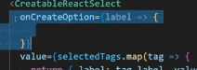we're having but it looks like we're getting an error here with our tag IDs so if we look at our raw note you can see our raw note we forgot to include our raw Note data there we go that should fix this now all this information should be a part of our note and that should get rid of this error and it does so now our notes with tags you can see it has all of our information about our tags our ID our title and our markdown and we don't really care about the tag IDs but it's still there and something we can use so now let's create a function that handles the creation of a note. We'll call this onCreateNote.

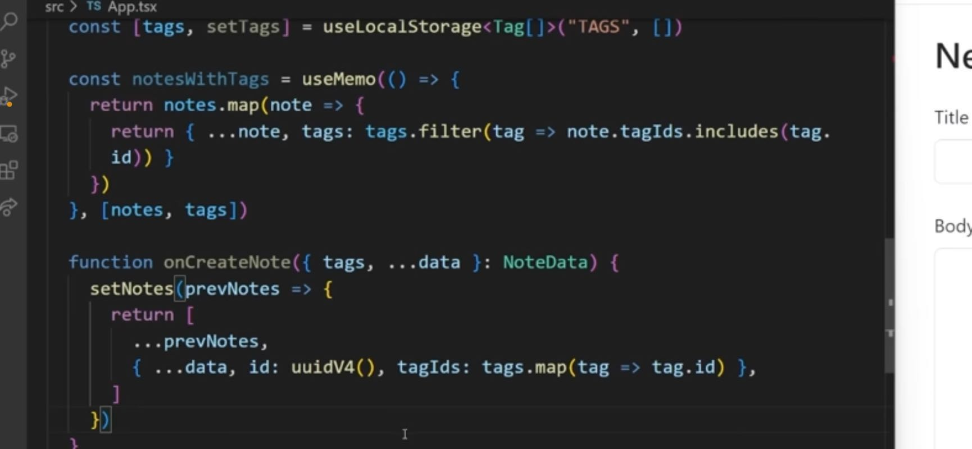 And this is going to take in essentially some note data, which is going to be the type of note data. We know that this is what we're going to be using when we create a note and we want to we want to set our notes based on our previous notes. We want to return an array that has all of our previous notes. And we want to have our data as well like this. But our no data is not a raw note. We want to convert this into a raw note. So instead of storing the tag itself, we just want to extract the ID. So what we're going to do is we're going to change this here to have our tags, as well as all the data for our note, and in here. What I want to do is I want to get all the data just like this. And then I want to set a specific ID which in our case is going to be a UU ID V four, which is a library we're going to install and PMI and PMI UU Id just like that. That's going to install this new UID library. And then up here we can import V four as UU ID V four from that UU ID library. This just allows us to create a string based ID that's always going to be unique. Id li for from that UID library allows us to create a string based ID that's always going to be unique. And the last thing we need to store is going to be our tag IDs.

So w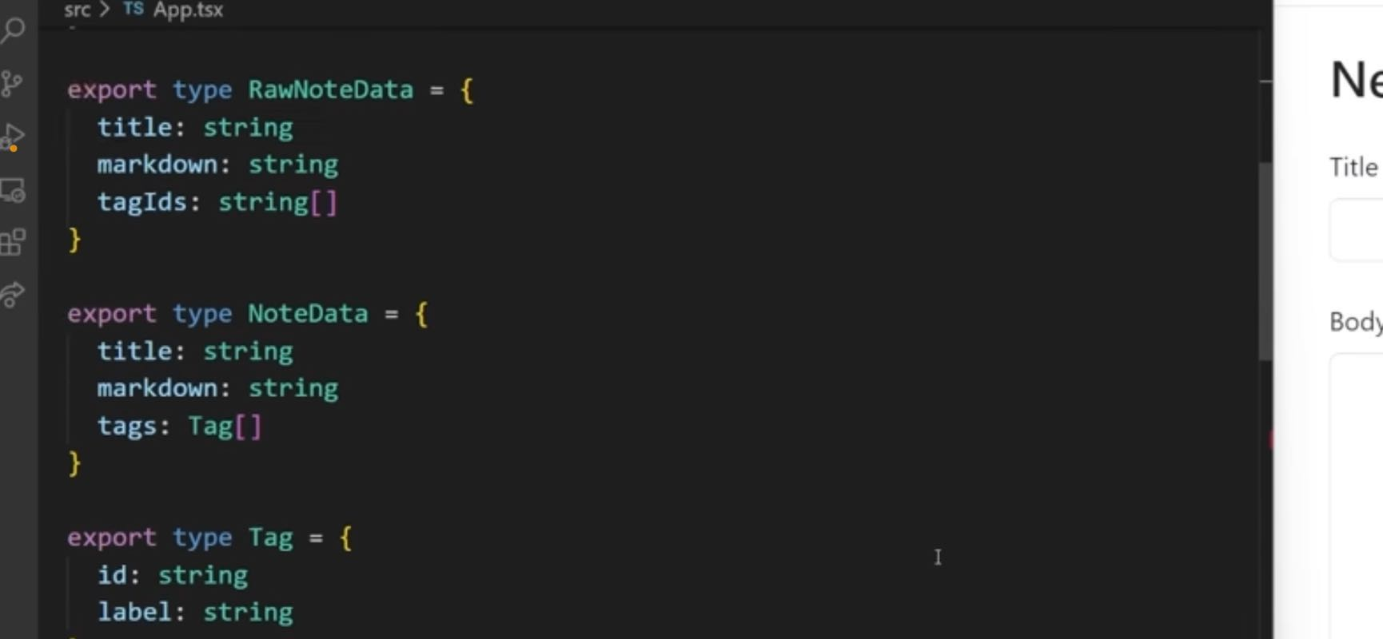e can take all the tags that we have, I don't want to map them and I just want to get the tag.id essentially just extracting the ID from our tags. And as you can see that got rid of all of our errors for us. So we know that this should work. Now we have a function that when we create a note and call this function, it's going to save that inside of this note array right here, which is stored inside of our local storage. Now we can do is we can scroll down quite a ways here to where we have our new note and this was going to have an onSubmit that we're going to pass to it and this onSubmit is going to be an on Create note. So now what we can do inside of this new note is we can make sure we accept an on submit this on Submit is going to have the type of new note props. New note props and this is going to have an on submit. And we already know that this onSubmit is a function. This function is going to take in some data which is a node data just like that, and it's going to return void. And now we can pass that to our note form and that should clear up that final error that we've been having for a while. Now we do still have another error if we scroll all the way up here you can see it's saying that there's an error with this could not find the type declarations, we can call NPM. I save dev the types for this and that'll install the types for you UID four, which is important to make sure we have all of our types like we should. So once that's done now that should remove that air force which is exactly what we want. And now we can continue adding with our project. The final thing we need to do before we can actually create a brand new node is to handle what happens when we actually create a brand new tag.

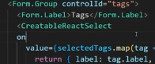  So if we come into here, our creatableReactSelect like has an on Create option function or property that we can pass here. And it's going to take in a label which is the thing we type in and then we need to do something with that label. And this means that we need to automatically set the value because it does not call on change.

When we create a new tag instead it calls this function right here.

So I want to get a new tag, which what I'm going to do is I'm gonna set an ID equal to UU ID V four. And then we're just going to set our label like this. I'm gonna make sure I import this UID V four, and a copy the same import I used up here, over into here. There we go. So now we have this we can create our ID. And I'm going to call a function called on Add tag. I'm going to pass in our new tag. We'll handle that function in a little bit. But I also want to set our selected tags to be this previous value, as well as all of our tags here so that of that previous new tag. So we're just taking all of our existing tags and adding this new tag on to the end of our selected tags. **Now you're probably wondering why do I have this on Add tag right here?**

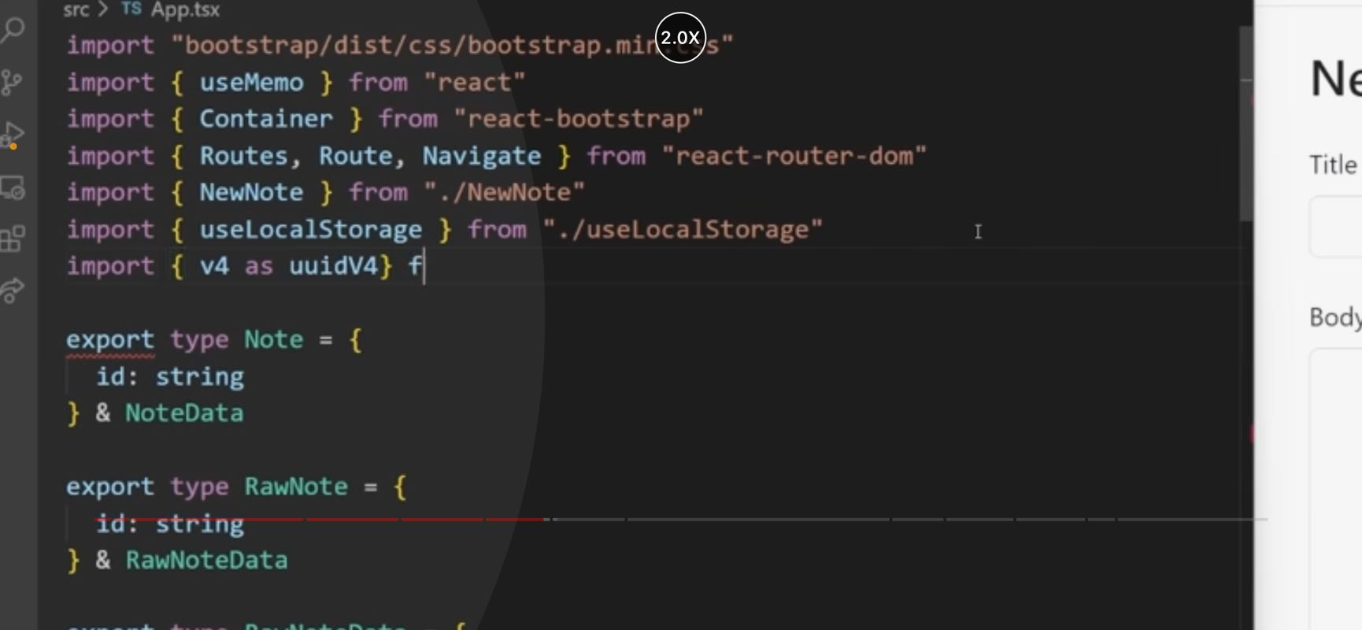

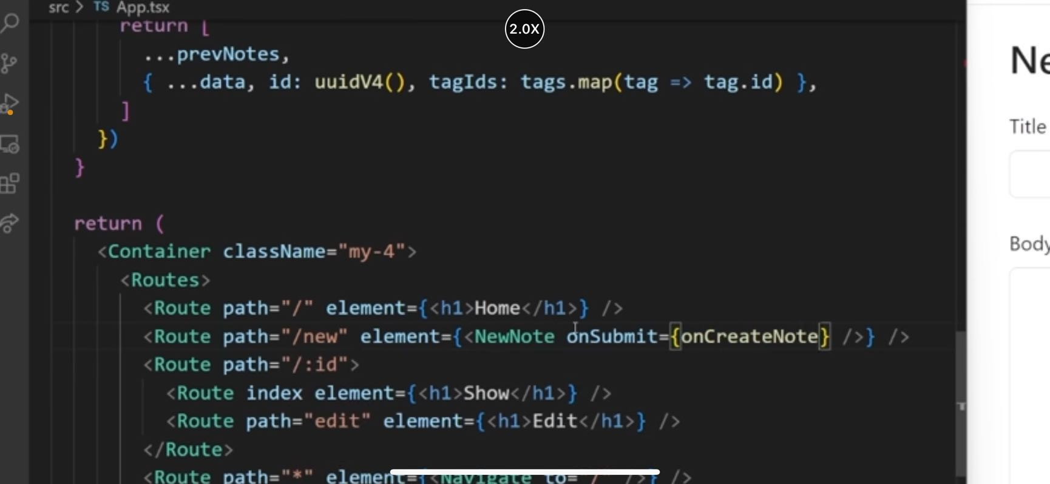

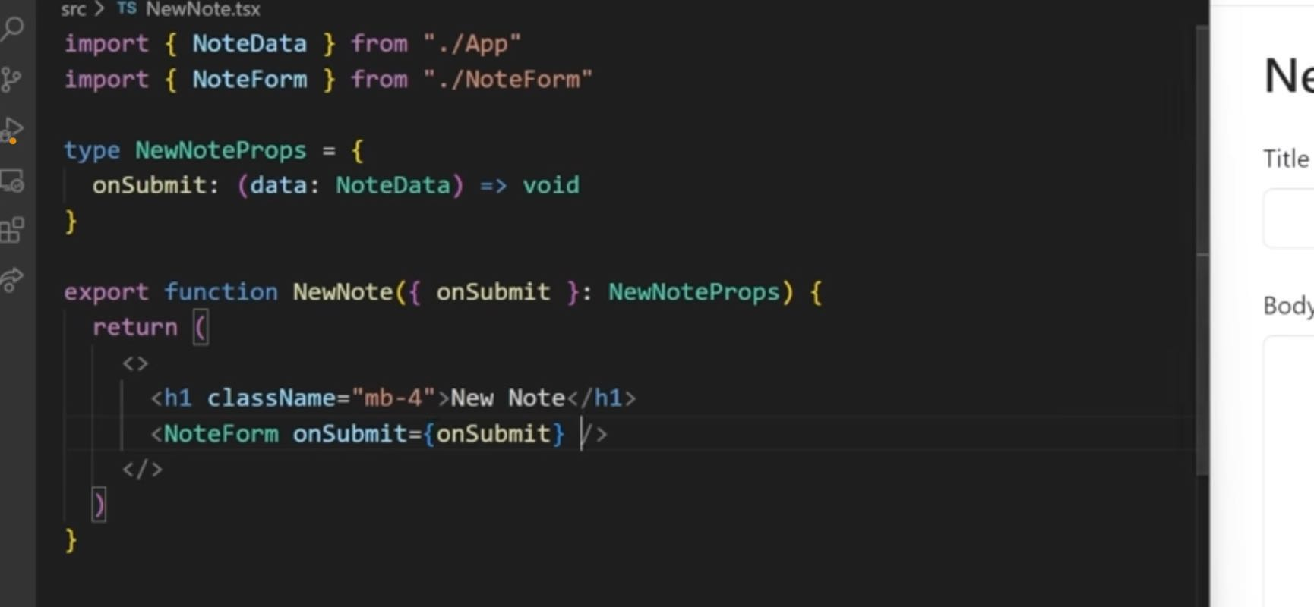

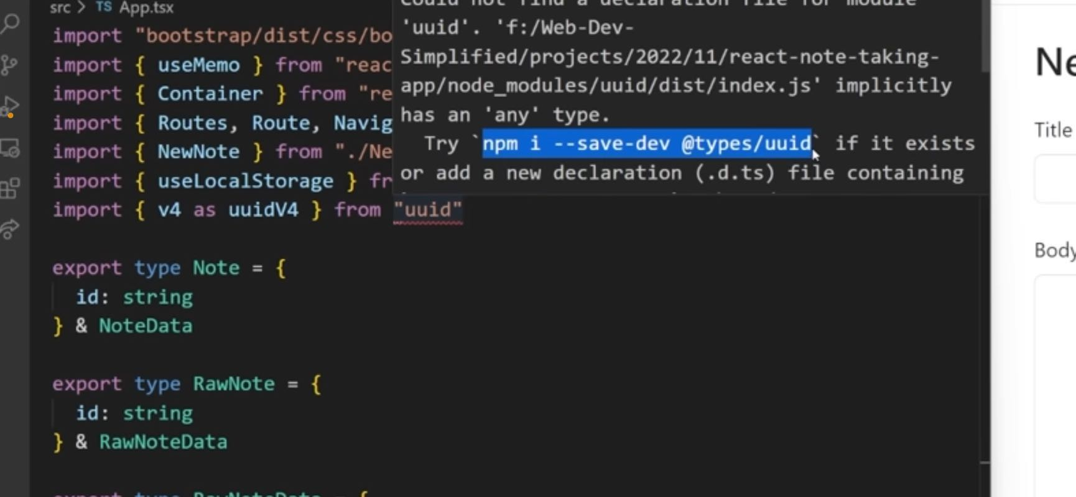

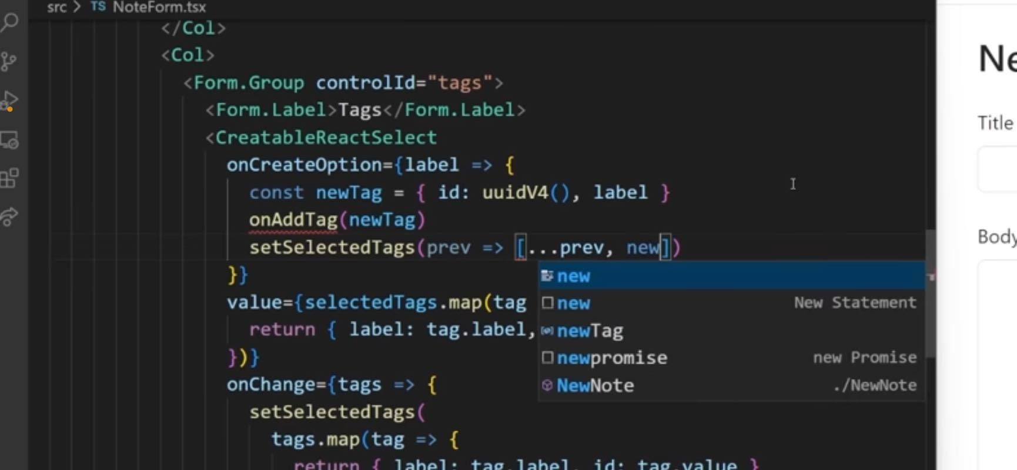

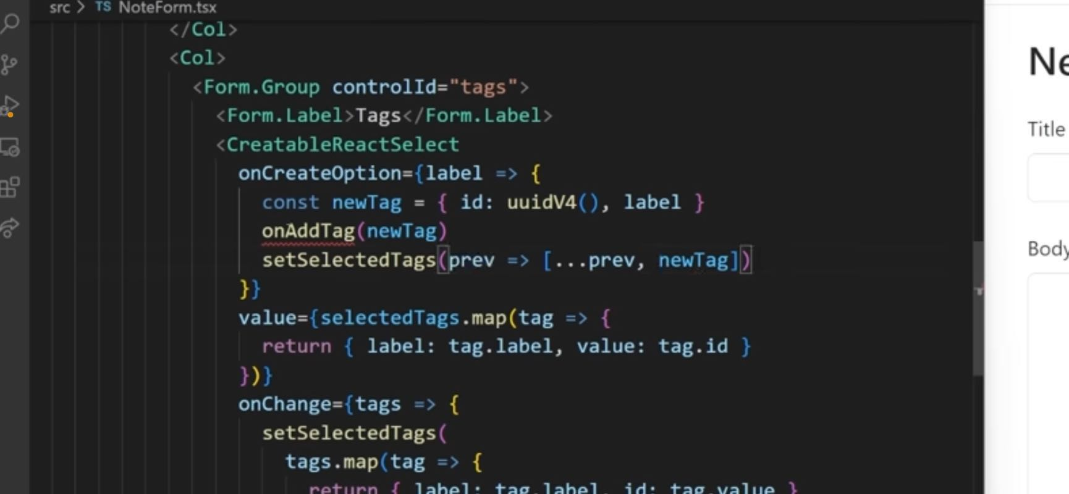

The reason for that is because we want to be able to make sure that we can store that inside of our local storage which is persisted in our application. So we need to handle a function for that.

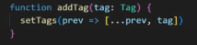 So back inside of our app here was to scroll down function, add tag. This is going to take a tag just like this and this is going to be really straightforward function. We're gonna call set tags with the previous value. Get all the previous ones and add the other tag to the very end. And now we can pass that into our new note. So we can say on

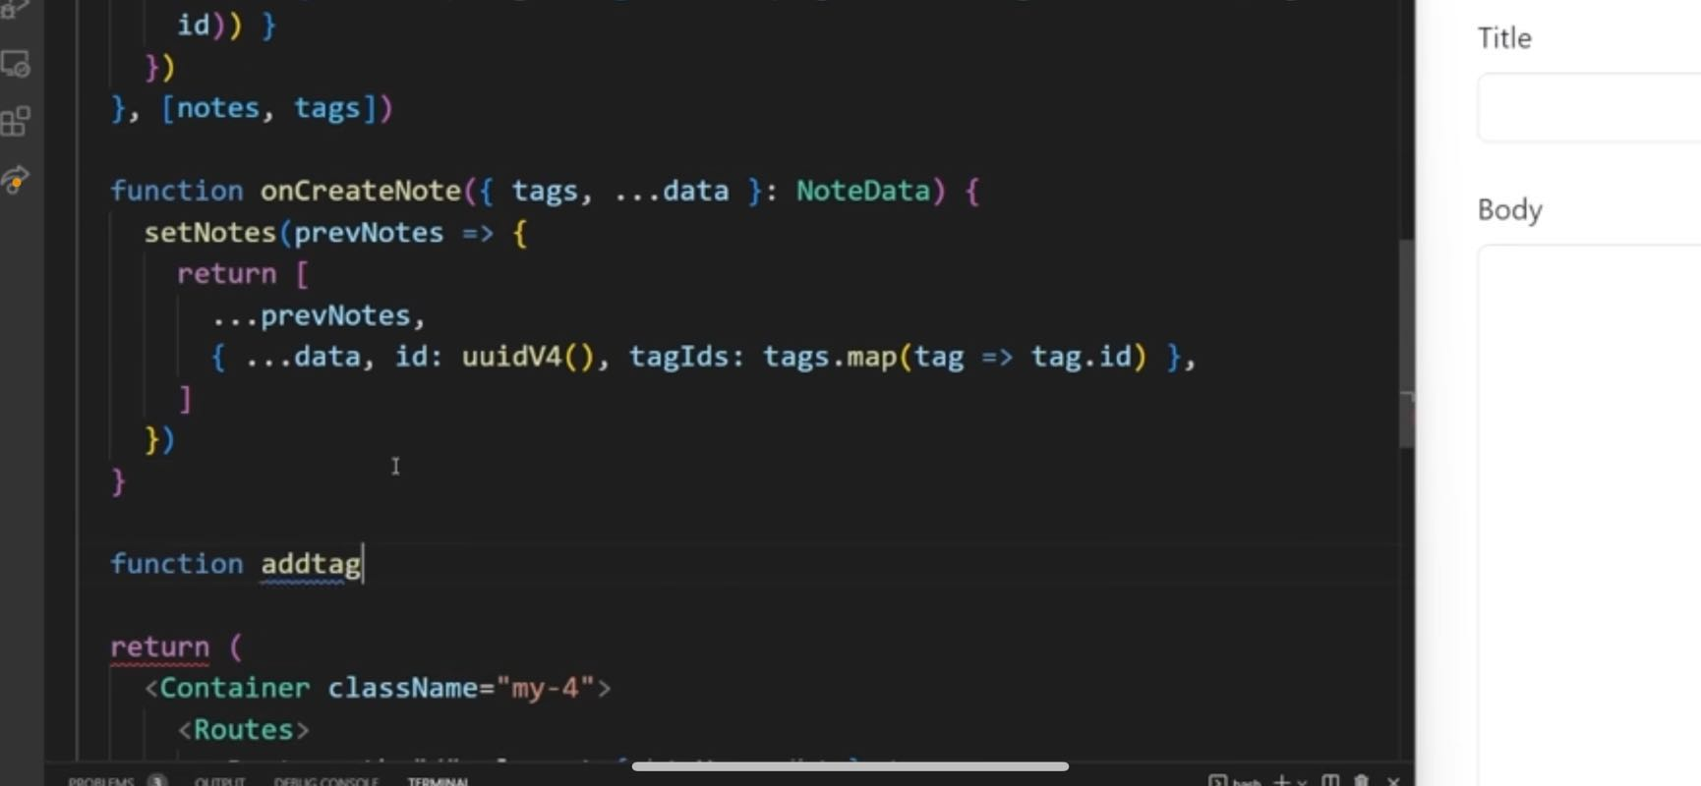

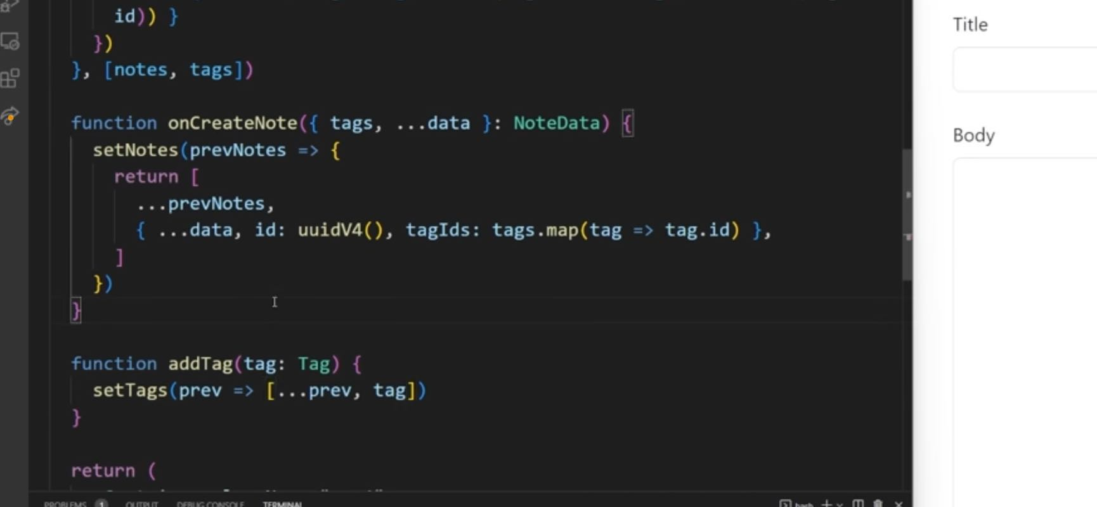

05:05

the tag is equal to add tag and I also want to pass in all the available tags that we have. So this is going to be equal to our available tags just like that. So now what we can do inside of our new note is we can make sure we handle that information. So we have here

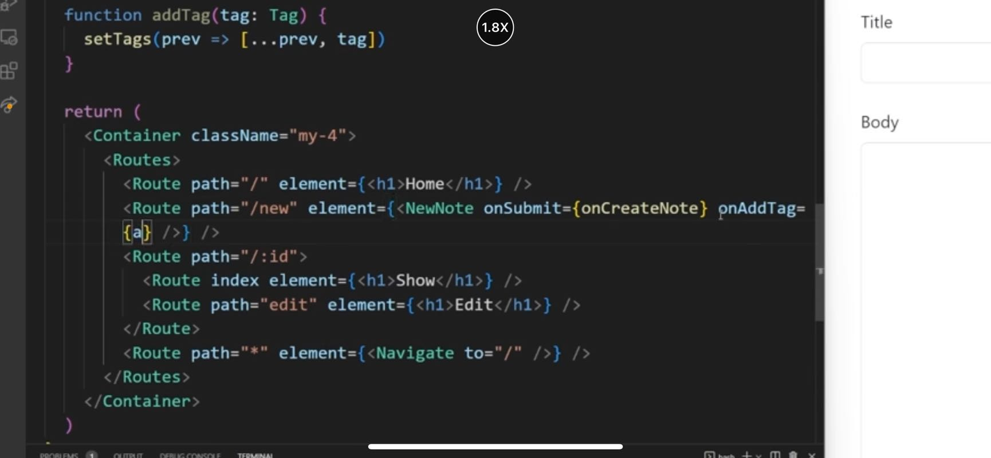

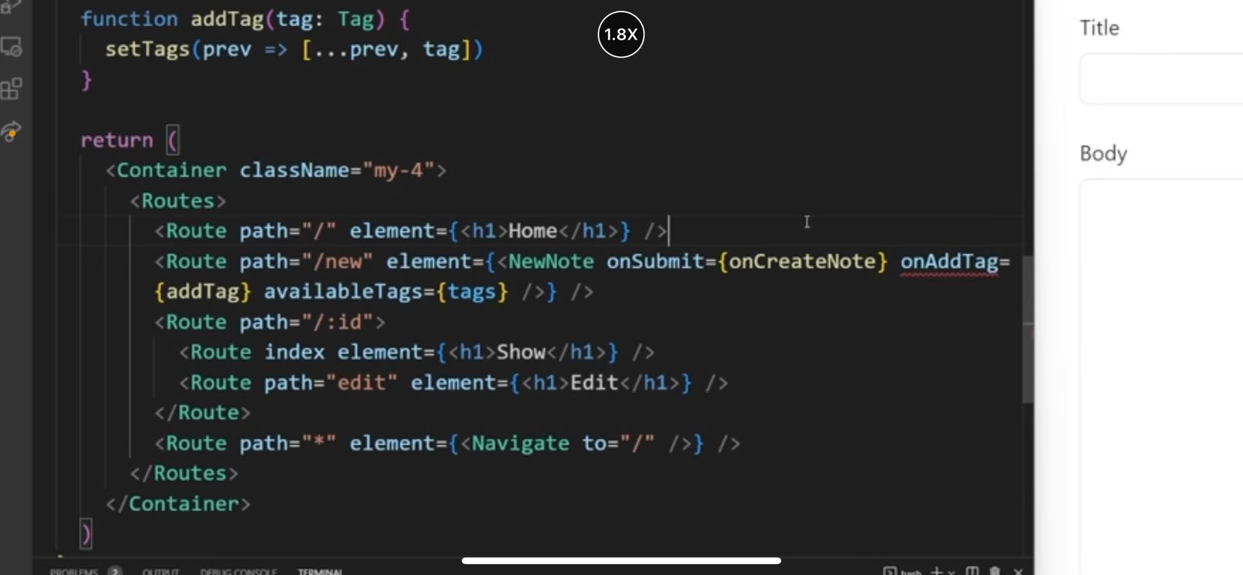

05:30

on add a tag, which is going to be a function that takes in a tag and returns to us void and then we have our available tags, which is gonna be a tag array. And then we just need to make sure we import this type of tag. There we go. Now we can use those on Add tag available tags, and these up just want to pass down directly into our note form. There we go. I'm just going to copy this type because it's going to be sharing a lot of information with our note form up here. Is that down and let's get that on Add tag and available tags from our props. So now this on Create option should work fine.

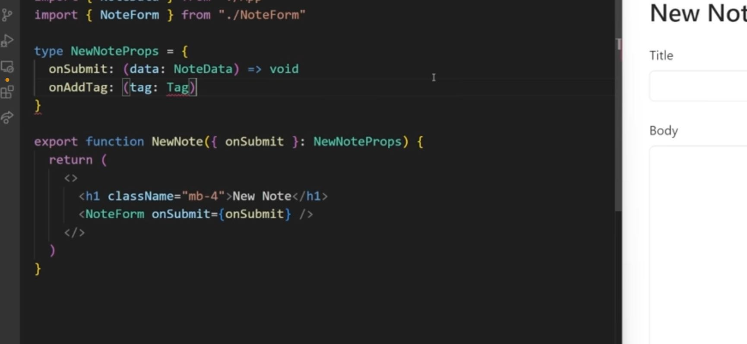

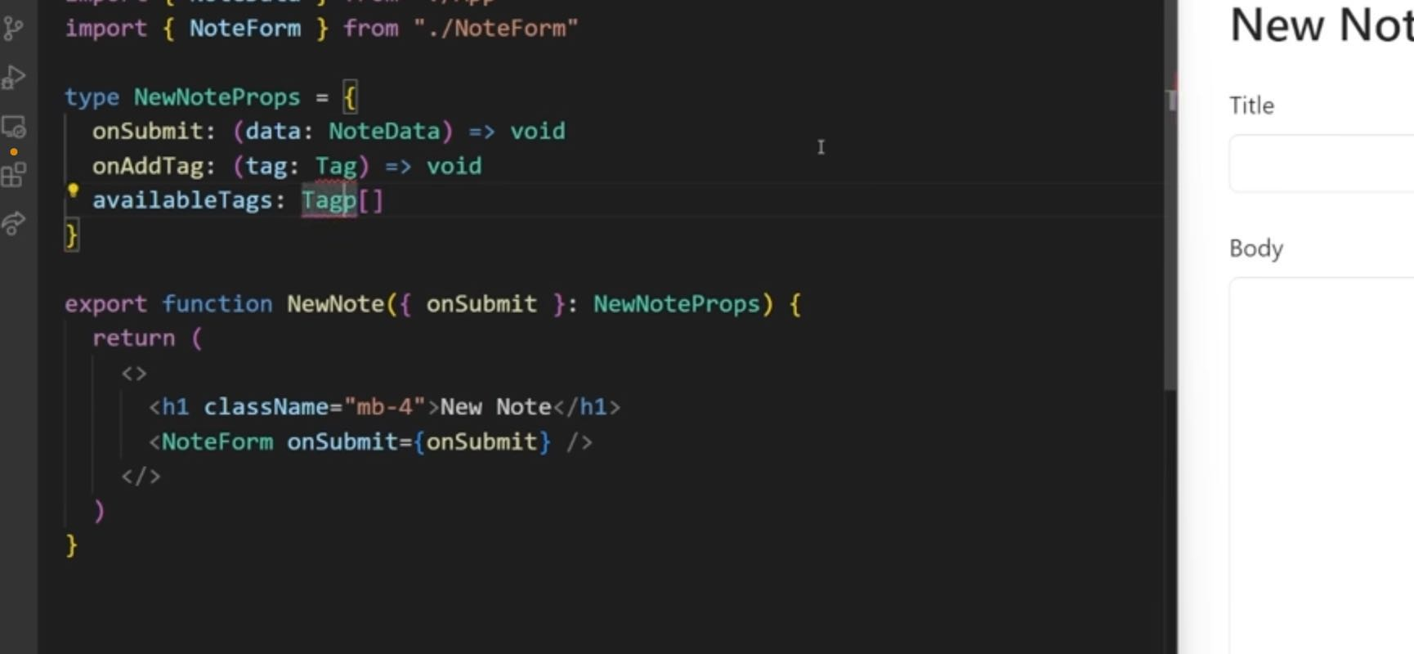

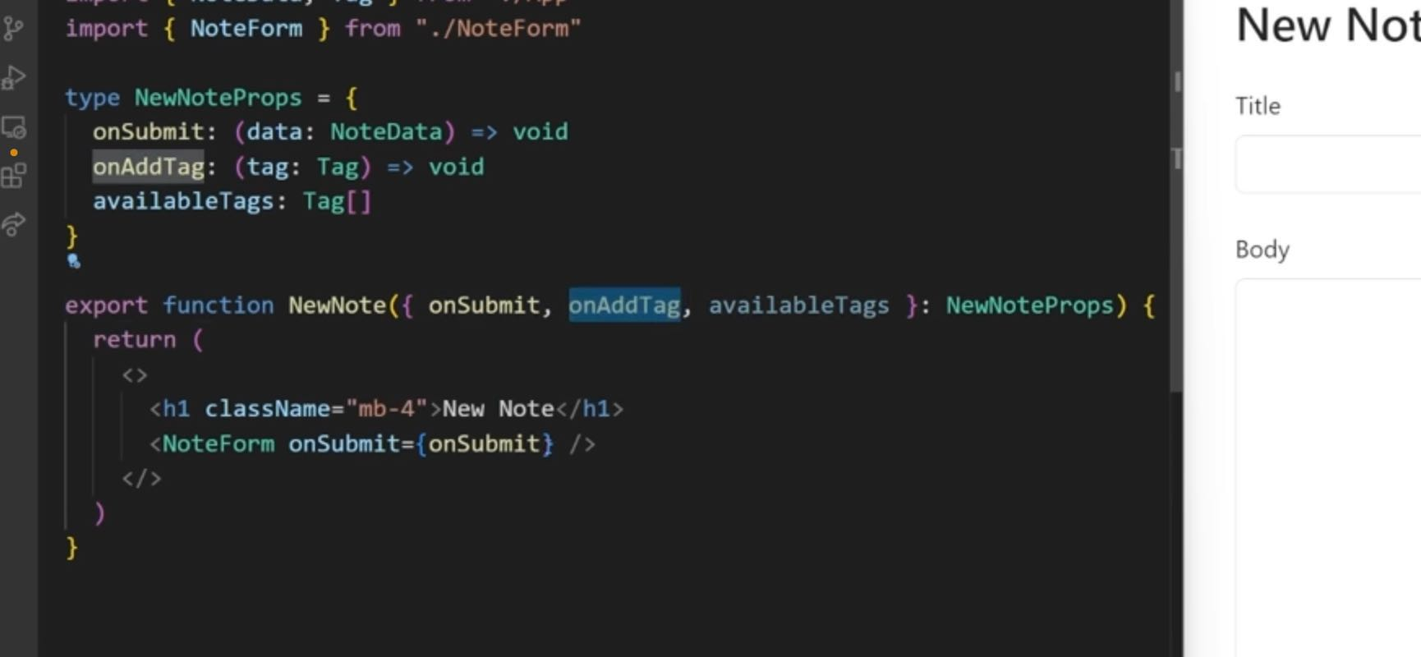

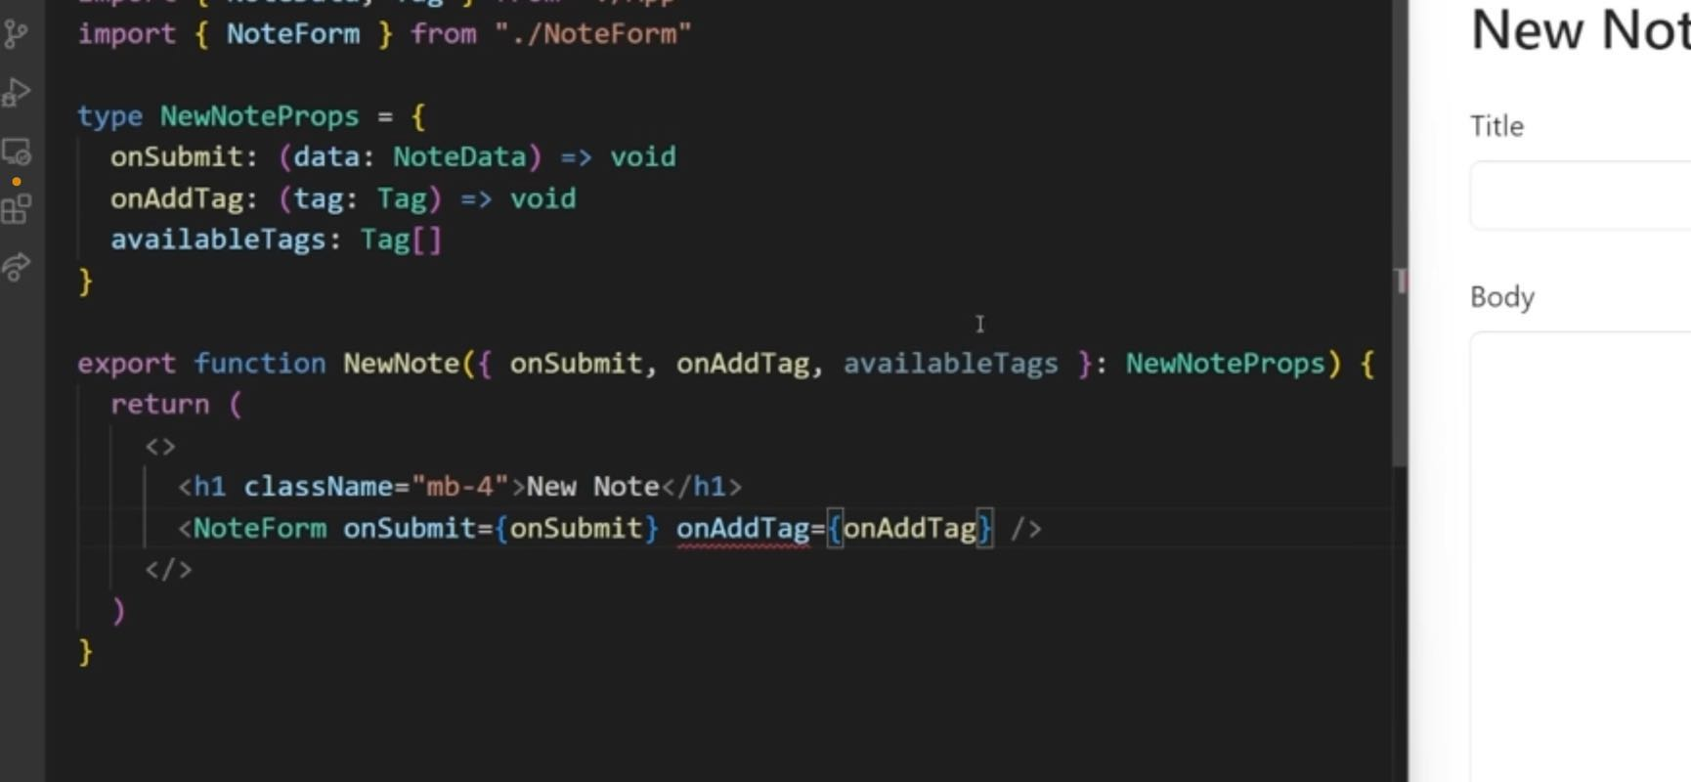

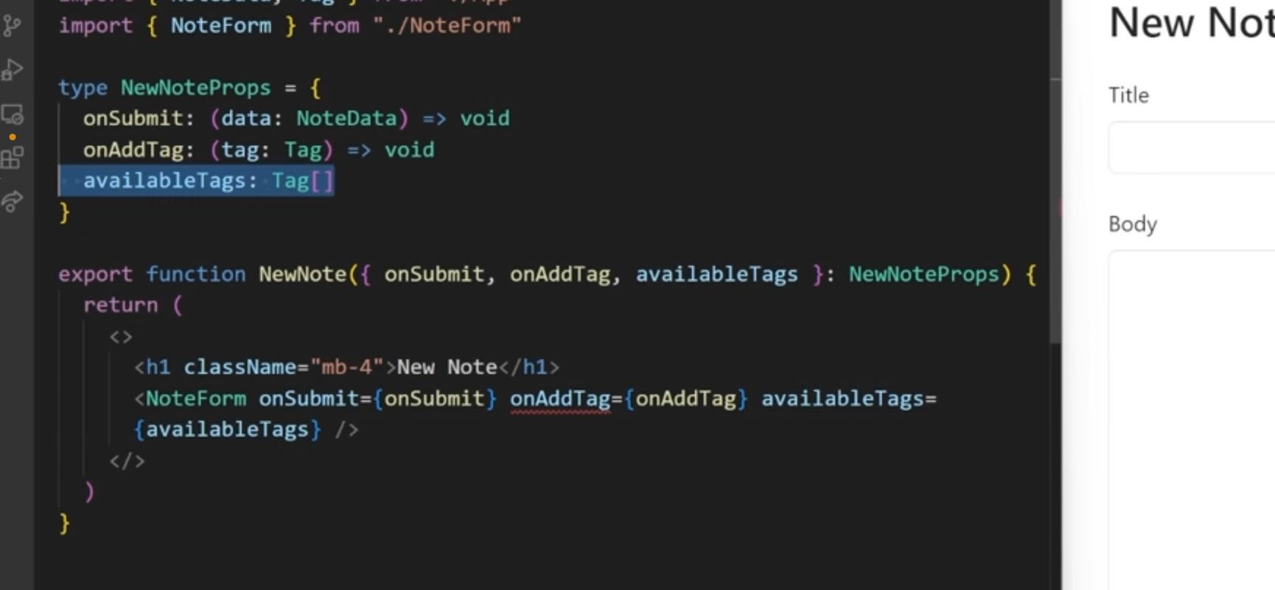

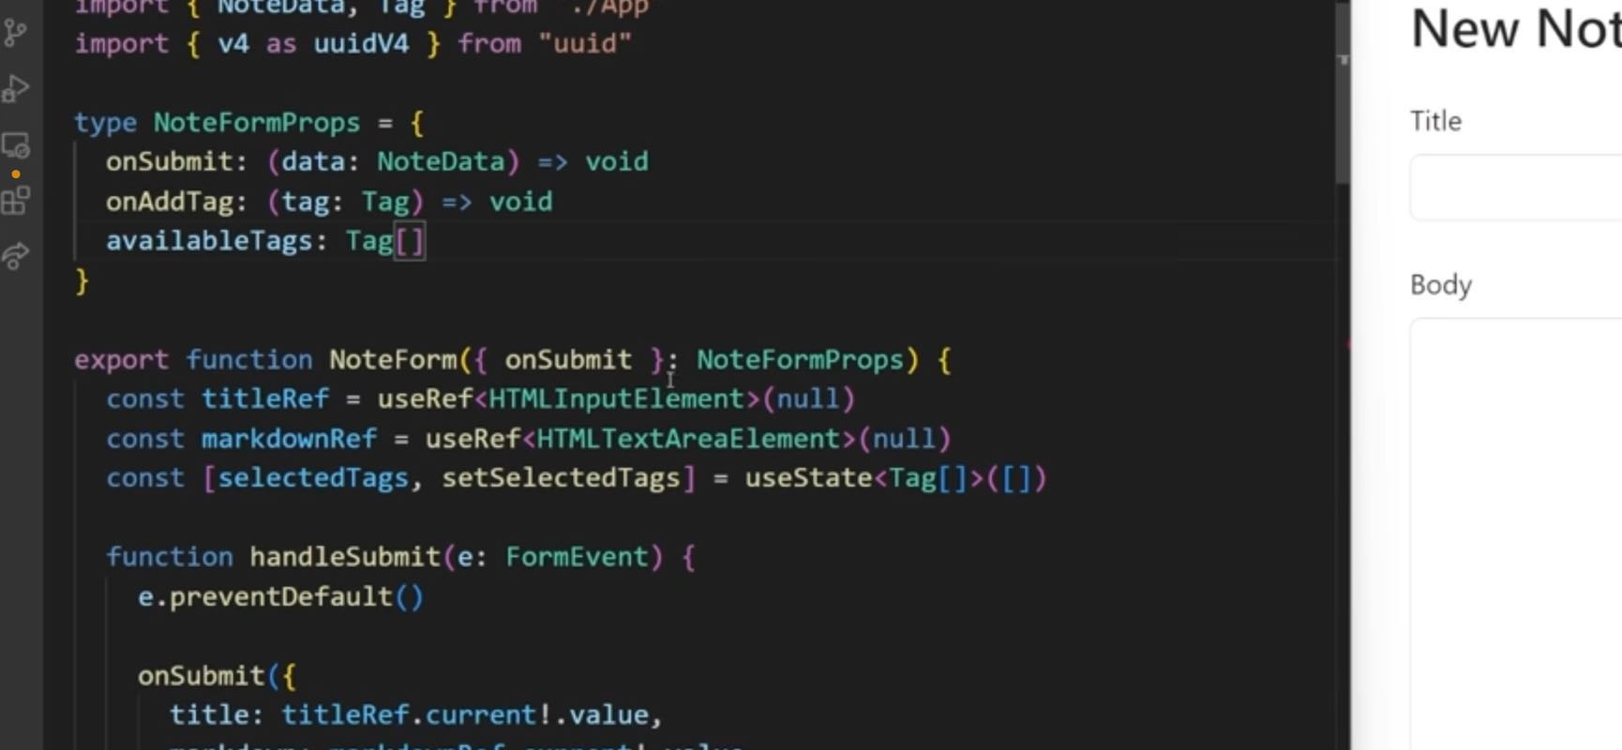

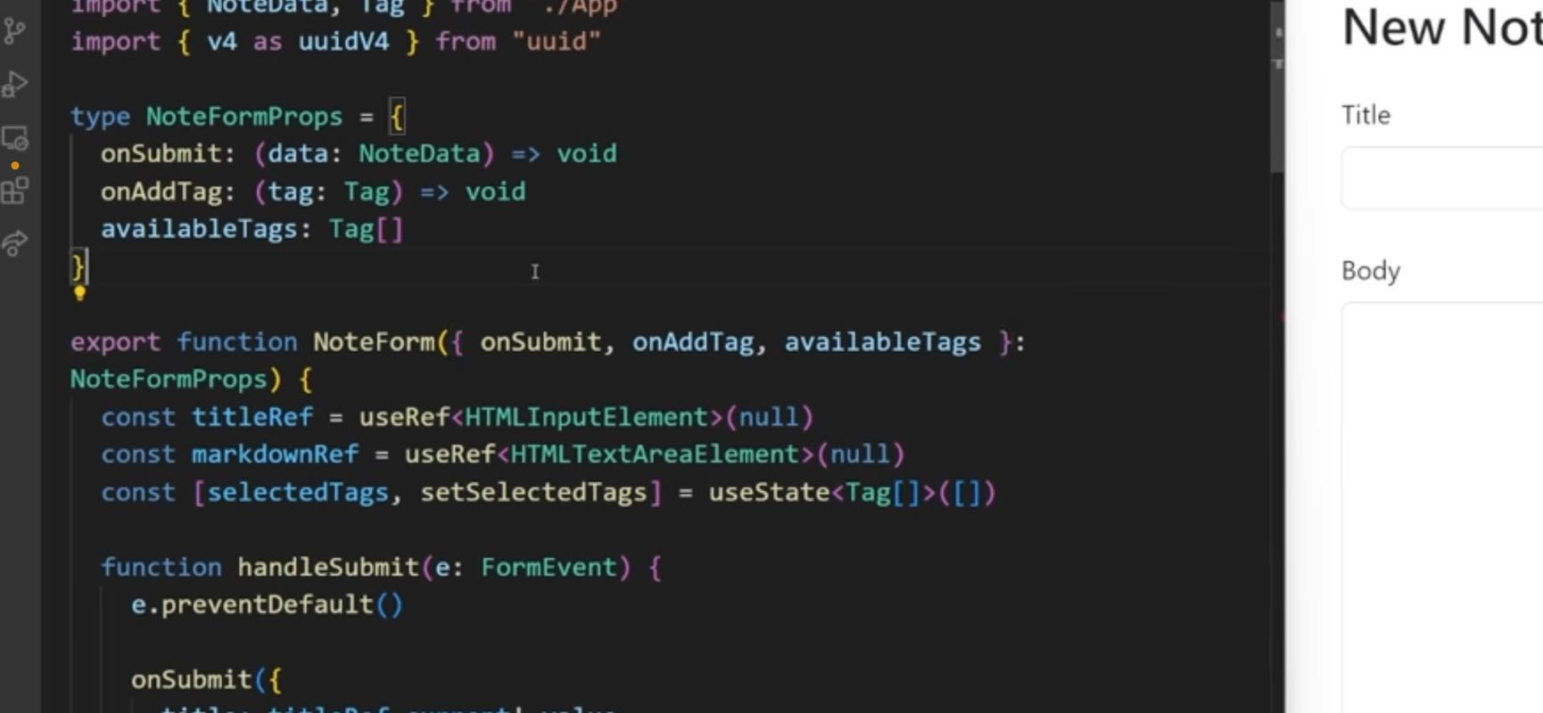

06:28

values we ever change and we need to do options as well. These options are going to be coming from our available tags and again, we just need to map through this to make sure that we actually are returning the correct format. So our label is tagged dot label. And our value is our tag.id Just like that. So now with all of that done, we should actually have everything we need to store information. So if we just inspect our page real quick, we go over to the application tab. You can see inside of local storage that we have this upper case notes, which is the array and we have this upper case tags which is again also an empty array

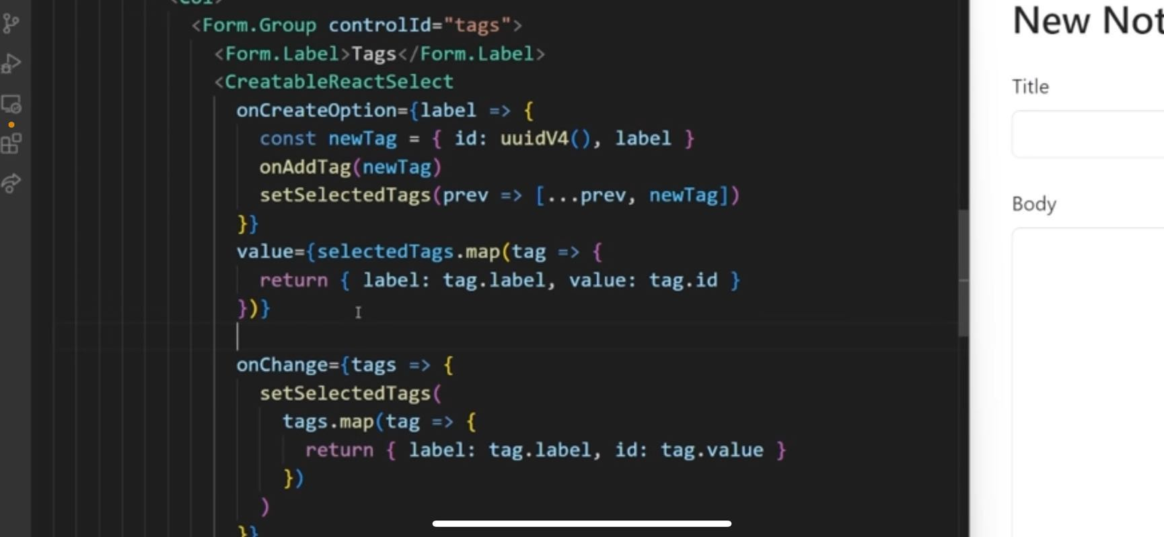

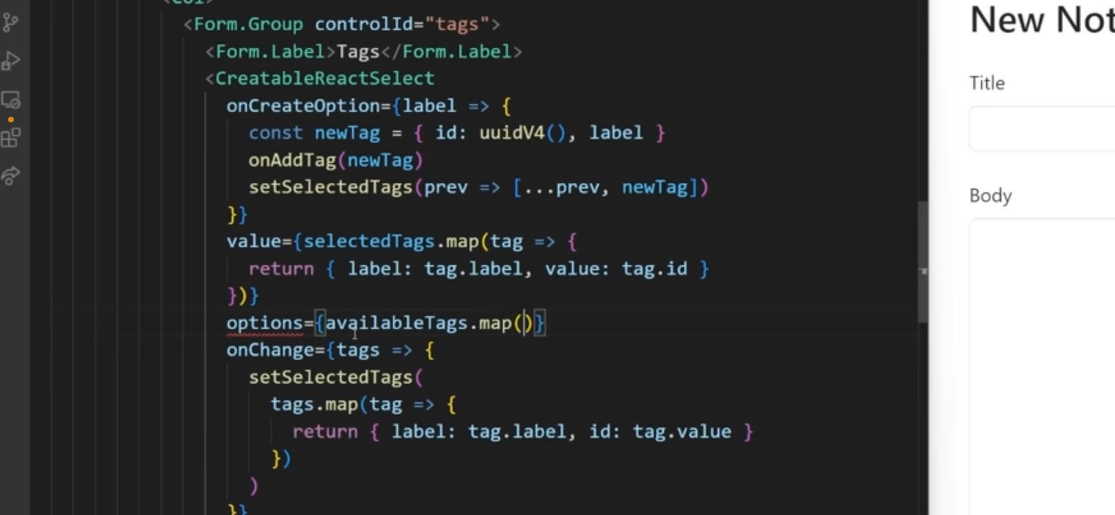

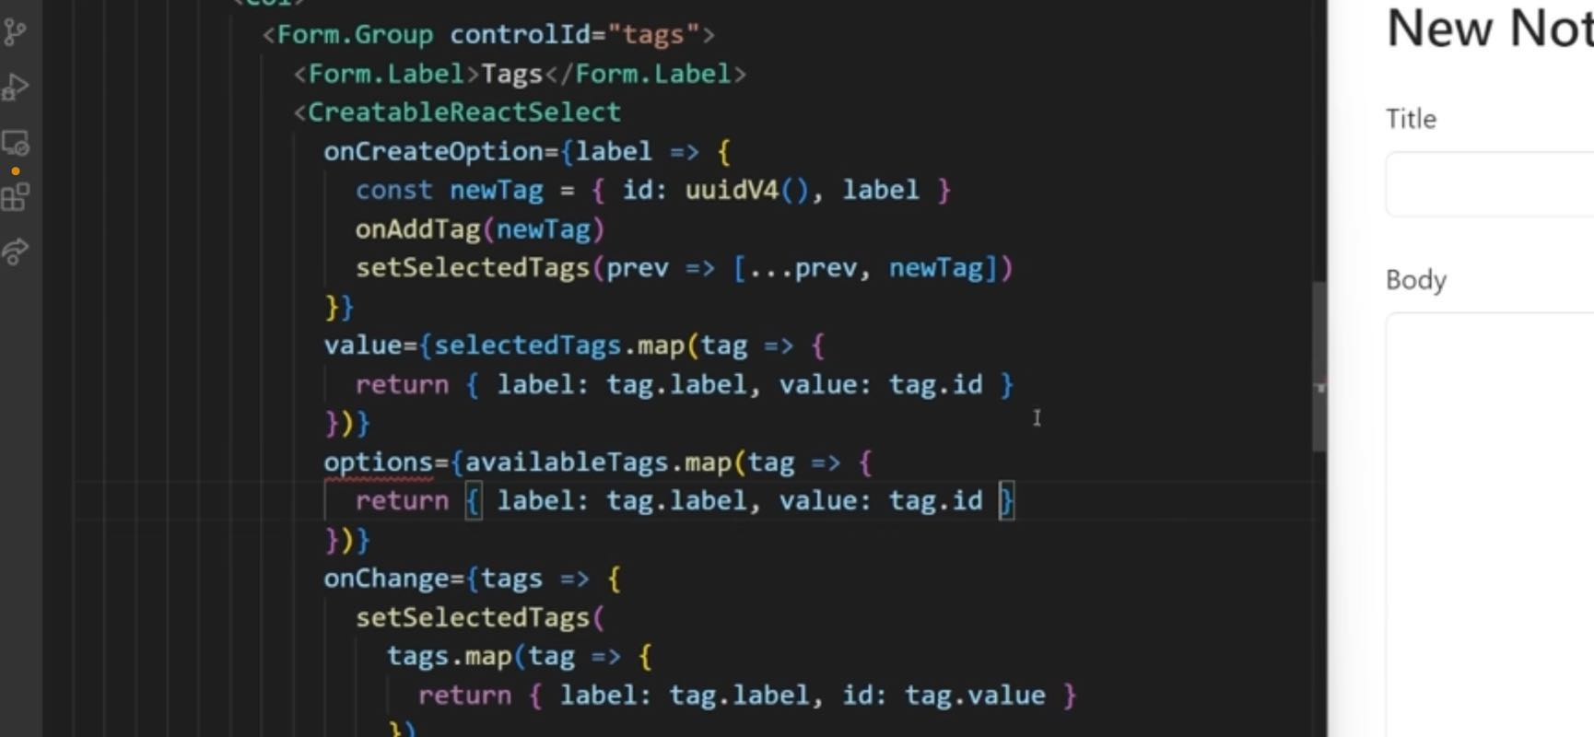

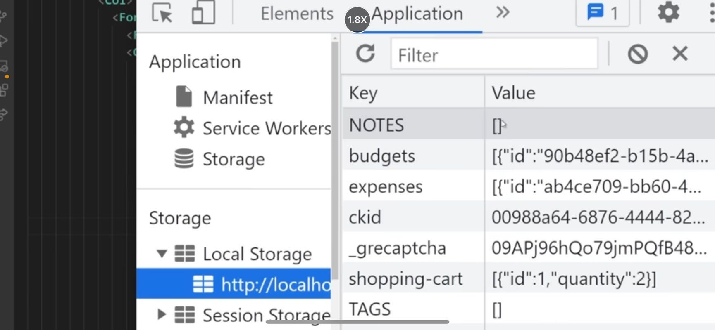

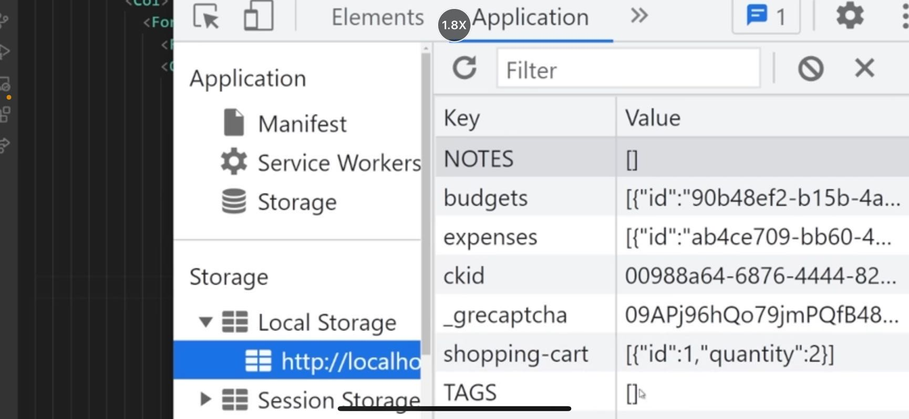

07:15

in the console under the application tab.

07:21

So we have no information all being stored in our notes or in our tags. So let's see what happens if we create a brand new tag if I just say new and hit enter. You can see immediately we have a new tag been added. And this new tag has an ID that's randomly generated as well as the label of new that worked just like I expected. Let's try creating a brand new note we can say title is going to be test and body is test body. If I click save, you can now see in our note we have a title that says test or markdown says test body or tag IDs is an empty array. So that's clearly not working. We need to fix that. And then our ID is properly generating itself. I already know why the tags are not working just because we never passed them along here. We just need to pass our selected tags along and that should fix that problem. So now if we save this, we just inspect our page real quick. And we just check this notes. If we click Save again, you'll see we have another node and this one properly does have our tag ID has been set to the ID for the brand new tag that we created. So that's working exactly what we expect it to be. You'll notice when we click save, it's not redirecting us anywhere. We should probably redirect the user and we can do that really easily using a custom hook which is called

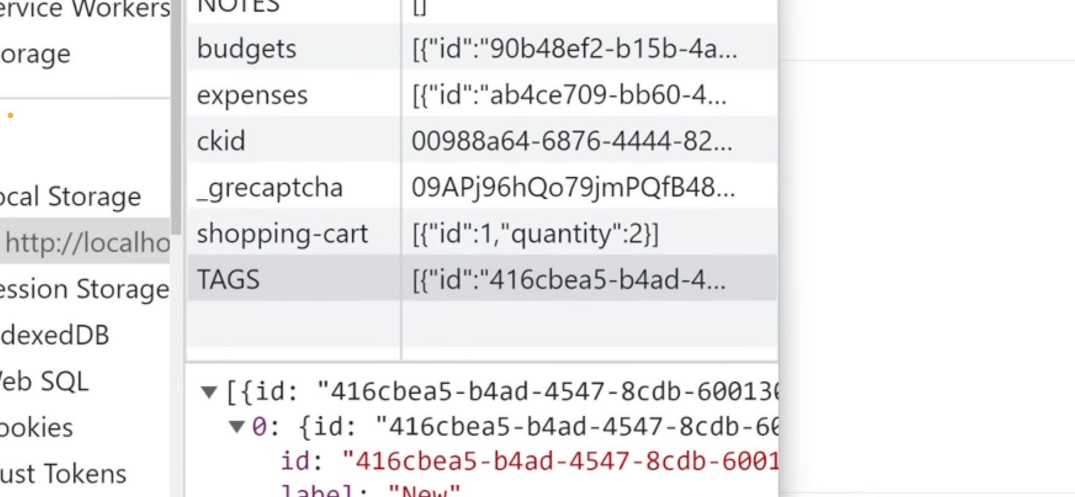

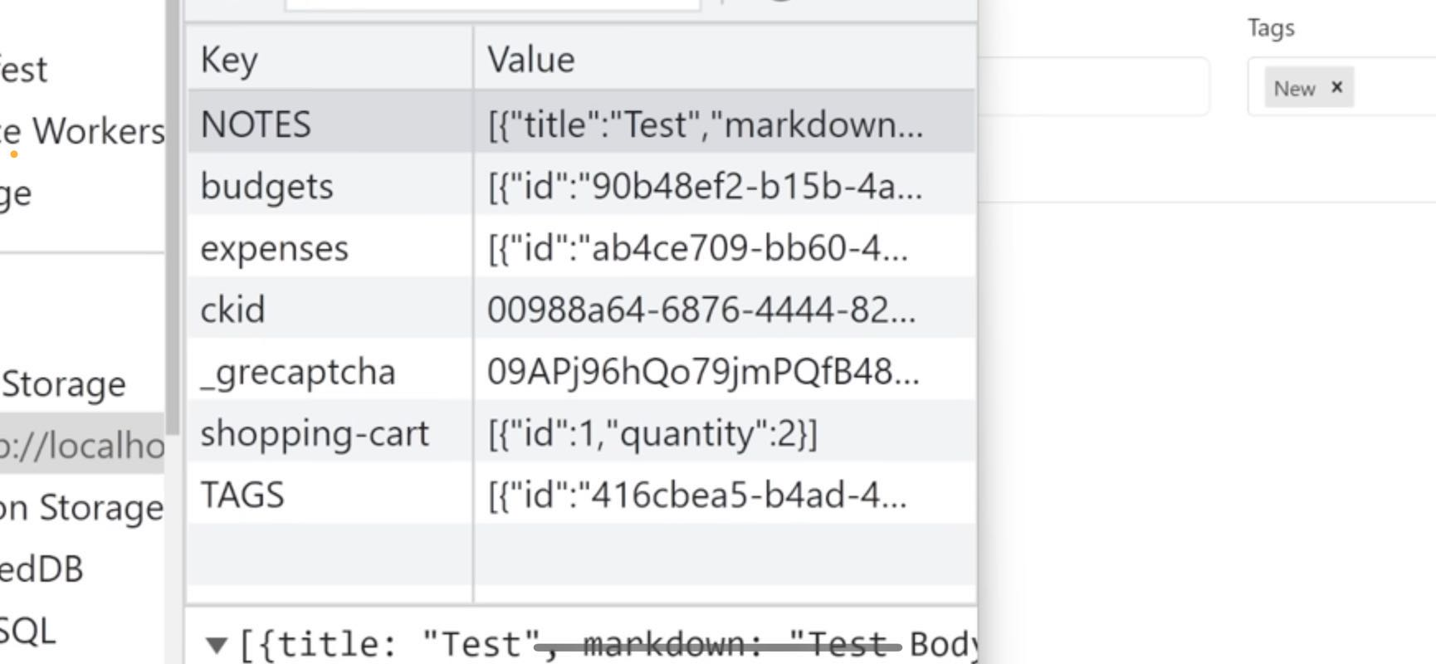

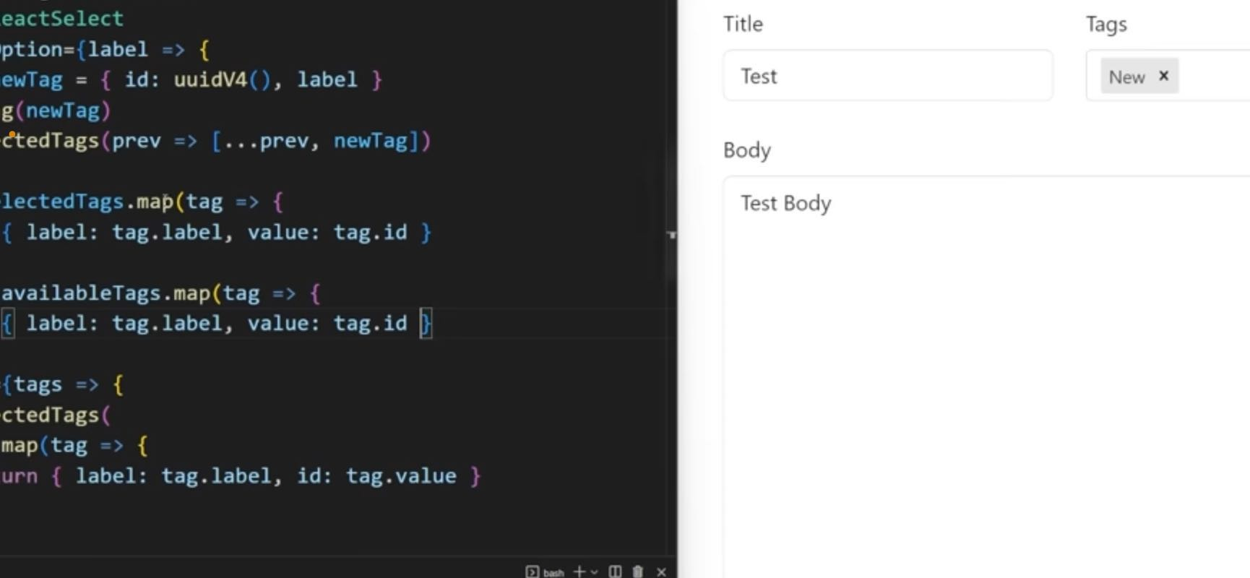

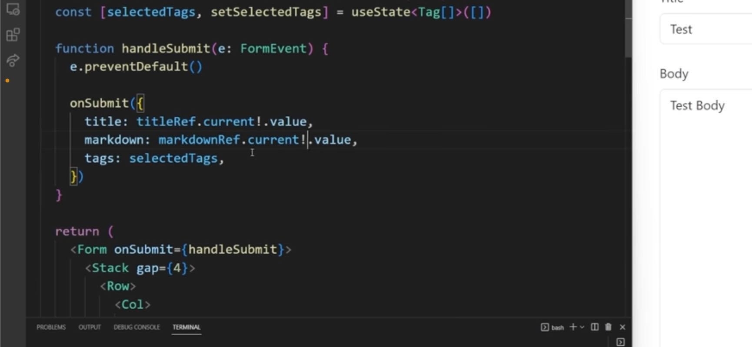

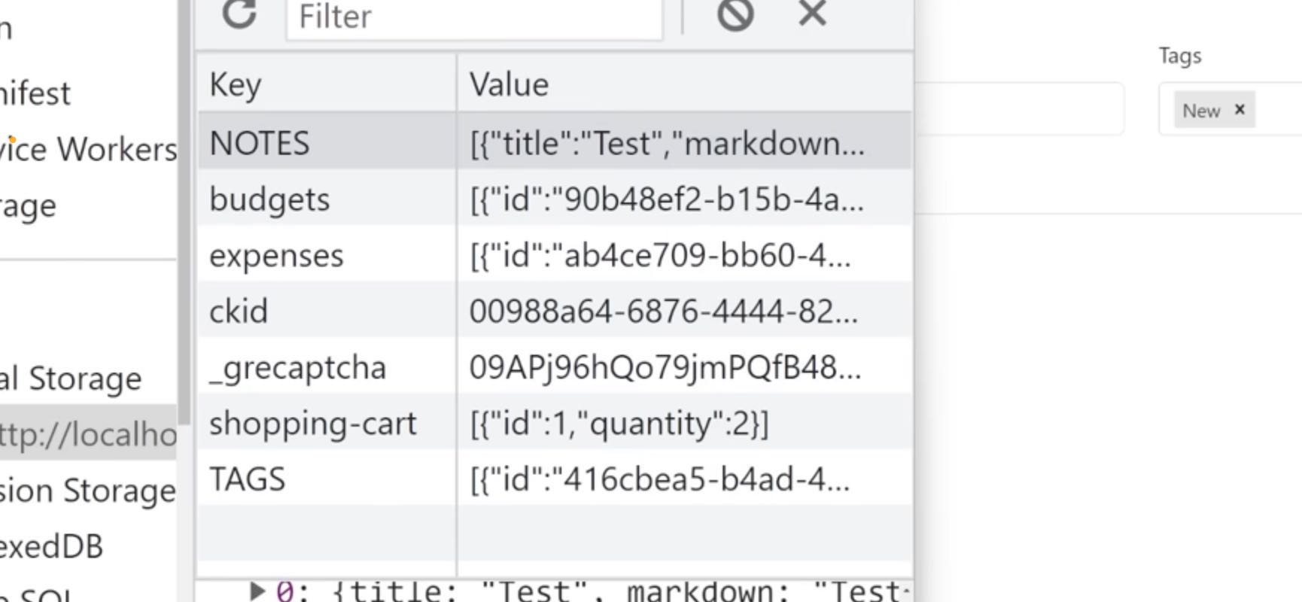

08:31

redirecting the user by using a custom hook

08:34

views navigate. Let's make sure we import that custom hook just like that. And then we can just say navigate and we just want to navigate to the page that we were previously on and that show is going to move us backwards one page whenever we do this. So if we just say new to new body, and I click Save is now navigating me backwards, which in our case is just bringing us to the home page. So now with that done, let's page whenever we do this, so if we just say new to new body, and I click Save is now navigating me backwards, which in our case is just bringing us to the homepage. So now with that done, let's actually go ahead and try to focus on the homepage which is going to be storing out our notes because now that we can create notes we can actually view those notes on our homepage.

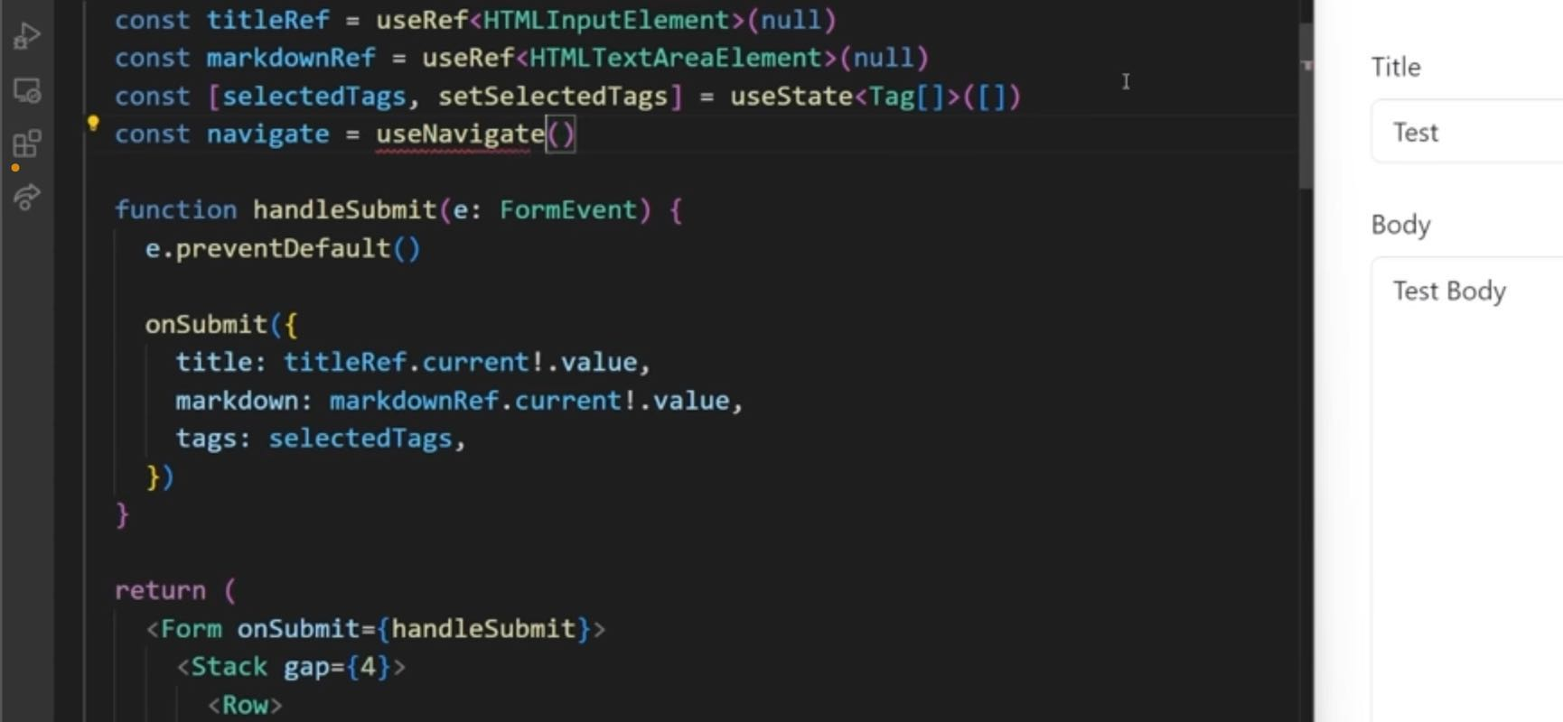

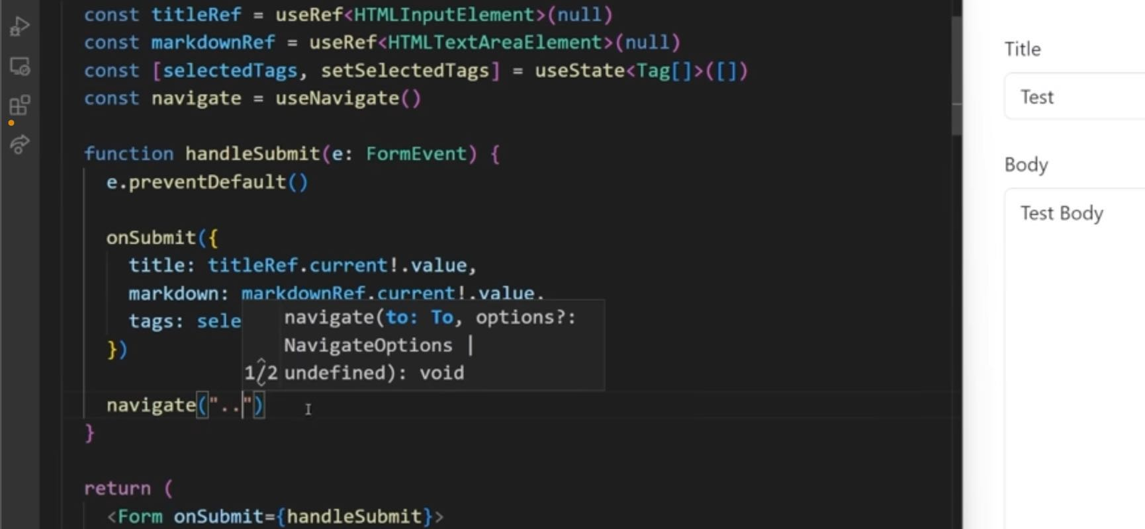

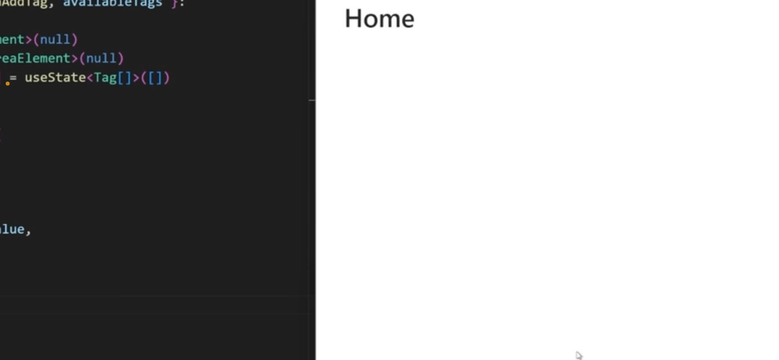

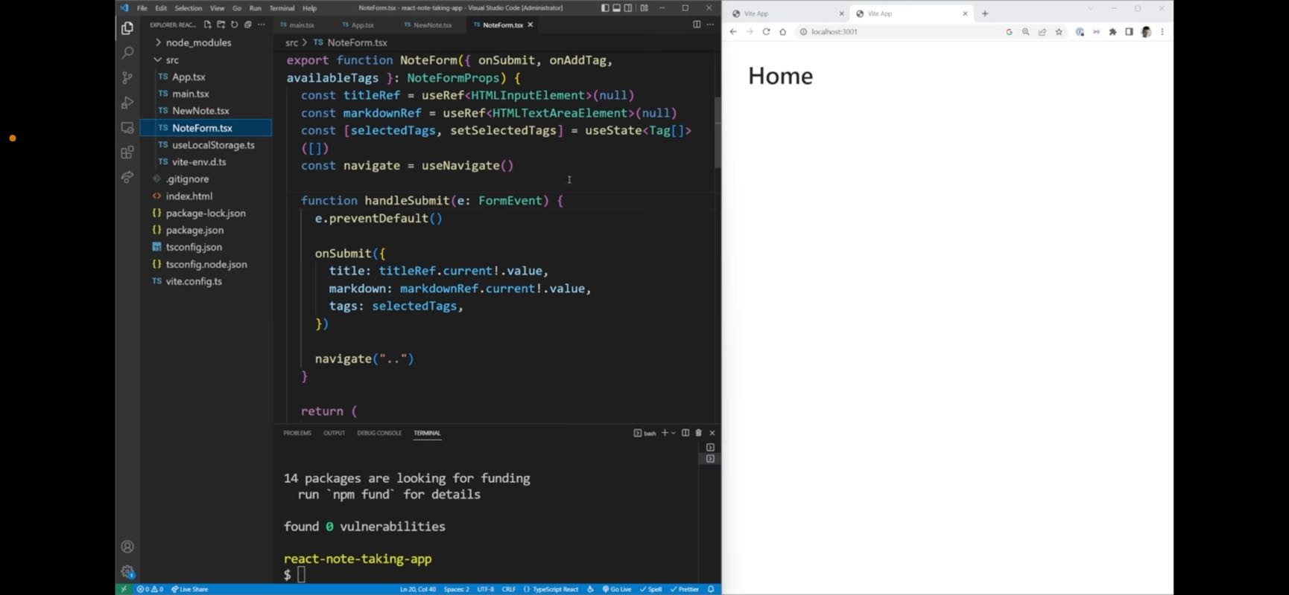

09:22

Next section. Home Page

# Section 3

Thu, Dec 15, 2022 5:16AM • 7:43

**SUMMARY KEYWORDS**

tags, note, create, import, column, function, button, form, modal, uu, errors, row, title, id, stored, type, list, option, array, stack

n whoops

35:03

note list there we go and we can just return H1

35:10

list and now it should render out list to our screen as long as we make sure we import this component right here there

35:17

we go there we go it's pretty not listed okay perfect

For 15 years let's go back to our app TX x here. And what I want to do right here is I want to render out a note list which is close that off that we can go and create a new component for that note List dot TSX export function oops note list there we go. And we can just return h1 list. Now it should render out listed to our screen as long as we make sure we import this component right here. There we go. There we go. It's printing out list. Okay, perfect. So now we can go back to our note list, and we want it to look essentially just like this. So we're going to have a part at the top for our searching as well. As this create and edit button that we're gonna have the cards for our notes down here. What I want to do is I want to create this empty fragment here and the first thing I want to do is create a row and this row is going to be for our title as well as these two buttons and import that row. So inside of here, we're going to have a column and this column is going to be an h1, which is going to say notes. So that's super straightforward right there. Next, we're going to have another column and we're going to set the extra small size to auto. What that's going to do is it's just going to force the size of our column to be as small as possible to fit all of our content, which means that it's going to be pushed all the way to the right hand side. Column being the child of row because this other notes column is going to take up the rest of the space. Now inside of here, I want to do a stack which is something we're pretty familiar with want to add a gap of two inside here, and our direction is going to be horizontally just like that. Let's make sure that we import this stack component, just like that. Now inside the stack, I want to have a link that's going to go to that create page. So a link which is going to go to slash new. And inside here I want this to actually be a button so we're gonna say button, variant is primary. And it's gonna say create just like that. Now let's make sure we import those components. So we have our link and we have our buttons. Now if I get that a click Save, and then come over here you can see it says notes as well as this Create button as edit tags is going to be a little bit more complicated because there's going to be opening in a modal but for now we can at least create the button for it. And the button has a variant which is going to be outline secondary. And it's gonna say added tags, just like that, because as we know, when we click this, it's going to open this modal so we're going to handle that in a little bit. But for now, we just have the button and it'll do nothing for now. Setting up the modal. The nice thing is when I click Create you can see it brings me to the Create Page. When I click Cancel, brings me back to the home page, which is exactly what we want. Now the next thing I want to render out is going to be the form and this form is going to be for all the information that you can see here for our title and for our tags. So let's just make sure we import that form. And inside of here it's going to be a single row, I'm gonna give it a class name of margin bottom four, just to space it out from this section down here we have our different notes. Now inside of our row, we're going to have a column and this column is going to be for our very first form dot group, which has a control ID of title. There we go. Now inside of this, I want to have a label which is just going to say title. And then I want to have a form dot control. And this form control is going to be a type of text. There we go. So now if we look over here, you can see we have our title showing up. Now I also want to have a section for our tags. I'm going to copy this almost exactly word for word from here because it's going to be very similar actually. So I'm going to copy that. Come over to here actually, I'm just gonna copy the entire form group because it's going to storage. Now what we can do is we can scroll down quite a ways here. To where we have our new note. And this is going to have an onSubmit that we're going to pass to it at this note array right here, which is stored inside of our LGC that got rid of all of our errors for us. So we know that this should work. Now we have a function and this is going to have an onSubmit that we're going to pass to you note props we can do is because it got rid of all of our errors first. So we and this is going to have an onSubmit that we're going to add to this note array right here, which is stored inside of our local storage. Now we can do is we can scroll down quite a ways here to where we have our new note and this is going to have an onSubmit that we're going to pass to it and it's onSubmit is going to be an on Create note. So now what we can do inside of this new note is we can make sure we accept in on submit this onSubmit is going to have the type of new note props. New note props week allows us to that's going to install that which in our case is going to be a UU ID V four which is a library, we're going to install NPM I NPM I UU Id just like that. That's going to install this UU ID library. And then up here we can import V four as UU ID in this new tag onto the end of our selected tags. Now you're probably wondering why do I have this on Add tag right here. It is a new tag function and a little equal to UU ID because it does not call on change when we create a new tag instead it calls this function right here. So I want to get a new this means that we need to automatically set option function or prints when we actually create a brand new tag. So we're coming to here are credible racks lug has an on Crete option function or port we can actually have all of our types like we should. So once that's done now that should remove that air force which is exactly what we want. And now we can continue on with our project. The final thing we need to do before we can actually create a brand new note is to handle what happens when we actually create a brand new tag. So if we come into here are credible racks lead has an on create rich over errors for us. So we know that this should work. I don't want to map them. The tag IDs but it's still there and something we can tap as being stored. The last thing we need to do is make sure we only run this every time our notes or tags give information about them just includes oops, tags so and for each one of these, we're just going to take just like this and with our youth memo correctly and we save we're now no longer going to get any of those errors. We have a value in our set value which down here we can return. If I just make sure I spell initial value correctly and we save like you would expect from an option inside of an array or inside of a select sorry. And the next thing we need to do is we need to set up our onchange to be able to modify our values. So on change is going to get passed in an array of tags. But these tags are going to be in the form push our buttons all the way to the far right push our buttons all the way to the specific element. Instead what I'm going to do is I'm going to put routes inside of here and each one of these, for example are going to be going back that off for now. And let's bow as these ads are getting shorter and shorter. Just grab this week's tried on easy squeeze tags, it's gonna have a ctrl want to see a video up select and then when we create tags just like you saw over here if I type something

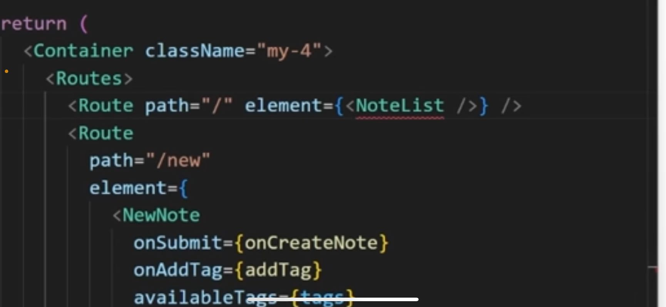

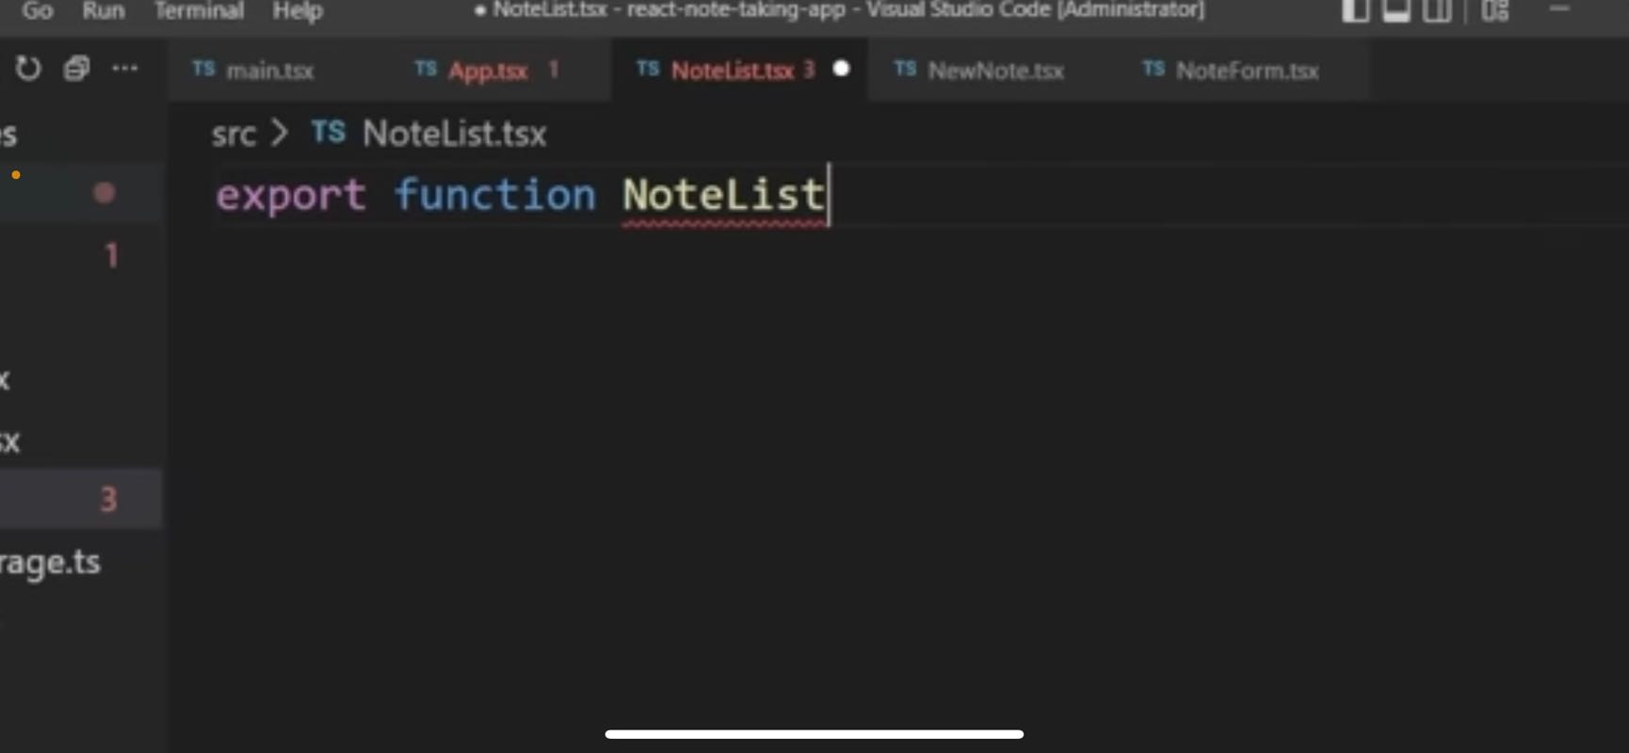

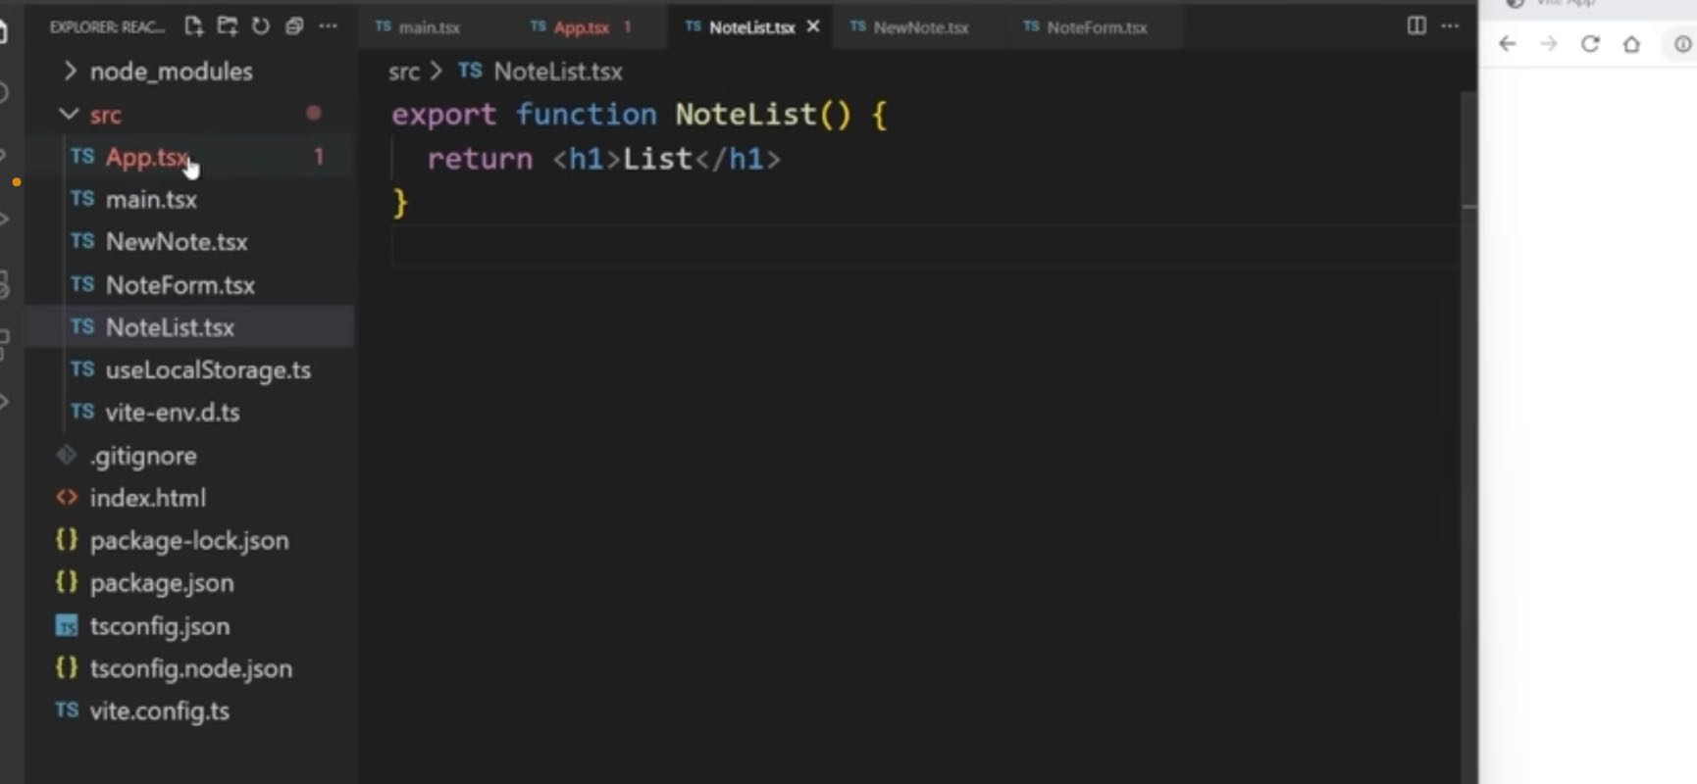

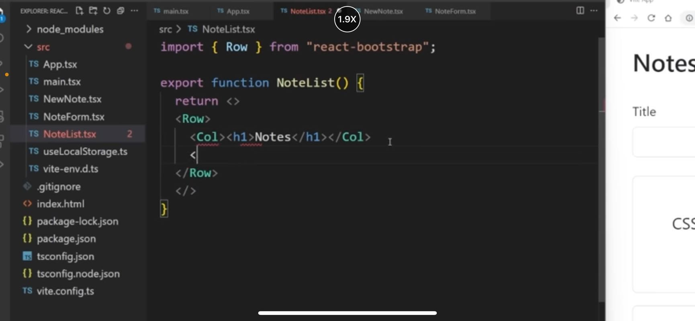

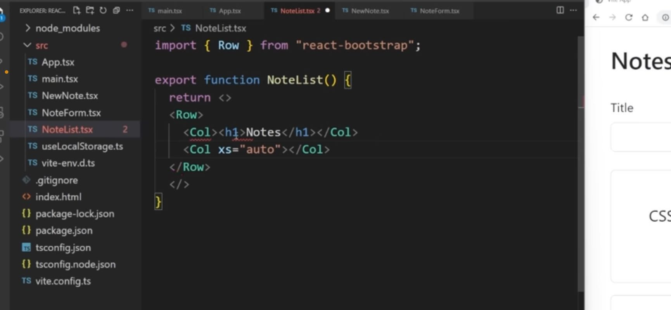

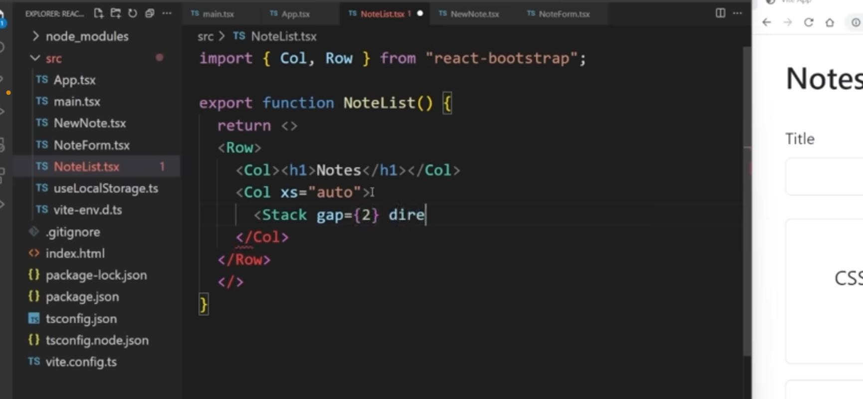

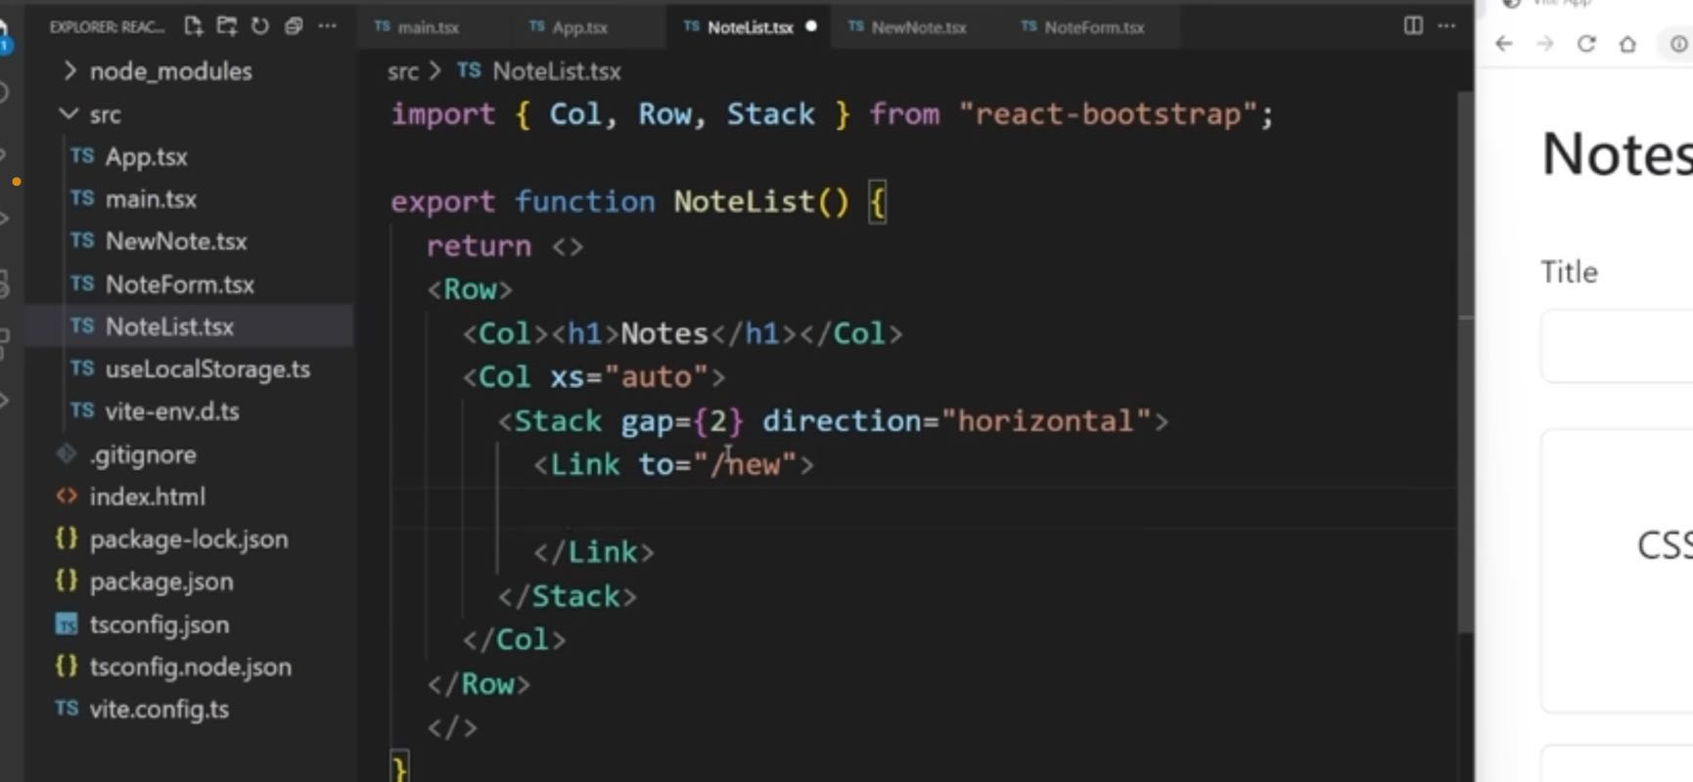

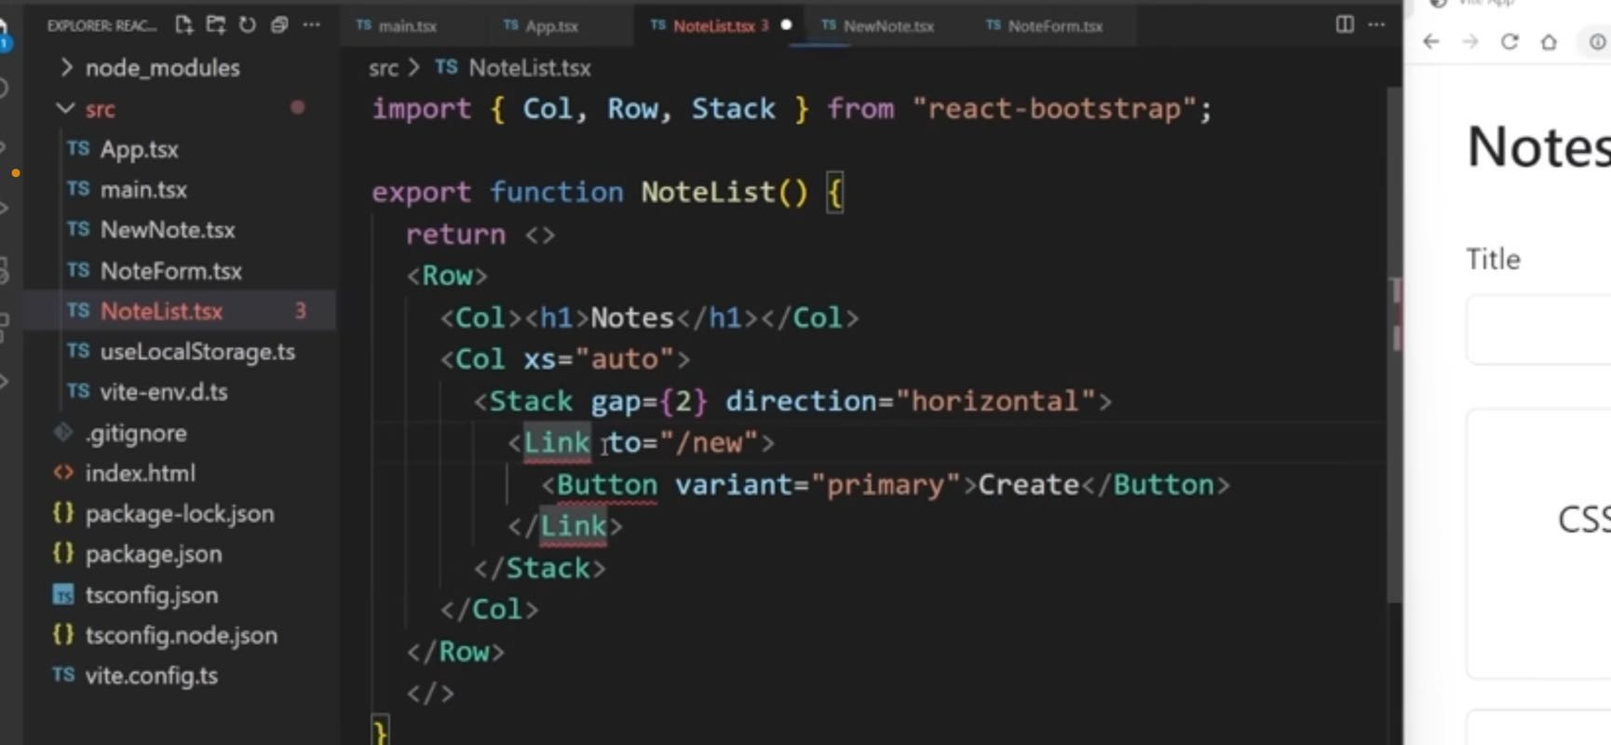

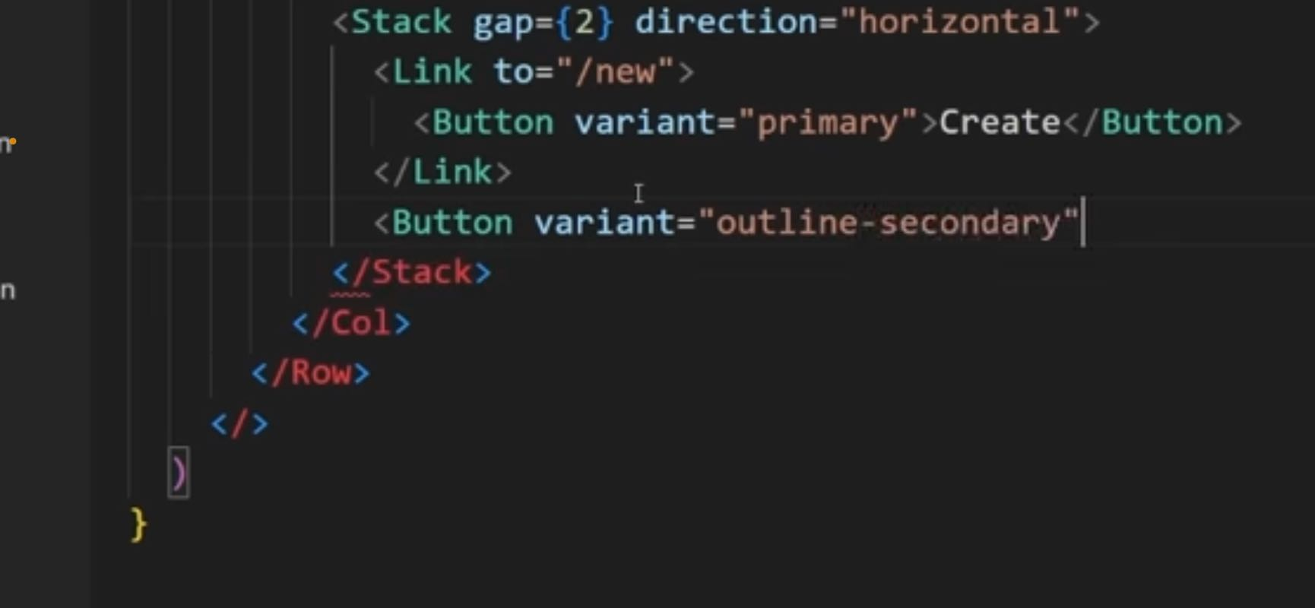

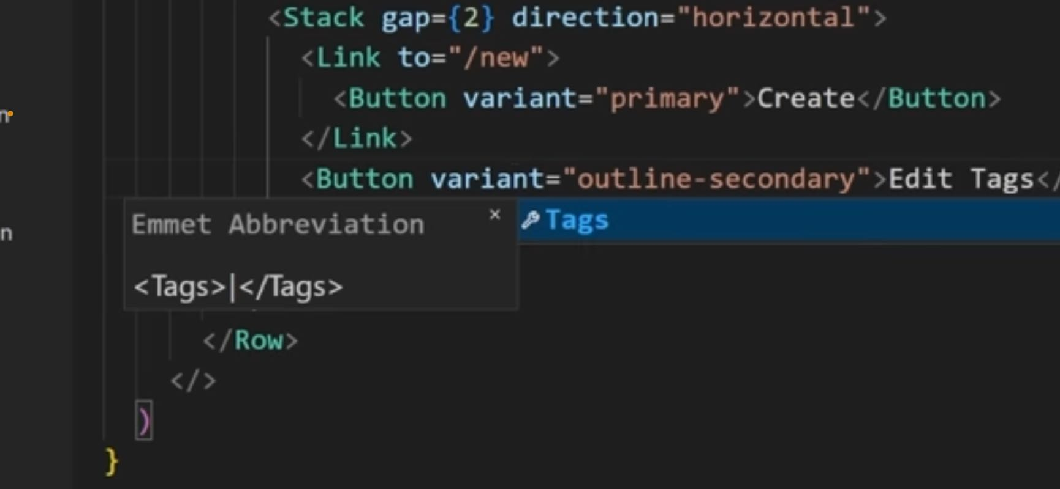

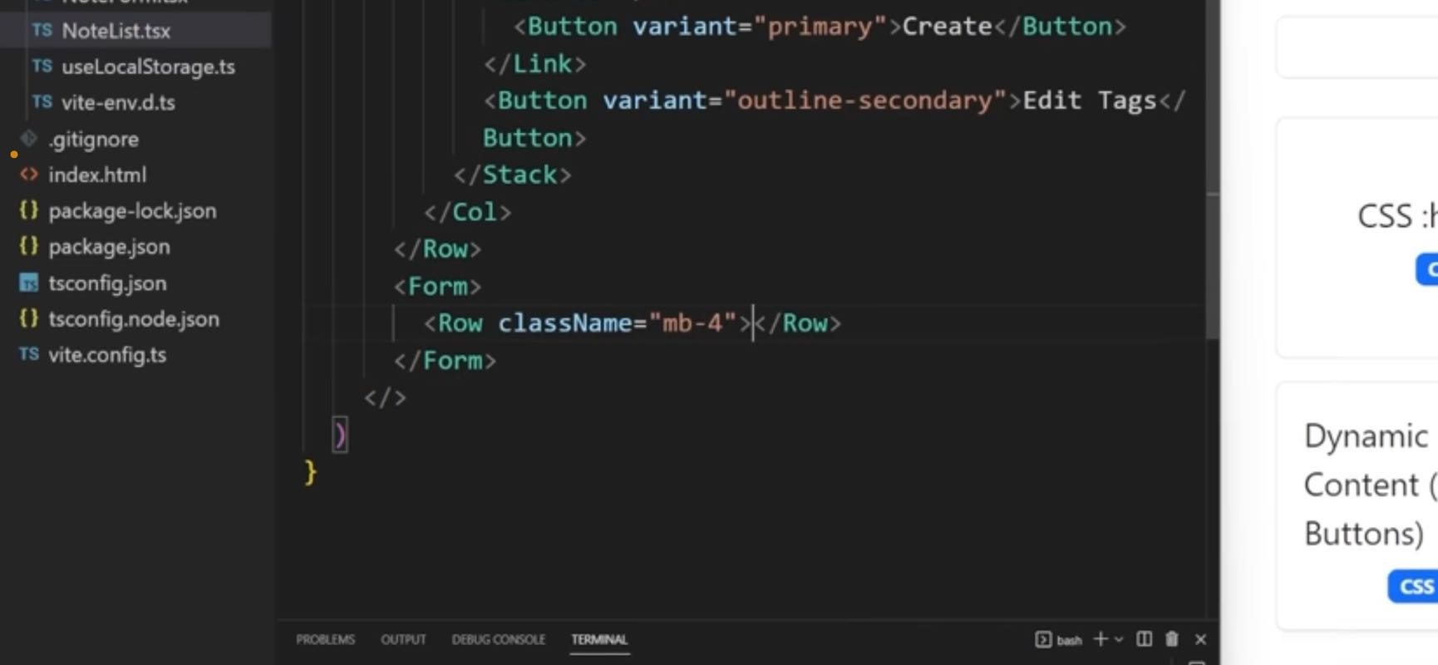

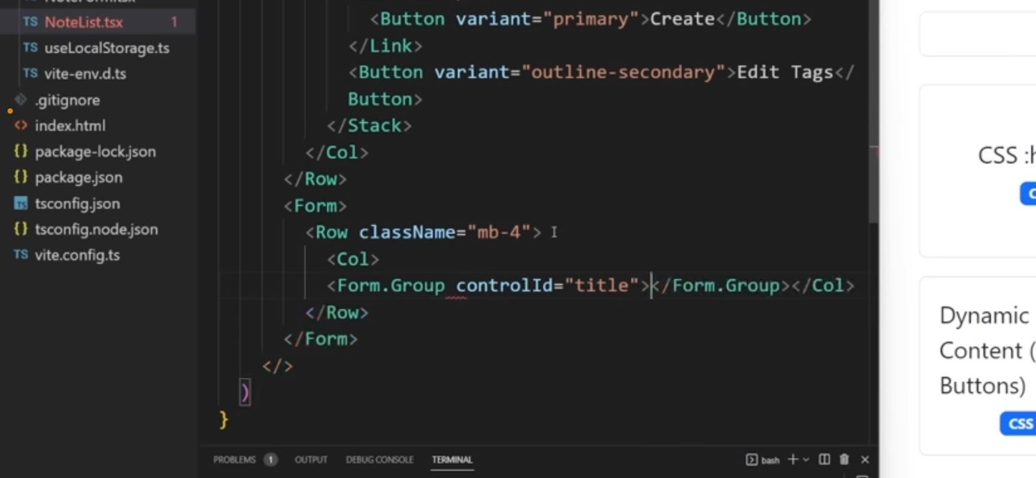

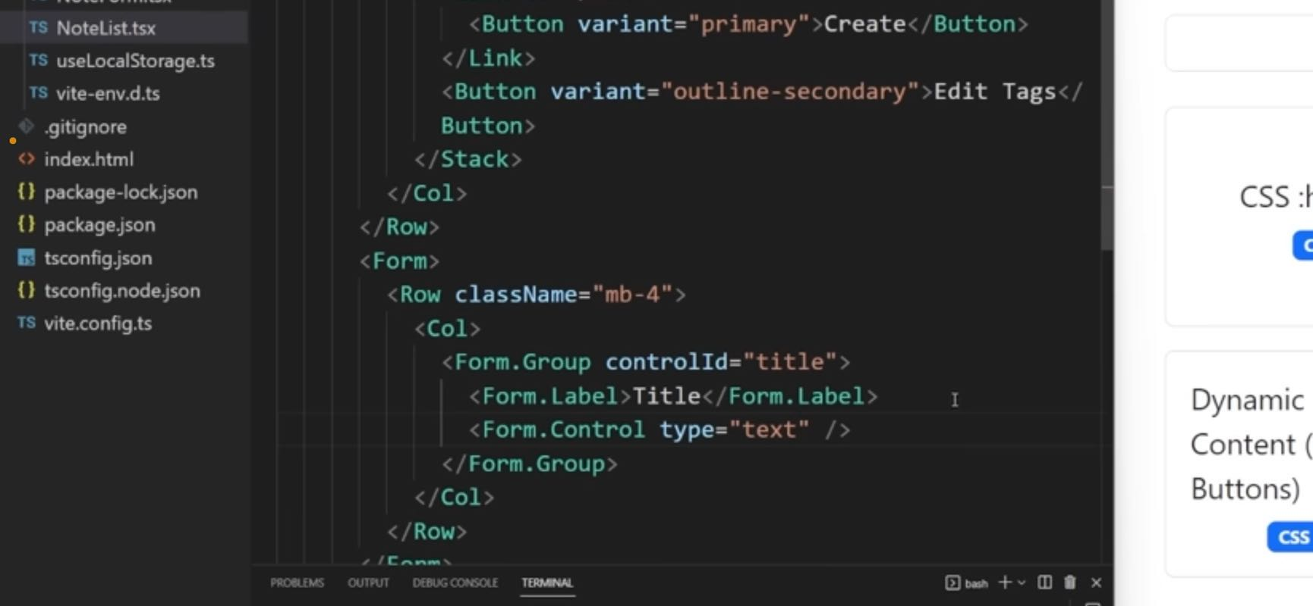

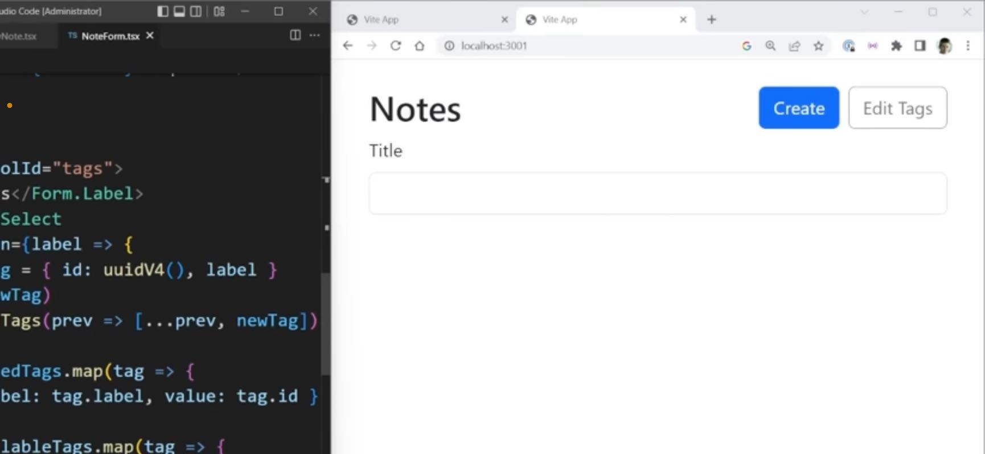

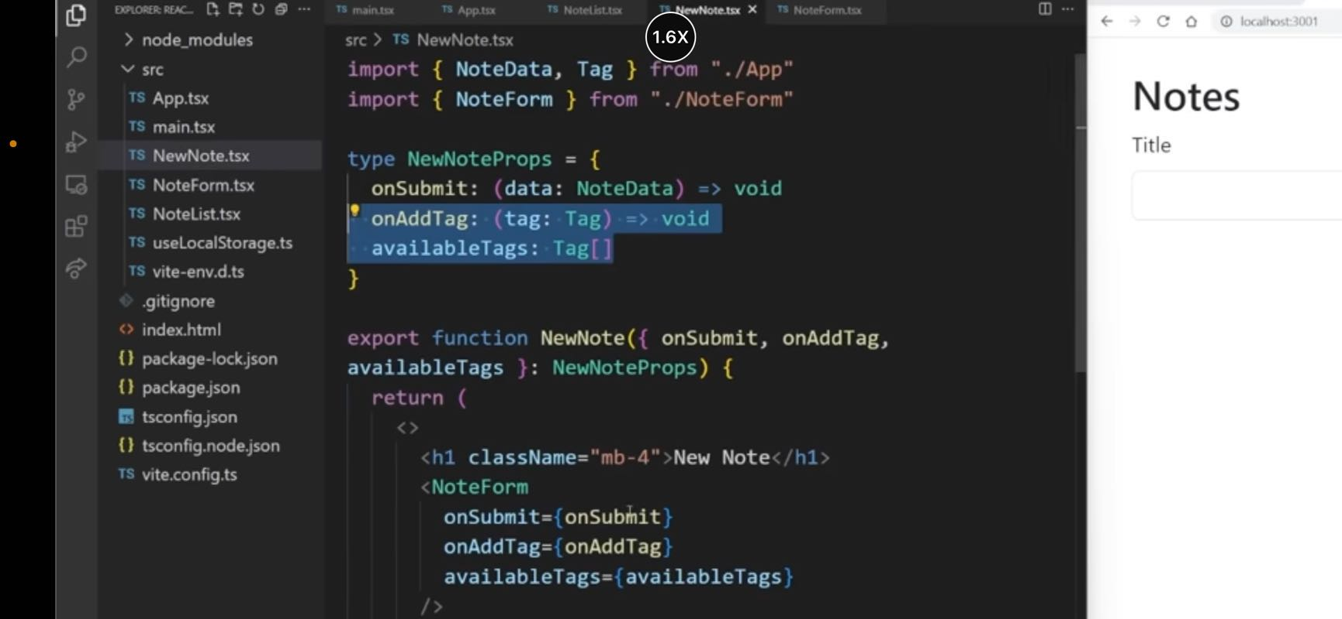

# Section 4

note, tags, title, import, card, selected, css modules, styles, dot, create, filter, column, pixels, css, node, empty string, dot css, translate, row, element

## 37:00

to be outline secondary and it's going to say edit tags just

like that because as we know when we click this it's going to open this modal so we're going to handle that in a little bit but for now we just have the

button and it'll do nothing for now, the nice thing is when I click Create, you can see it brings me to the Create Page. When I click Cancel, brings me back to the home page, which is exactly what we want. Now the next thing I want to render out is going to be the form. And this form is going to be for all the information that you can see here for our title and for our tags. Let's just make sure we import that form. And inside of here, it's going to be a single row. I'm going to give it a class name of margin bottom four, just to space it out from this section down.

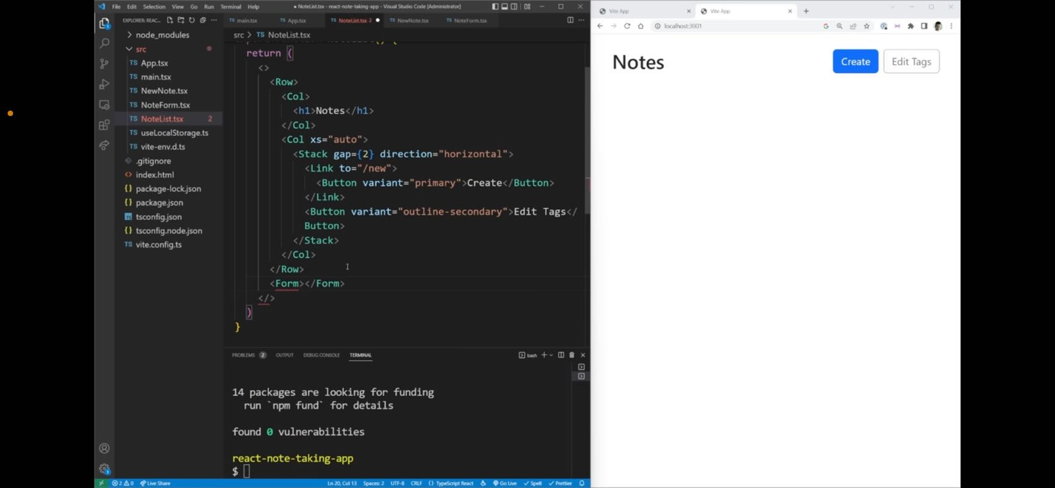

Going to send you because I had adjusted for this section down here we have our different notes. Now inside of our row,

## 37:45

we're going to have a column and this column is going to be for our very first form dot group, which has a ctrl ID of title. There we go. Now inside of this form group, I want to have a label which is just going to say title, and then I want to have a form dot control and this form control is going to be a type of text. There we go. So now if we look over here, you can see we have our title showing up. Now I also want to have a section for our tags. I'm going to copy this almost exactly word for word from here because it's going to be very sub text. There we go. So now if we look over here, you can see we have our title showing up. Now I also want to have a section for our tags. I'm going to copy this almost exactly word for word from here because it's going to be very similar actually. So I'm going to copy that and come over to here actually, I'm going to copy the

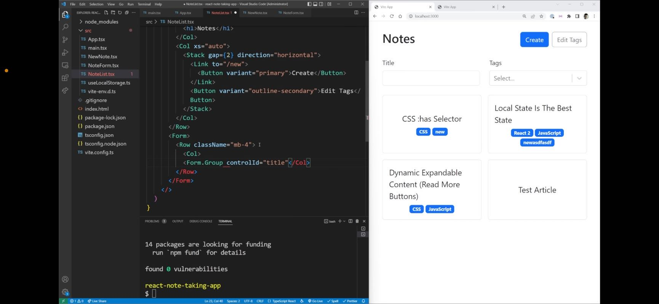

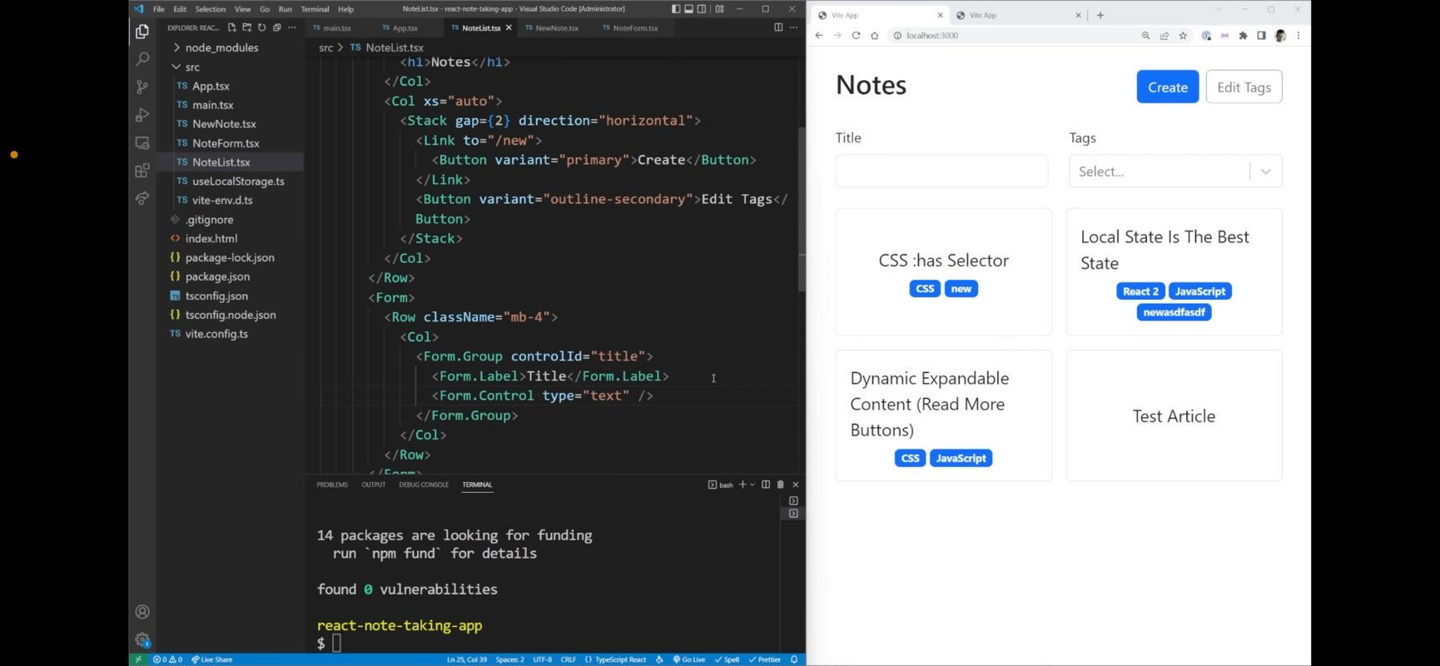

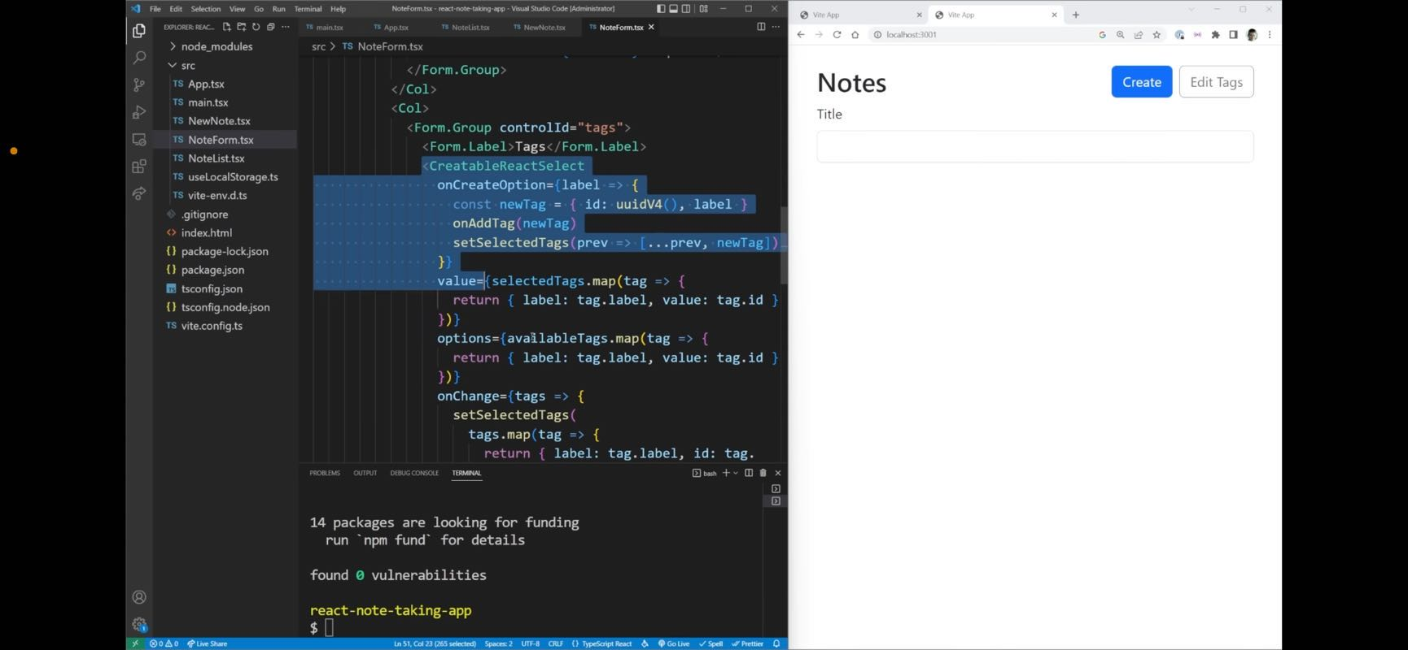

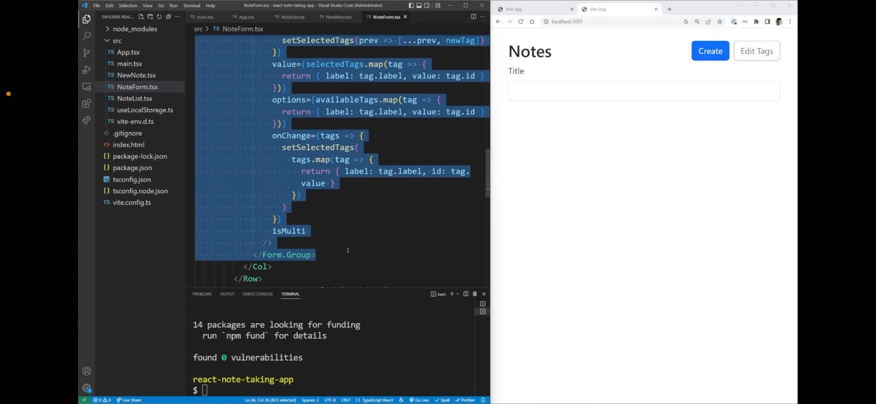

**Jon** 01:44

pictures of the copy section.

01:51

Perform a group because it's going to be almost identical. Go back to our note list. I'm going to paste that down. And that's going to be in its own column. Just like that. So paste that down, give it a save. And what I want to do is set to use an incredible rack select I'm just going to use a normal react select. So import, react, select from react, select just like that. And that means that we don't have to worry about this on Create option so that we can completely remove otherwise, remove on Grid option. So all these different options are going to be things that we need. We just need a way to store our selected tags. And we need to be able to pass in all of the different available tags that we're going to be using for our options. So up here, we're going to come in and we're going to take in our available tags and we're also just gonna copy this straight from here again, because why not it's exactly the same. We're going to be getting our selected tags, and that's going to be coming from a use state. So we need to make sure that we import use state, we need to make sure that we import our tag type. That'll make sure we import that and then we need to make sure we set a note list prop. There we go. Type note list prompts, and is going to be our available tags, which is just an array of tags. There we go. Now with all of that done, all these arrows that we had down here should be gone. And if we come over to our app, we just need to make sure we pass in our available tags, which is just our tags like that. There we go. Perfect. So now you can see we have just our one tag because we currently only have one tag but I can filter by that one tag. And the nice thing is I cannot create new tags that's only allowed when we're creating new elements. And you can see I can filter and search all these different values. Now since I've hooked up this, you know on change and a value for our select. We should do the same thing for our title here. So value is title. On change, we're going to get that E element. I'm just going to say that we're going to set the title to set title to be dot target dot value. And that's going to be its own state title. Set title, and that's going to be simply a string. So we'll just leave that off like this. So now we just scroll back down

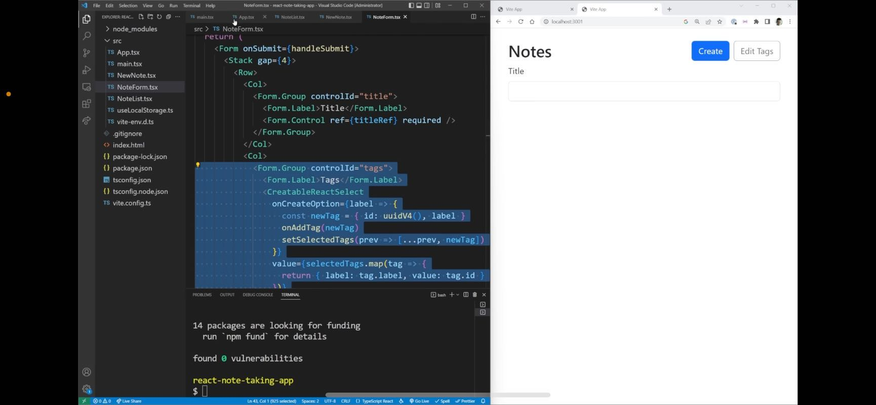

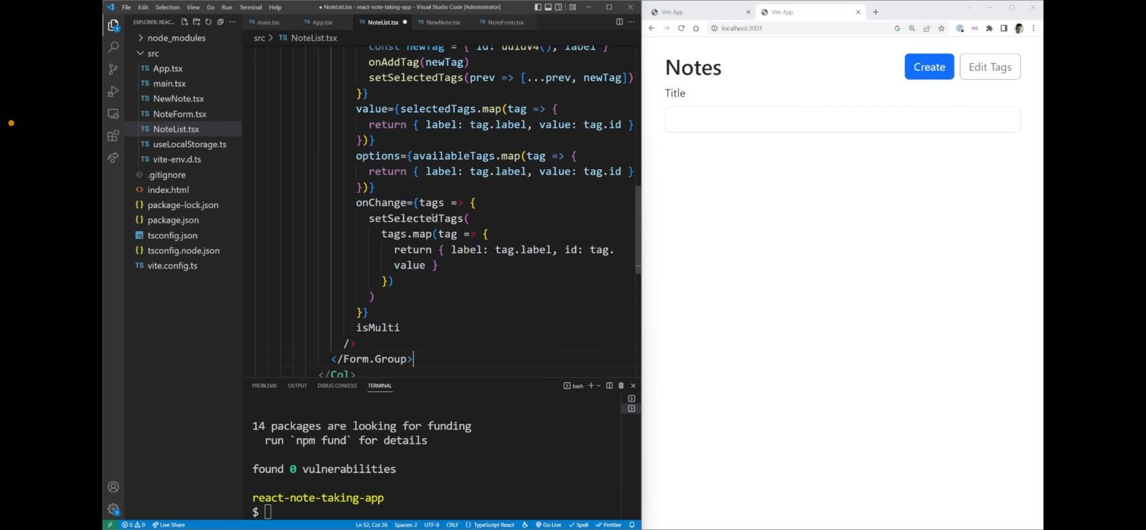

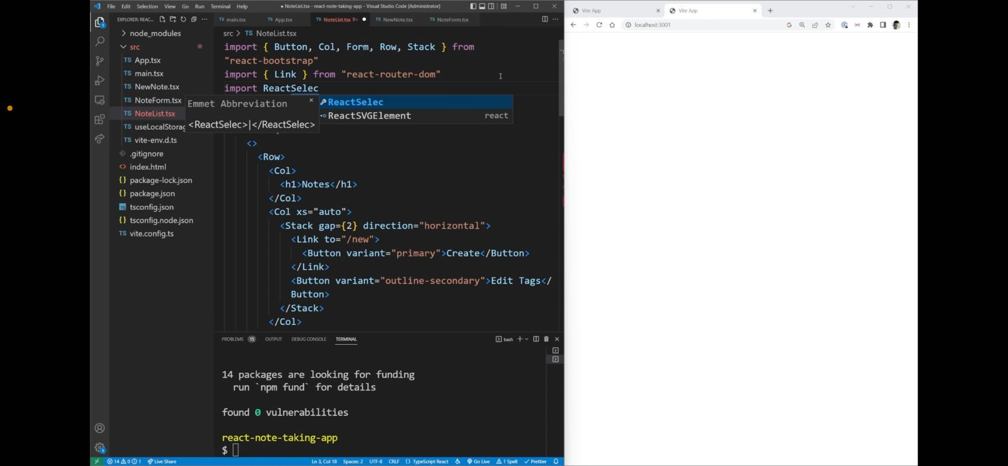

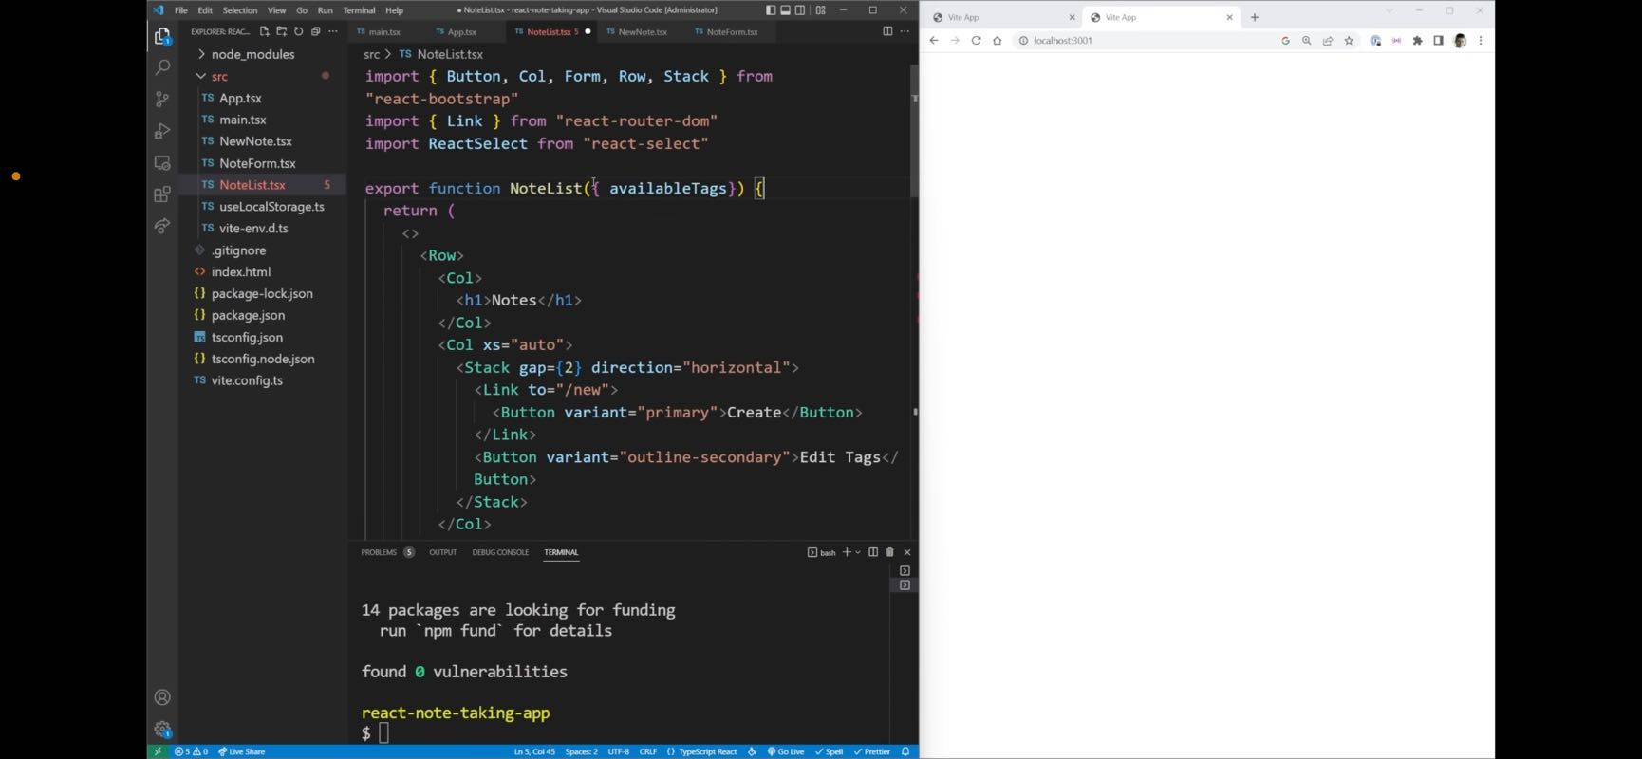

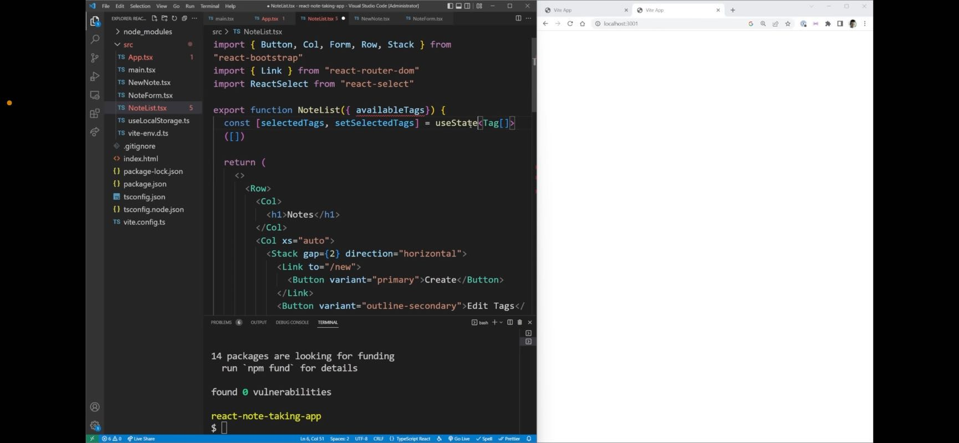

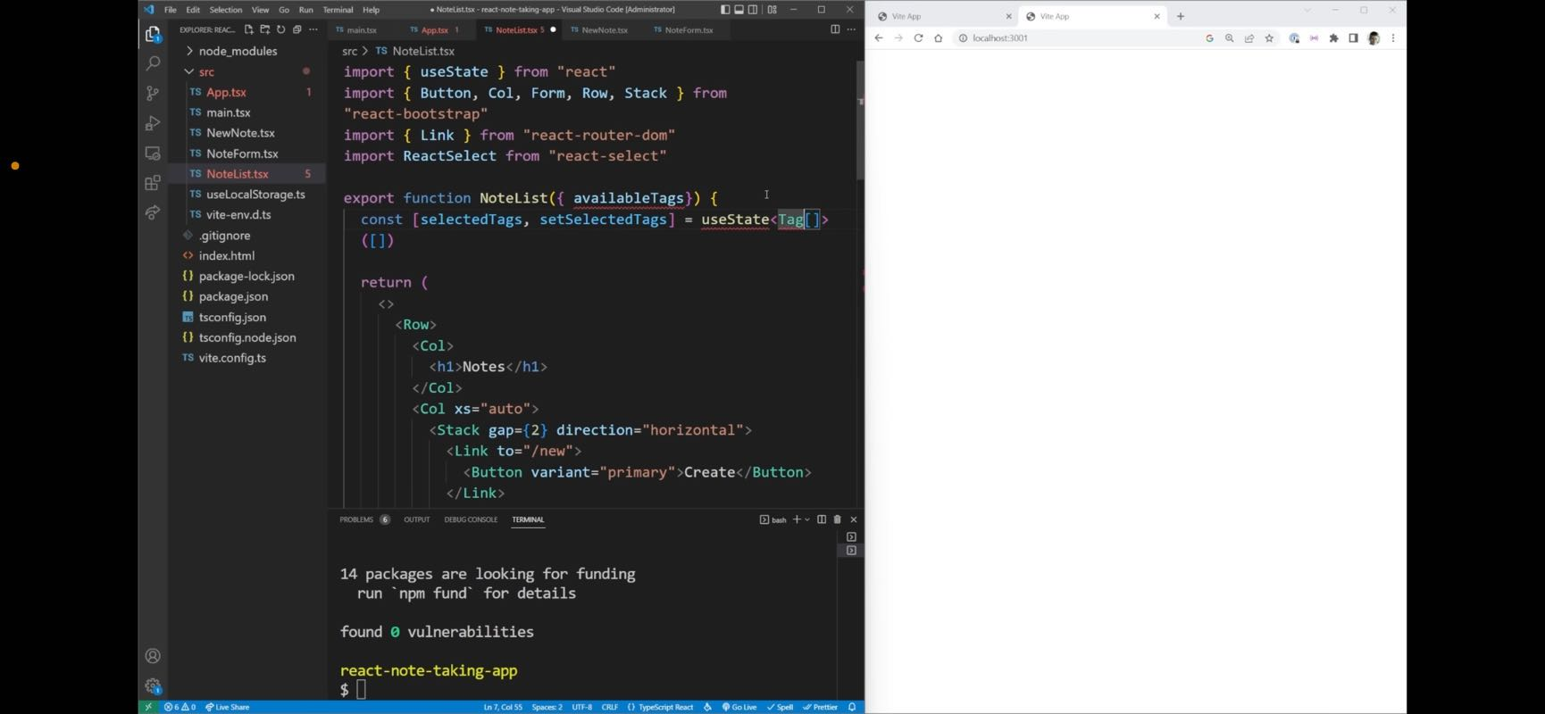

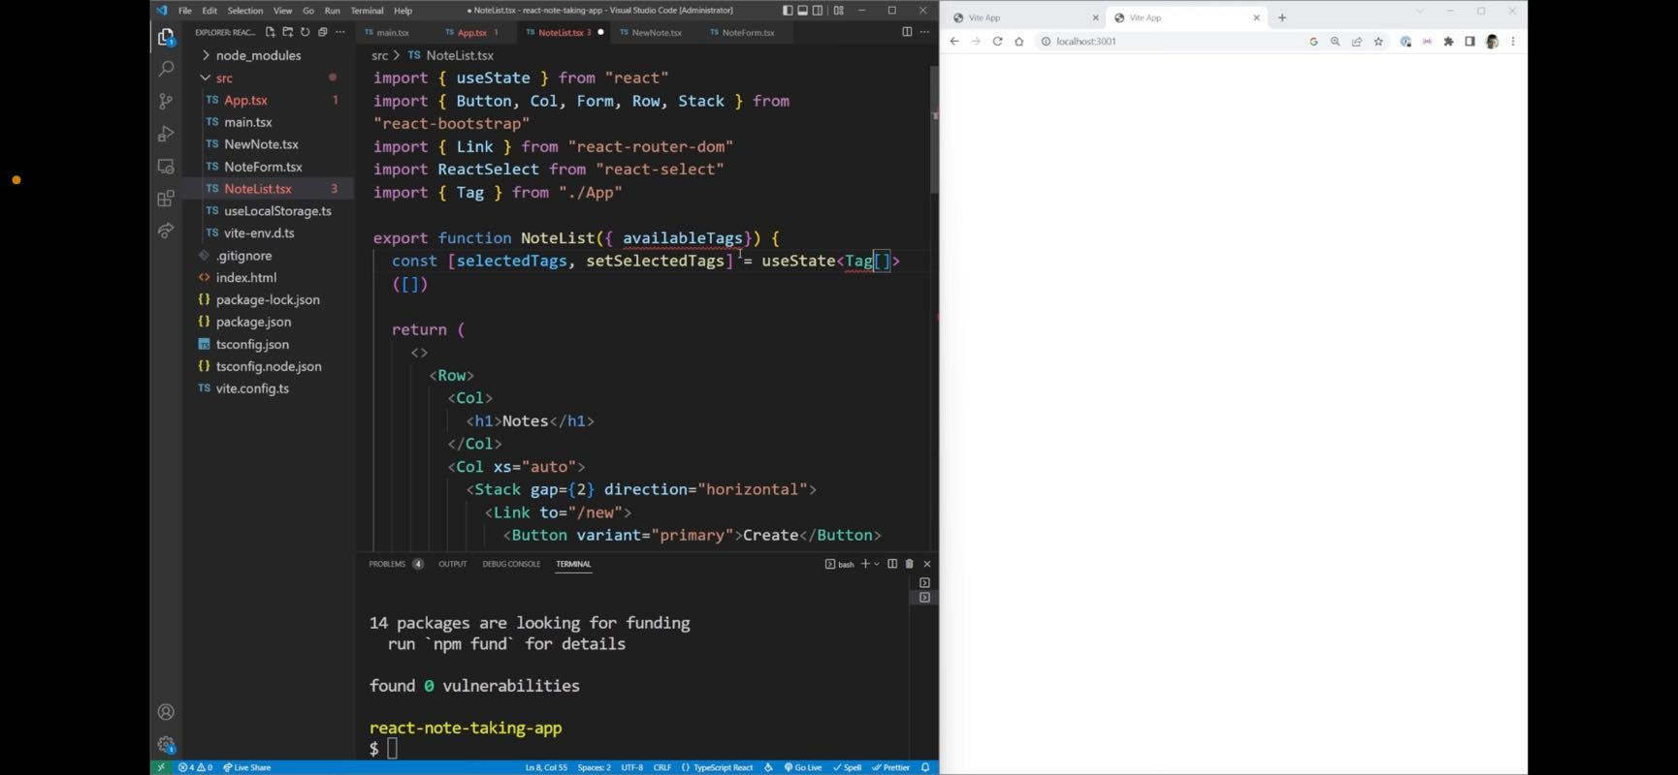

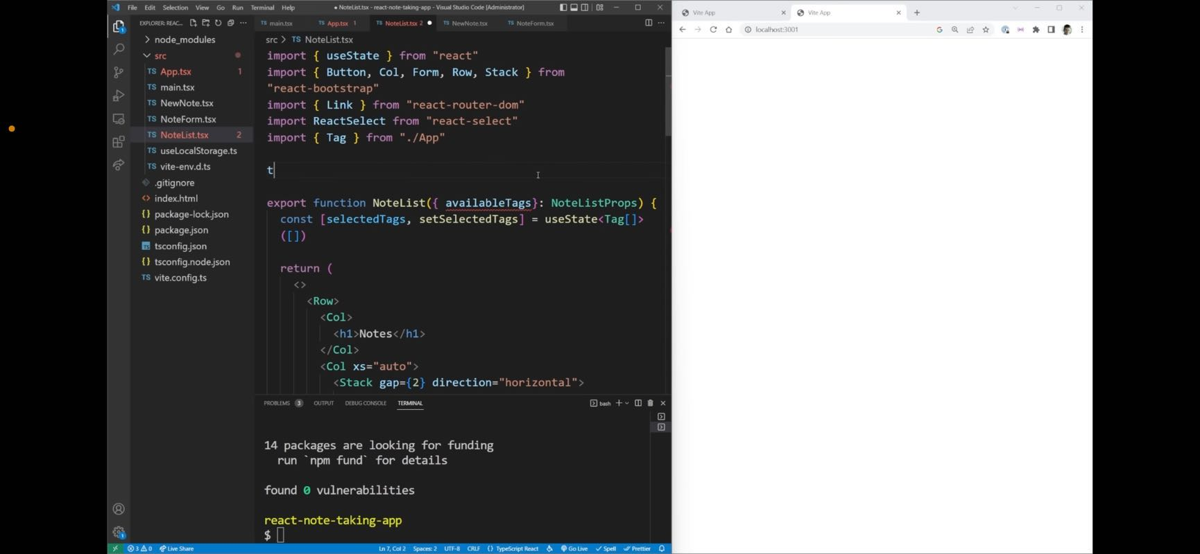

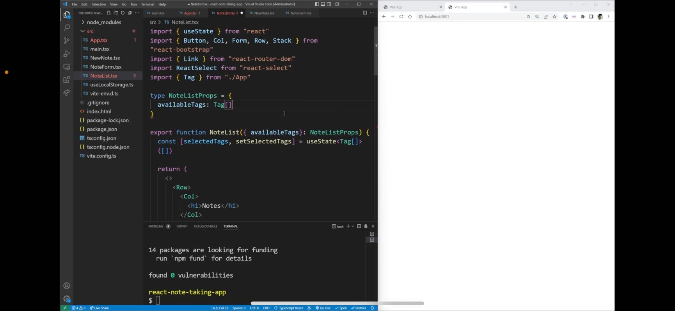

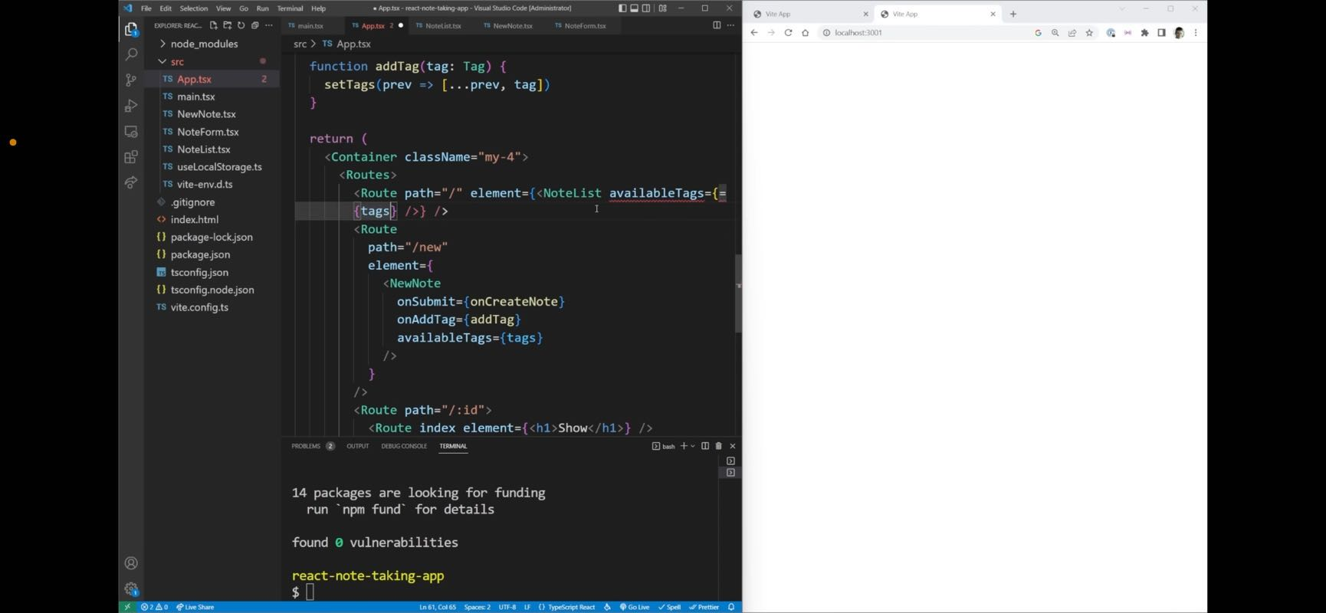

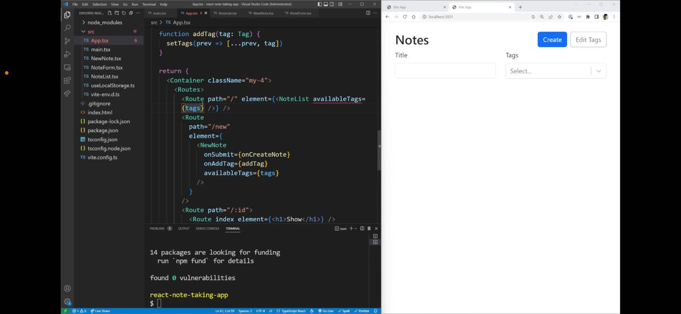

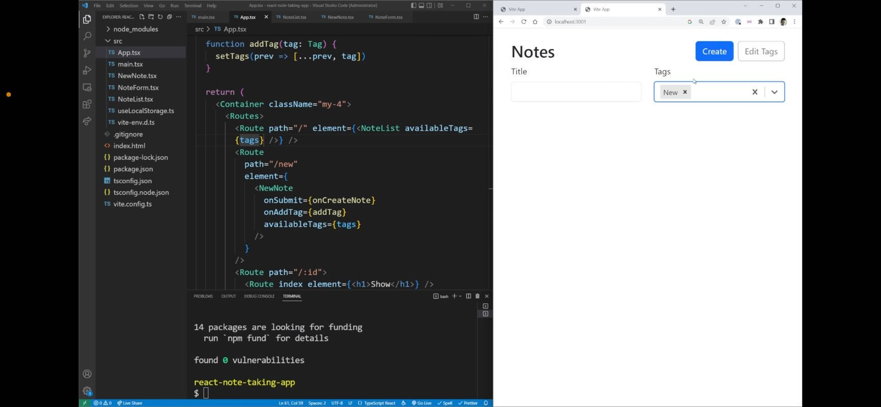

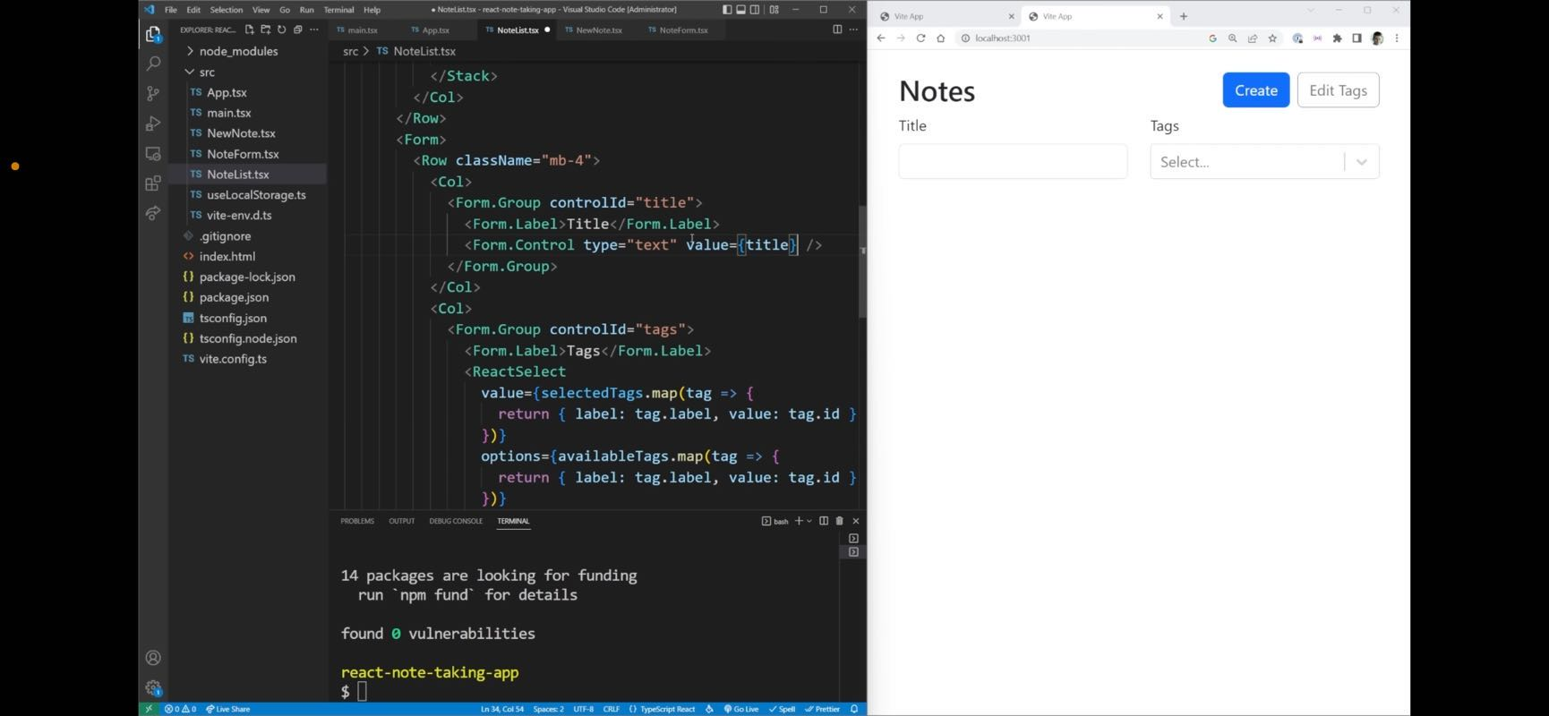

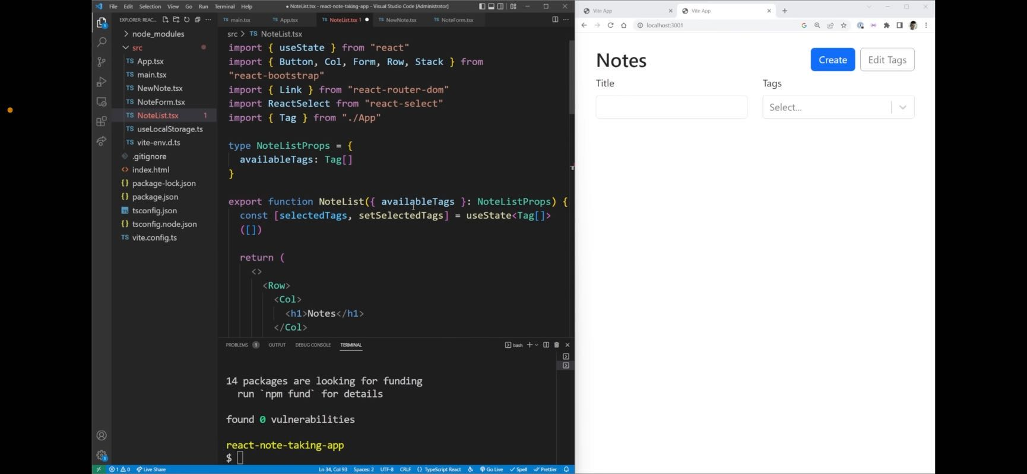

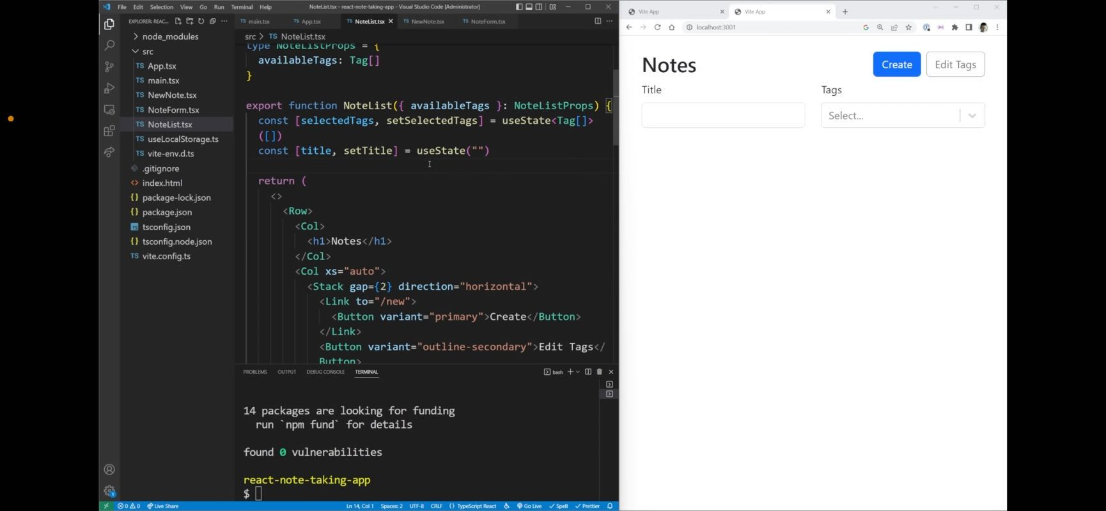

**Jon** 04:12

all setting up use state as an empty string.

04:30

gone and everything is working exactly the same but we have access to the value in the on change event here. Now before we move on to the next step,

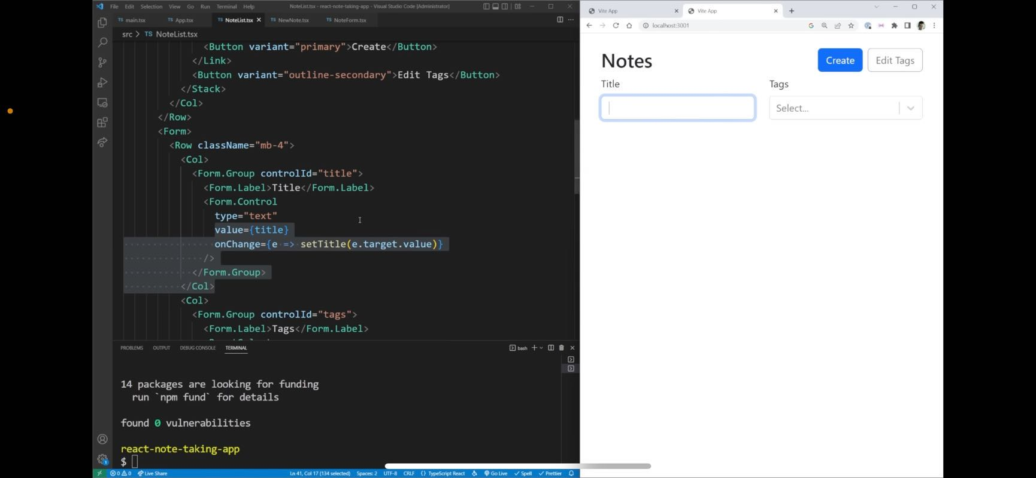

**Jon** 04:37

setting up the on change event and form control saying property value to title

04:53

should I collapse this down, collapse this down and on this row, I'm going to add some classes. We're gonna say align items center and margin bottom four gives us some space and aligns our buttons in the center of our actual notes text. So now the next thing we need to do is to render out each one of these note cards right here. So we can do that fairly simply, what I can do is create a row and this row I want to say that based on the size of our screen, we should have more or less of these elements showing so the number of columns we should have should change. So on an extra small screen, we should have one column on a small screen we should have to on a large screen, we should have three, enter an extra larger screen, we should have four separate columns. And I'm also going to set a class name here of G three to make sure we have a gap of between these different rows of three which is just going to look really good.

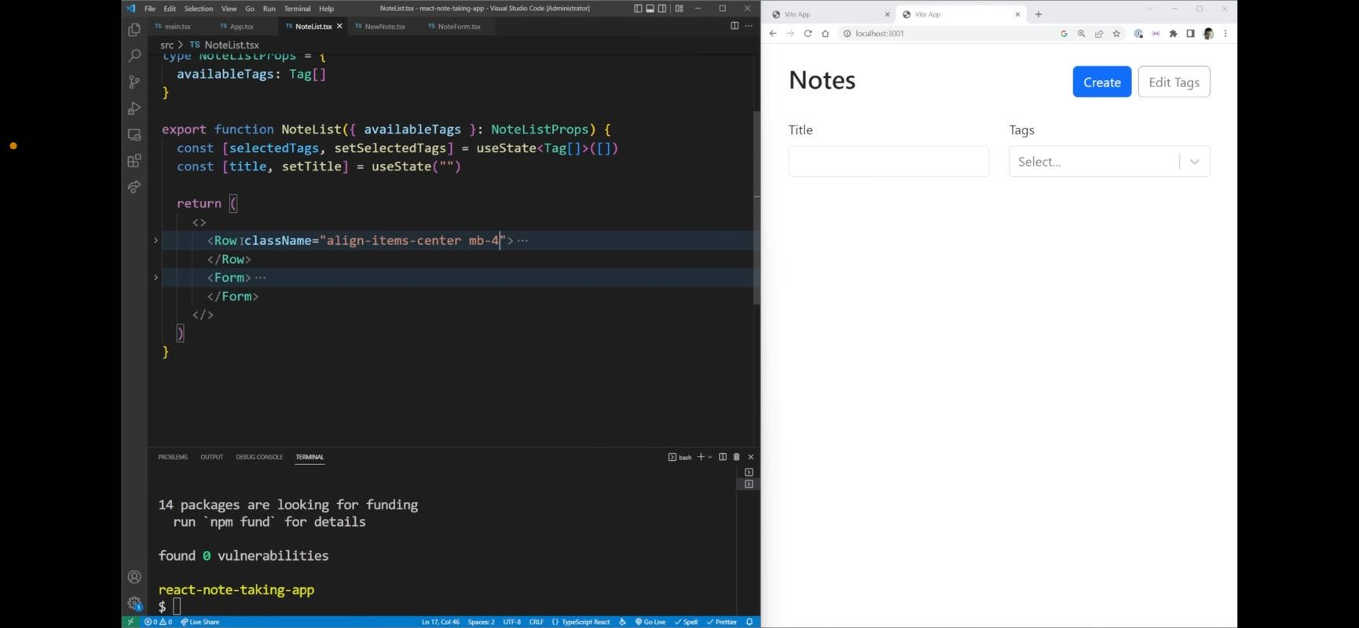

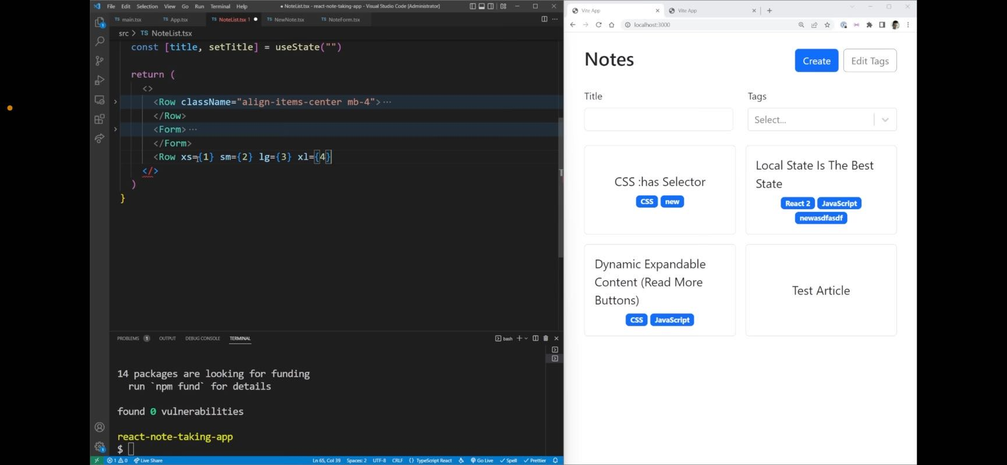

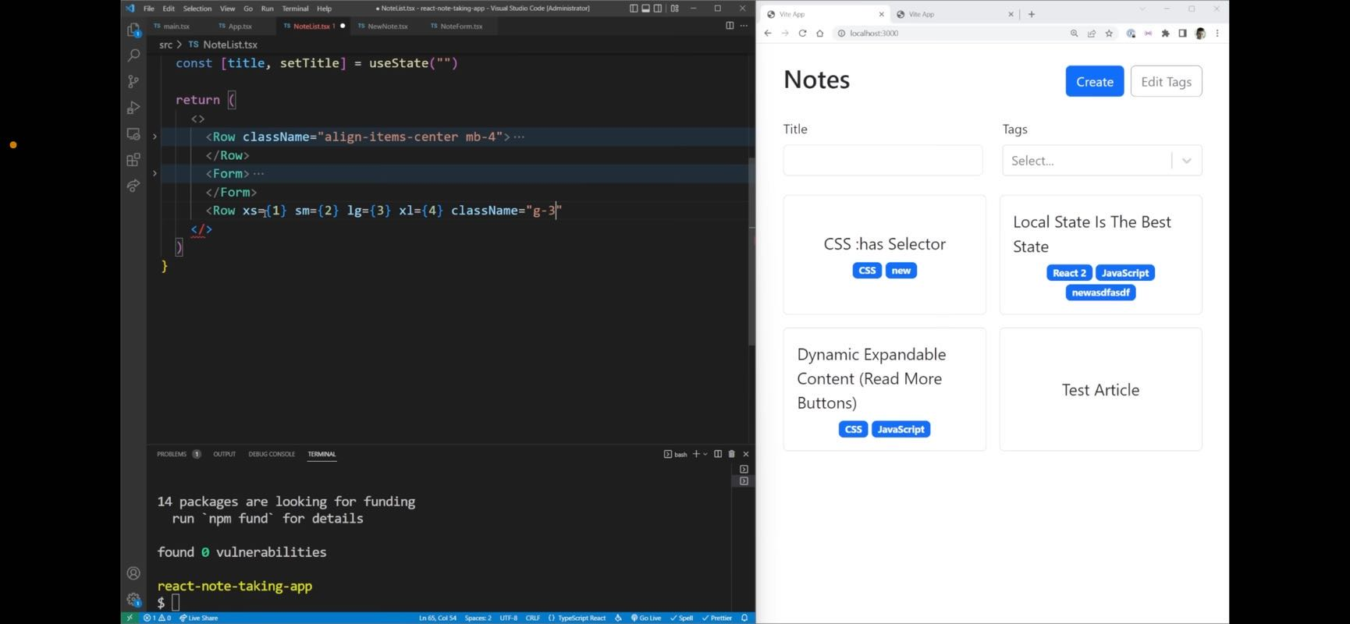

**Jon** 05:42

Setting up responsive layout within the parameters of the element.

05:51

The next thing I want to do is to loop through all of our different notes, but I only want to loop to the notes that are actually being filtered to by our filter right here. I'm going to loop through some filtered nodes, which is a variable we're going to create in just a little bit. But essentially I want to map through each one of these notes. And I want to return to us a column for each one of them. That has a key which is the ID of our note. And then inside this column I want to render out our note card which for now we'll just close off we'll add the information to it in just a second. So we need to create this filter notes. In order to do this, we need to first pass our notes in so we're going to have notes that are coming in which is a note array just like that and this is going to be using use memo. And our use memo is going to update every time we change our title, our selected tags, or our notes just like that. And inside here, we want to return a filtered version of our notes. So we're going to filter through each one of our notes. And then we're just going to return essentially a big Boolean statement. So if our title is equal to an empty string, or if our note.title.to Lower case includes our title.to lowercase and what we're saying right here is that essentially we have a match. So if our title is blank, that means we haven't typed in a title, so don't do anything. Otherwise, check to see if our note has that exact title in it. Let's import us meme and while we're at it. So this takes care of all of our title stuff. But I want to do another check for our tags. So we want to check to make sure our tags and our titles match. Let's make sure we import the note up here as well. There we go. So for this one, I'm going to do almost the exact same thing. So if our selected tags dot length is equal to zero, then that's fine. We don't want to do any matching. Otherwise, if it's not, we're going to check our selected tags. We're going to make sure that every single one of those tags is going to be a tag that's inside of our node dot tags. So we can check our node tags to see if some of them include this exact tag. So is it our note tag? Our note tag.id is equal to our tag that ID. So I'm gonna explain this one function a little bit because it's kind of complicated. So essentially, the way this works is an explanation of

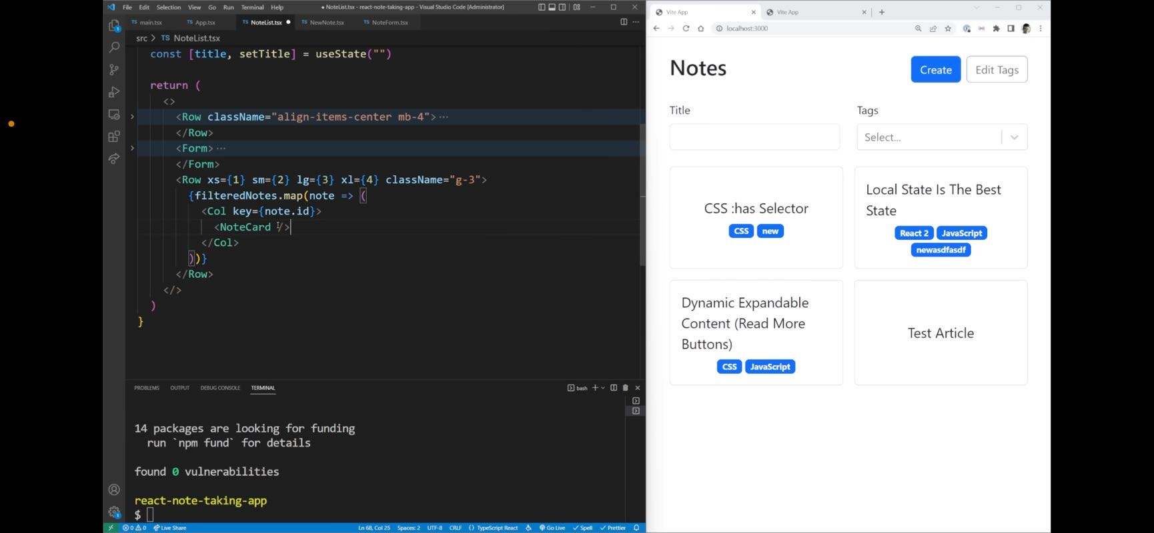

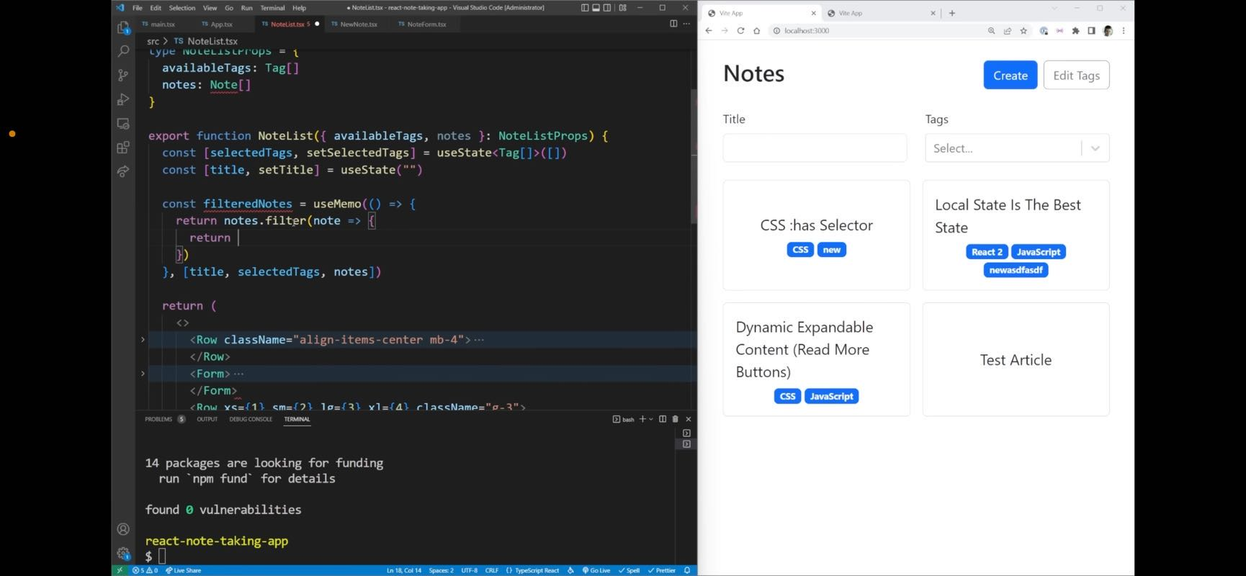

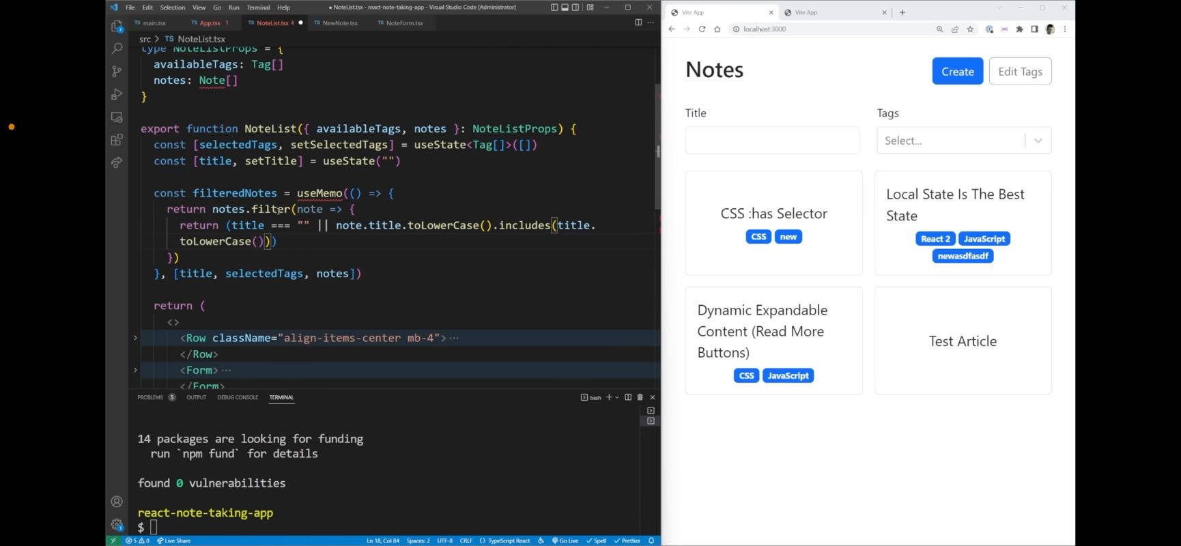

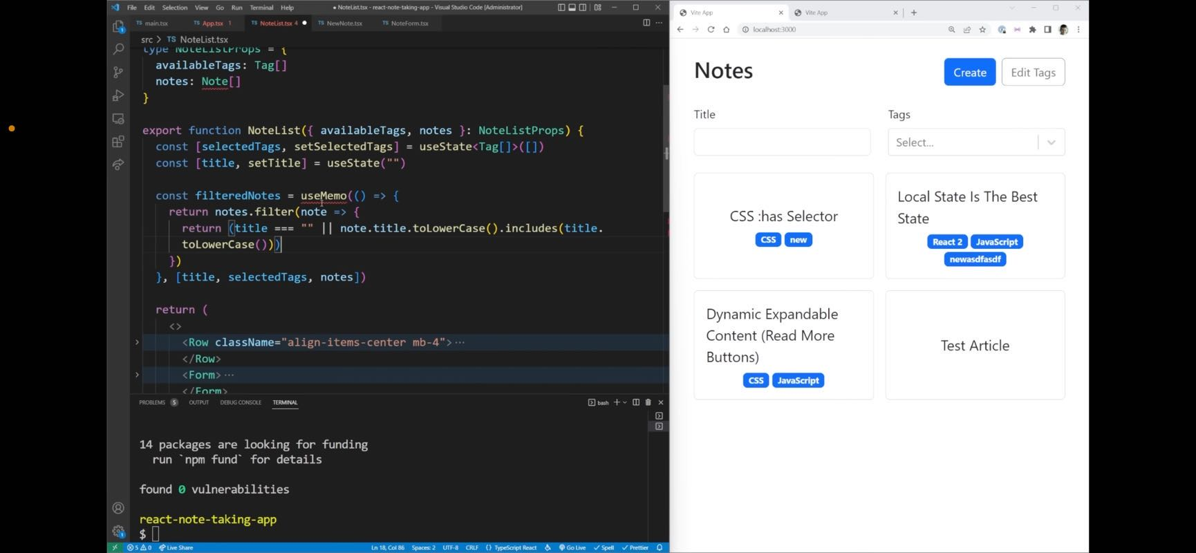

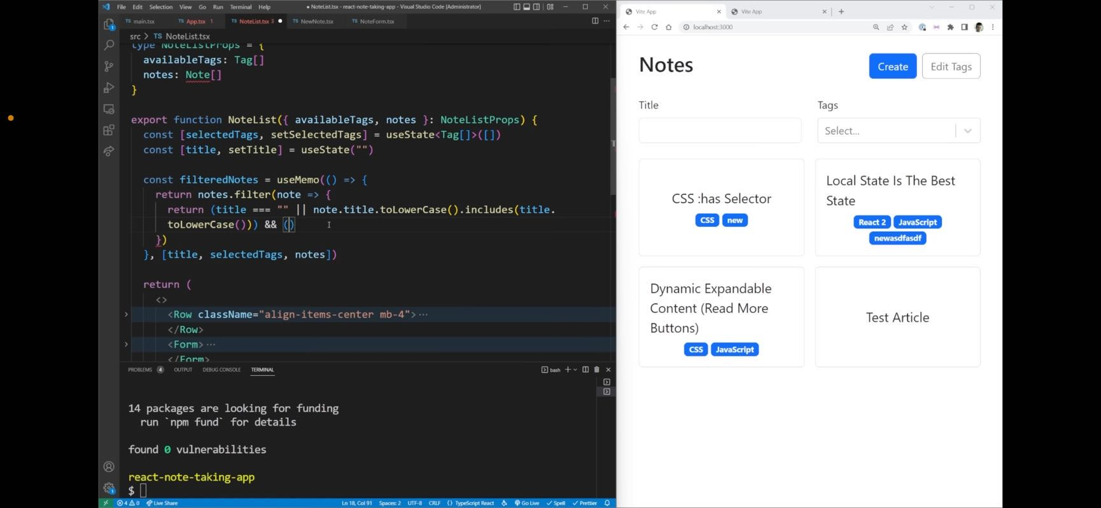

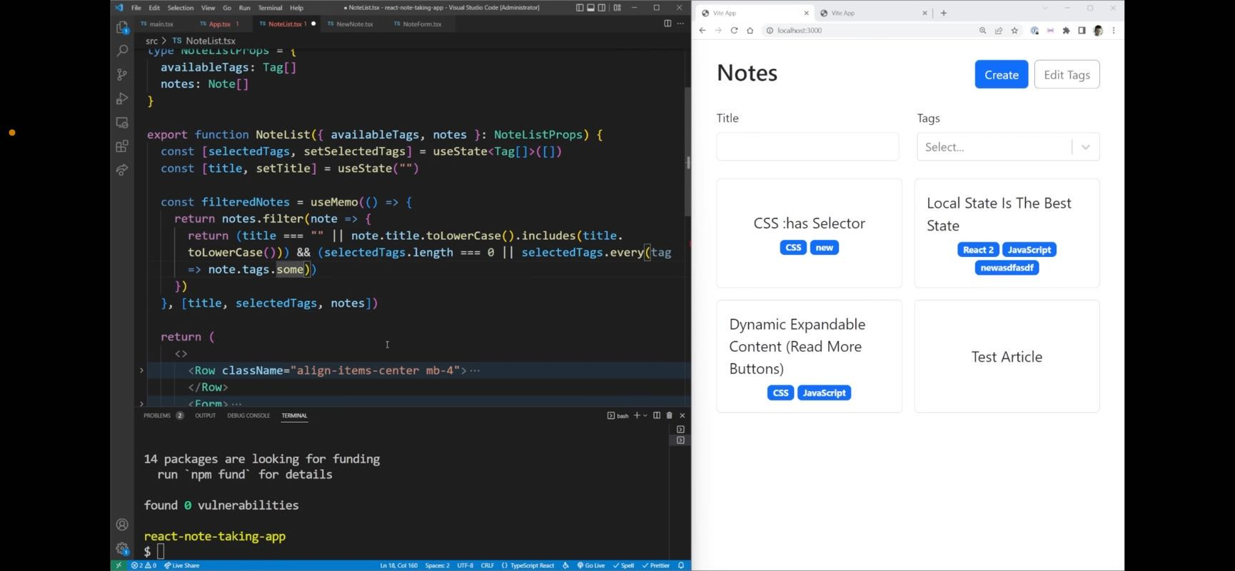

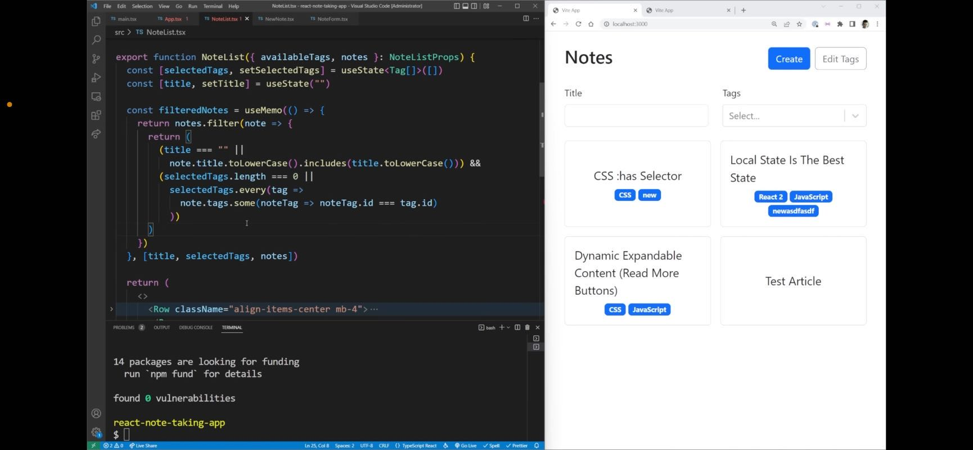

**Jon** 08:11

filtered notes function

08:16

through all of our selected tags, and make sure that every single one of them returns true for this statement. And this statement says check our note to see if it contains the tag we're looping through

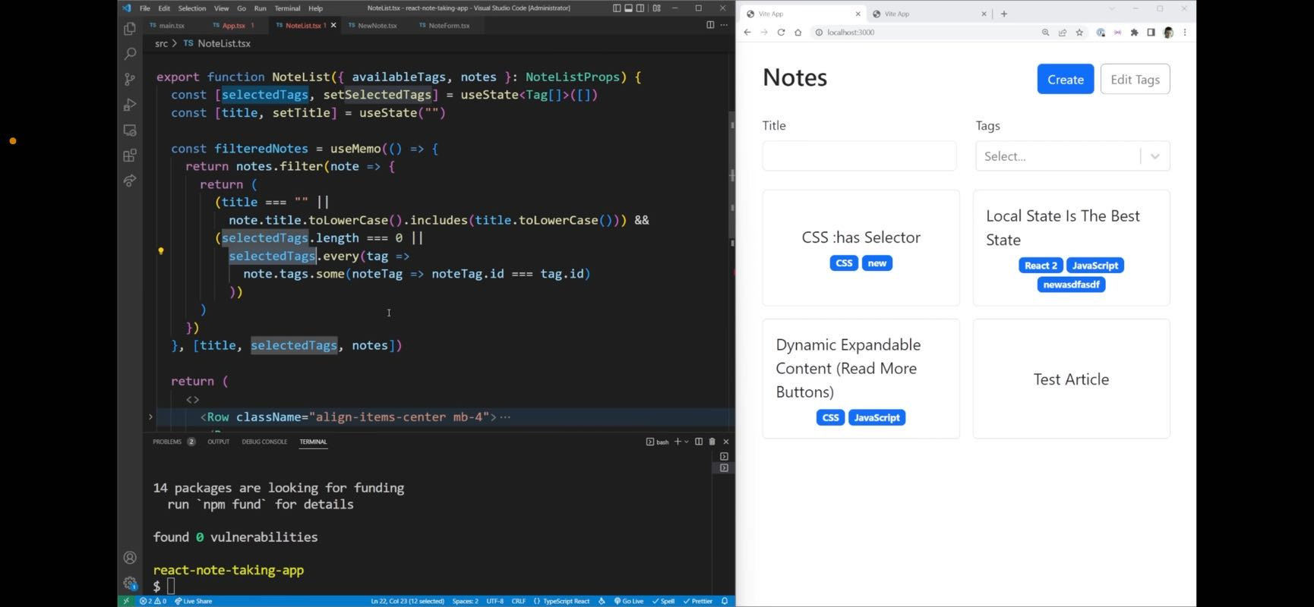

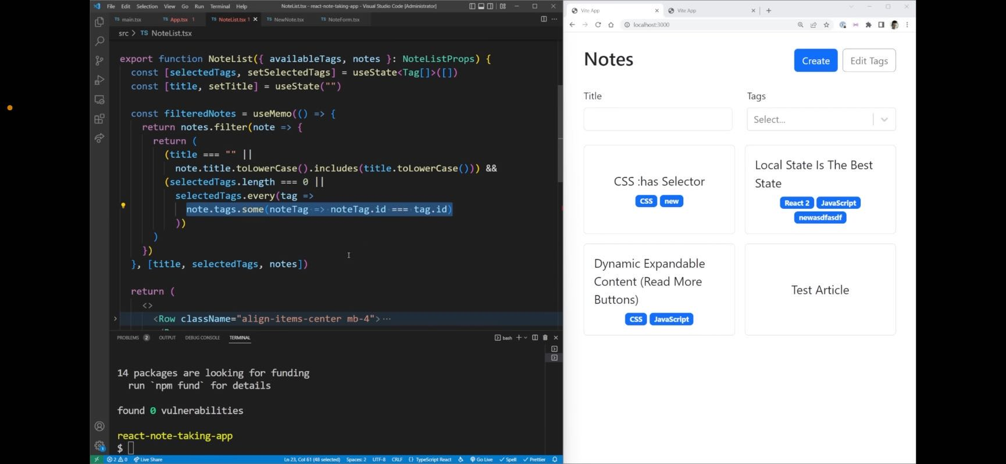

08:28

node dot tags.

## 44:00

So this kind of code is doing is is checking to make sure our note has all of the tags that we're searching for. For example, if I search for CSS, you can see we get both of these. But if I narrow it down to have new as well, you can see we only get this one element. And that's essentially how this function is working is making sure all of the tags match, not just one of them. So now let's get rid of all that filter and we can scroll down here to our note card. And you can see that our no card essentially has a couple different parts. First of all, we need to be able to click on it so it needs to have access to the ID. We also need the title and we need the tags. So we can say the ID is our note.id. The title is our note dot title. And we have our tags, which is our node dot tags. Now let's create a function for our note card. And we know that our note card is going to take in some props. Those are ID title and tags. And this is essentially just a note object. But we don't want a full note we want a simplified note because

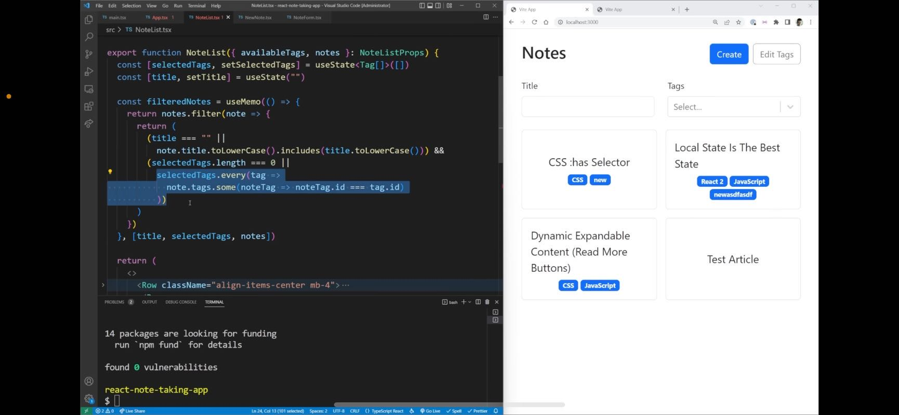

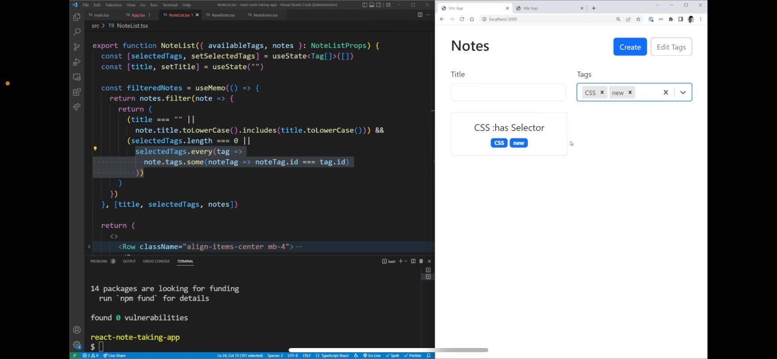

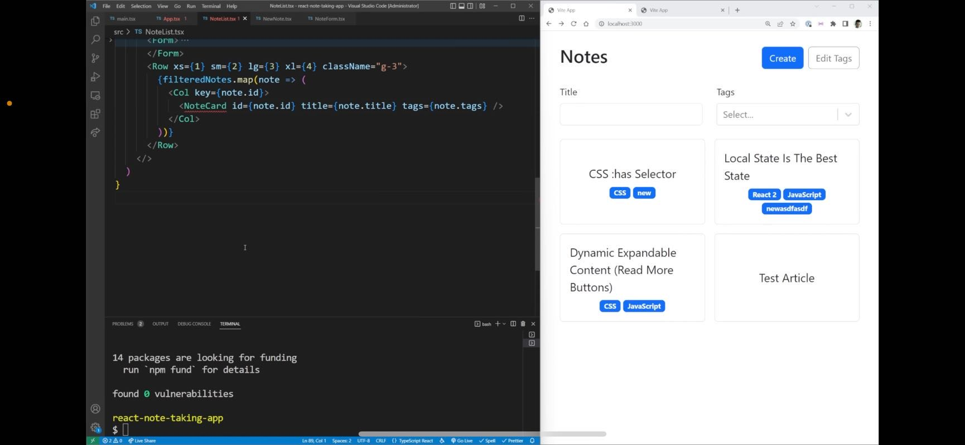

**Jon** 09:32 44:52

the note card function.

Card is going to take in some props. Those are ID title and tags. And this is essentially just a node object. But we don't want a full note we want a simplified note

## 45:00

because we don't care about the markdown portion. So let's create the type for a simplified note. Simplified note equals a simplified note is going to have an array of tags. It's going to have a title. And it's going to have an ID just like this. And here we don't really care about our notes being anything but a simplified version of the note because we only care about the properties of ID, title and tag. We don't really care about our notes being anything but a simplified version of the note because we care about the properties of ID, title and tags just like that. So now inside of our note card, what we can do is we can just simply return an h1 that says hi just to make sure everything is working. If we come over into our page looks like not quite everything's working because our note list is not passing down our notes. There we go. Now if we pass on our notes, you can see it prints out hi three times because we have three separate notes that we have created. We are getting an error though because we actually want our notes with tags. That's going to be a slightly different style of note and that's going to get rid of the Air Force. So now we can actually move over back into where we are working in our note list and finalize our node cart. So our no cart is going to be using the bootstrap card. So we're just going to import that card right here. And inside of our cart, we're going to need to have a body as well. I'm going to add a few different things to our cart first of all, I want to make this a link. So I'm going to say that it's going to be as a link. I'm going to set the to property to be equal to here, a string interpolation. And that string interpolation is just going to be our ID property. So we can link to this specific note, essentially the Show page. And then I'm going to add a bunch of classes onto this and these classes are going to be fairly complex because we're going to have H 100. That means it's going to fill the full height. We're going to have a text reset that's going to reset the color of our text back to the normal color because as a link the text changes to blue. We don't want that. Also our text decoration is going to be none and then the final complex style is going to be styles dot card. And this is going to be coming from CSS modules. Because if we want to have these fancy hover styles, we can only do that inside of CSS. So we're going to be using CSS modules for that. So what we can do is we can just come in here we're going to create a new file called note list. dot module modules dot CSS. And inside here, I just want to have some really simple styles for our card. So we're gonna have our card, and then we're gonna have a hover style as well as a focus style. So what we're going to do is we're going to translate zero and negative five pixels. That's just going to lift our note up five pixels. And then we're going to add a box shadow as box shadow is going to be zero and the x and y direction down by five pixels. It's going to have an eight pixel blur, zero pixels spread, and it's going to be a black color that is mostly transparent. And then what we can do instead of our card, is we can just make sure we specify a transition on our translate property, which is ease in out over 100 milliseconds. And the same thing for box shadow. We want this to be easy and out over 100 milliseconds. Now in order to use CSS modules we need to import them. So at the very top here, we can say that we want to import we can get rid of this note input since we're not actually using that anymore. We're going to import files from and this is going to be from dot slash note List dot modules dot CSS. And now when we actually use that styles dot all the way down here dot card. It's going to get that card class from our modules dot css right here, you will notice we're still getting an error. That's because this should say module that CSS not modules. And up here when we do our import, it should say Module A should get rid of that error down here. And as you can see it has now if we go back over to our application, just make sure we save everything it says failed to resolve this file, no list dot module dot css, no list.tx S of C note list thing, module. CSS. We're going to need to have a body as well. And bootstrap card so we're just going to pay a link page to reset the style css here I just translate down by five pixels. It's going to have an eight pixel blur, zero pixels spread. And it's going to be a black color that is mostly transparent. And then what we can do inside of our card is we can just make sure we specify a transition on our translate property, which is ease in out over 100 milliseconds. And the same thing for box shadow. We want this to be ease in out over 100 milliseconds. Now in order to use CSS modules, we need to import them milliseconds and zero pixels shadow, translate card jewels dot css and inside here I just want to have some really simple styles for our card. Coming here. We're going to create a new file called note List dot module modules dot css and inside here I just want to have some really translate. Get rid of this note input since we're not actually using that anymore. We're going to import styles from and this is going to be from dot slash note List dot modules dot CSS. And now when we actually use that styles dot all the way down here dot card is going to get that card class from our modules dot css right here, you will notice we're still getting an error that's because of this should say module dot css not modules. And up here when we do our import, it should say Module A shouldn't get rid of that error down here and as you can see it has now if we go back over to our application, just make sure we save everything it says failed to resolve this file, note List dot module dot css note list.tx s of C note List dot module that CSS Oh, it's because this should be called note list not notes list. There we go. Now if we give it a refresh, that should hopefully fix it. And now when we hover over this you can see we get that hover style being applied, which is exactly what we want. So now we can focus on putting the content inside of our cards.

